Pres. Steve Kuhl
V .P. James Barry
Sec. Helen Barry
Treas. Sharon Smoot
Sgt. in Arms: Glenn Sanders
The Stephen James
CSRA Coin Club of Aiken
P.O. Box 11
New Ellenton, SC 29809
Web site: www.sjcsracc.org
The SJ CSRA CC now meets on the 1st Thursday of the month at the Aiken Public Library

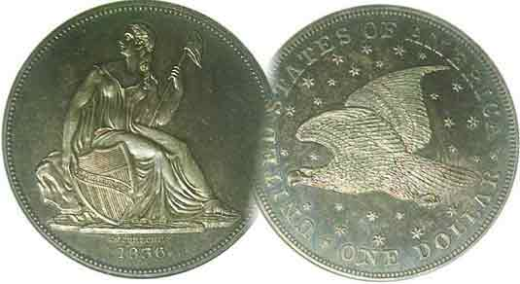
Committees:
Programs: James Barry
2010 Show Chairs: ?
Newsletter: Arno Safran
E-Mail: arnosafran@comcast.net
Auctioneer: Glenn Sanders

2010 Club Meeting Schedule
Volume 9, Number 1 the Stephen James CSRA Coin Club, Founded in 2001 January, 2010
Monthly Newsletter
Library Meeting Room Refurbished and Well Lit
Our next meeting is on the first Thursday, Jan. 7, 2010 from 6:00 to 8:45 PM

Jan. 7 Apr. 1 July 1 Oct. 7
Feb. 4 May 6 Aug. 5 Nov. 4
Mar. 4 Jun. 3 Sep. 2 Dec. 2

____________________________________________________________________________________________________________

Return to Aiken Public Library Shows Positive Signs

After meeting at the Cedar Creek Activity Center for 3½ years, the SJ CSRA CC moved back to the meeting room at the Aiken Public Library on December 3 where it began its new tenure at the more centralized location. Upon entering the meeting room, it was evident that improvements had been made to the walls and lighting. Everything looked clean and bright. The room is equipped with a pull down large screen suitable for PowerPoint and slide film programs as well as a wheel-in table that houses a TV monitor screen with a DVD and VCR player for showing pre-recorded programs. Switching the meeting schedule from the second Thursday to the first didn’t present any problems in attendance as the more than 20 members and guests seemed delighted with the surroundings when President Steve Kuhl called the meeting to order. It is hoped that some of our former members will receive word of our club’s return and rejoin us along with new members.

Despite a fairly healthy treasury balance of $1,864.17 reported by Treasurer Sharon Smoot, the club needs to review its financial procedures carefully during these uncertain economic times. President Kuhl mentioned that as of now, no one has come forward to serve as Bourse Chairman for our 2010 show. Such a position does not have to be held by an individual. A show can be run by two people or by committee working in coordination with each other. The most important item is choosing a date that does not conflict with a regional three day show within a radius of 200 miles. Such a conflict would siphon off the number of dealers who would likely do ours. The second is drawing up a budget that is based on the projected number of tables sold while pricing the tables accordingly. The third is finding a suitable site, and for now the spacious H. Odell Weeks Activity Center is more than adequate. The fourth is contracting the dealers and publicizing the event within budget.
______________________________________________________________________________________________________________________
(More Club News continues on the lower portion of page 4, column 1)

Eye Appeal is Buy Appeal
By Arno Safran

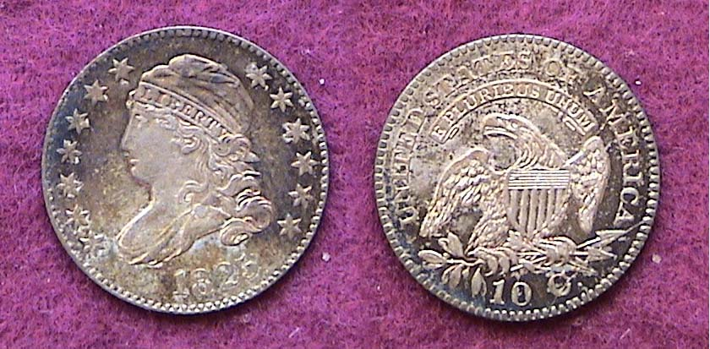

An 1825 Large size Capped Bust dime; JR-3 R3
[Actual size when printed; Magnify to 200% to view details]

In the days before certified coinage many neophyte collectors were hesitant before making an acquisition because they weren’t certain if the dealer’s grade of a desirable coin matched theirs. In those days, all coins were sold “raw” and most were inserted either in 2x2 stapled cardboard see through containers or vinyl plastic flips. On these inserts the dealer would pen the date, denomination, grade, also the asking price and in smaller print, a coded series of letters and numbers indicating what he paid for the piece. Some dealers didn’t even bother to place a grade on their flips. When asked what grade their coin was, the dealer’s response was, “$250.00!” or something like that. That answer did not always sit well with the prospective buyer, especially one who had by now acquired better knowledge on grading along with the price lists corresponding to specific grades. Such dealers sincerely believed that it was not the grade that generated a particular coin’s value so much as its appearance. A dealer with whom I did a lot of business some years ago coined the phrase, “Eye appeal is buy appeal!” It made good sense then, and after more than two decades of companies offering professional grade certification, the statement still makes good sense now.

The large size Capped Bust dime pictured above was purchased when I was a sophomore in high school. It was sold as an EF and cost $4.50. Today it would probably certify AU-50 and sell for $1,000; it has that much eye appeal. I was earning $2.00 a week for doing chores and errands and my father thought paying 2¼ times my allowance for a dime was absurd and forbid me to buy anymore. It was probably one of the few mistakes he ever made in rearing me but how was he to know?
____________________________________________________________________________________________________________________________
(Continued on page 2, column 1)

Eye Appeal is buy Appeal (Continued from previous page)

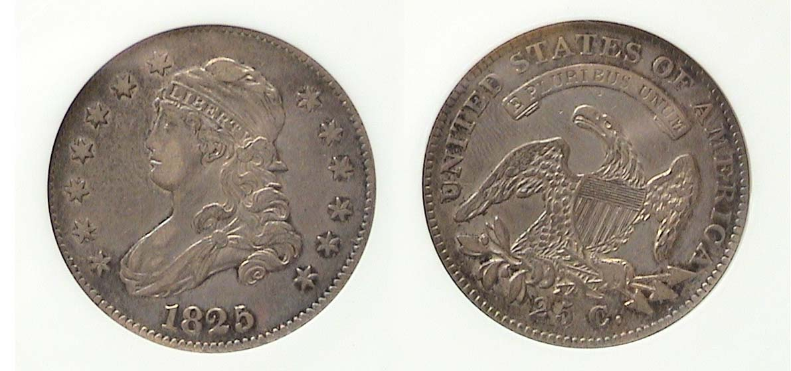
An 1825/3 large size Capped Bust quarter B-2, R2
The coin was graded XF-40 by Anacs
168,000 with this date were struck; all in Dec. 1825
[Actual size when printed; Magnify to 200% to view details]

In 1976, our Bicentennial year, my interest in coin collecting was reawakened. Early US type coins--which I had favored over modern coinage even as an adolescent--had increased in value dramatically from my teen years and it took me a while to learn to grade and recognize a coin whose surfaces had been artificially “improved”. Uncirculated type coins were still fairly numerous back in the late 1970’s but were costly. Finding circulated obsolete type coins that were problem-free and “original” yet still affordable were a challenge as most specimens appeared improperly cleaned or marred by unsightly marks or scrapes along the surface or rims.

In 1986, third party certification was introduced and collectors found they now had some protection against overgraded coins by purchasing professionally graded coins hermetically sealed in see-through plastic holders called “slabs”, but the idea of not being able to handle one’s acquisition kept many old time collectors from jumping onto the “slab” bandwagon at first.

The coin pictured above was acquired in 1999 for $425. Despite a reported mintage of only 168,000, the 1825 Bust quarter is not considered rare as a date. Upon closer magnification, the certified XF-40 specimen shown is accurately graded and “original” for a coin of 185 years and is attractive to the eye. Today it would for retail for $1,400.

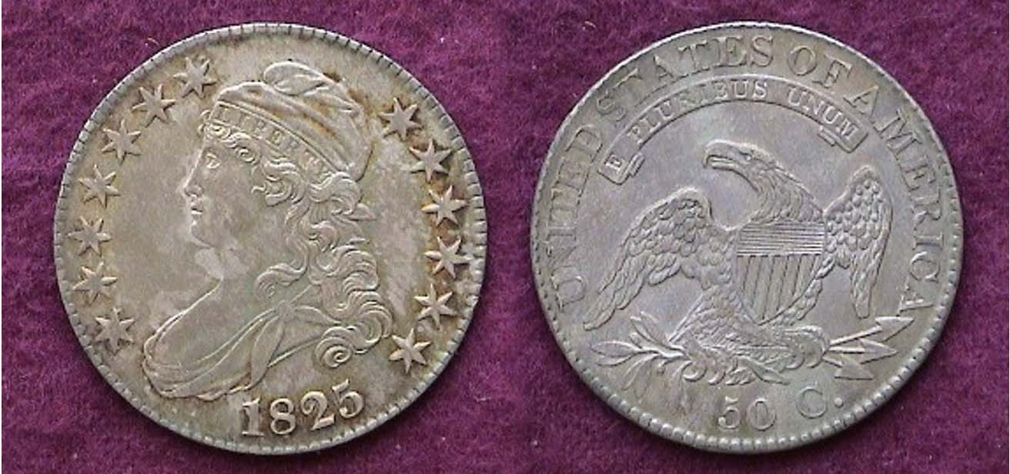

An 1825 Lettered edge Bust half dollar O-106 R4
The coin was sold “raw” as an AU-55
The reported mintage for this date was 2,943,166
[Actual size when printed; Magnify to 200% to view details]

As no silver dollars were issued during this period, the half dollar was the largest circulating silver denomination yet it didn’t circulate very much. Like the Morgan dollars of more than half a century later, the Bust half was stored in bank vaults as specie to back business ventures. The 1825 50¢ piece shown above has very little distinguishable wear. It cost $250 in 1999 and today it might sell from $450 to $500. The date is listed at nearly three million; a whopping mintage for that era and is considered fairly common especially in the higher grades. This accounts for the smaller increase in value. Like the other silver coins, the specimen exhibits strong eye appeal, with its natural russet toning on the obverse and an even strike on the reverse.

Copper Coinage

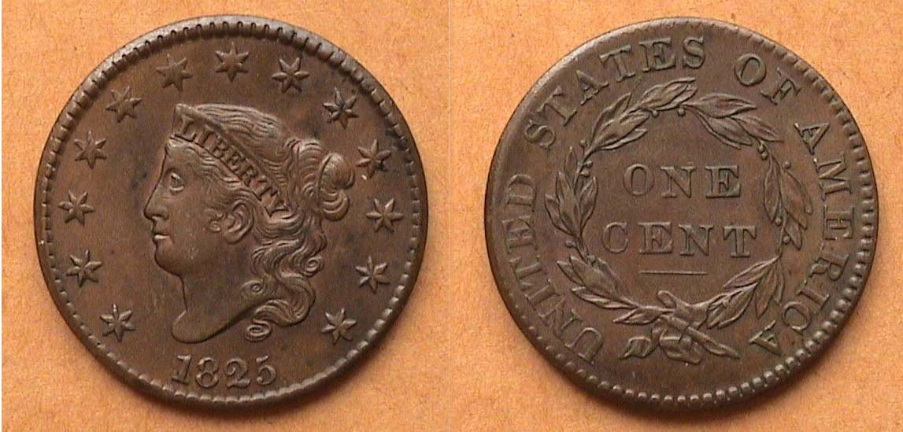

An 1825 Coronet Large Cent, N-6 R3
The coin was sold “raw” as an XF-45
The reported mintage for this date was 1,461,100
[Actual size when printed; Magnify to 200% to view details]

There is a large collector base for early American copper coins which collect mostly the half cents and large cents that were coined from 1793 to 1857. Many are seasoned collectors who prefer “raw” coins over “slabbed” for one very simple reason: In their view, the so-called professional graders overgrade copper coins almost to a fault. The sharpness grade of a copper coin is not as important as its overall condition or net grade. The net grade takes into consideration not just the amount of wear a coin has but the condition of its surfaces and rims, its color and its strike. To the copper coin collector it is better to own a lower grade VG-10 large cent with natural chocolate color, smooth surfaces free of rim dings or corrosion than one graded VF-20 appearing charcoal toned with lots of contact marks that is porous or corroded.

The 1825 large cent shown above was acquired back in 1985, one year before the age of “slabbing”. It has natural chocolate color, relatively smooth surfaces with no detracting marks and a good strike. Today it would certify XF-45 to AU-50 but Early American Copper Club members would probably grade it only VF-35, possibly XF-40. Back then it cost $125. Today it would sell for closer to $400. It has lots of eye appeal.

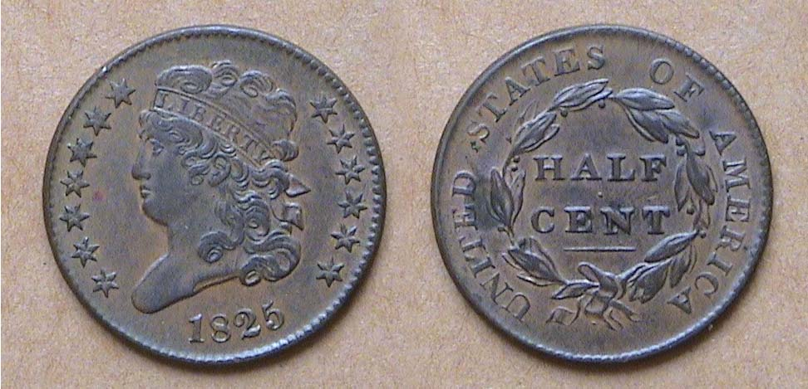

An 1835 Classic Head ½¢
The reported mintage for this date was only 63,000
[Actual size when printed; Magnify to 200% to view details]

The lowly copper half cent was never very popular with the public. It was used more to make change for the Spanish Real which had the value of 12½¢ and circulated in this country until 1857. Last coined in 1811, the denomination was resumed in 1825 at the request of some Baltimore businessmen. Despite the reportedly low mintage of only 63,000, the date is not considered rare. This XF-45 piece has nice eye appeal. In 1985 it cost $41. Today it would retail for around $175.
________________________________________________________________________________________________________________________
(Continued on page 3, column 1)
Eye Appeal is buy Appeal and the US Coins of 1825
(Continued from page 2, column 2)

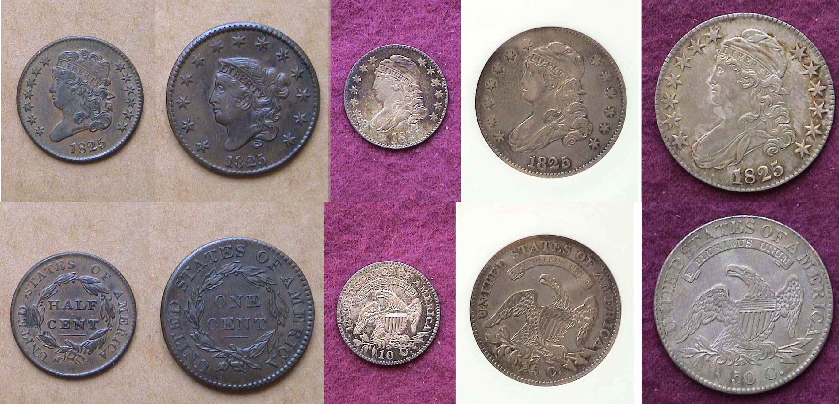

The Coins of 1825 (excluding gold) reduced in size
[Magnify to 200%to see set more clearly.]

It is no mere coincidence that the five coins chosen to illustrate moderately priced higher end circulated coins with eye appeal all have the sane date; 1825. From 1808 through 1824 the Mint struck only a small number of the authorized ten denominations each year; never more than four (excluding gold). The resumption of the half cent n 1825 is significant in US coinage history as five denominations under the value of the dollar were struck for the first time since 1807 in a single year. All of these pieces produced 185 years ago have turned out to be fairly good investments even though none are rare or could be considered the key dates of their respective series. Shown in a row, the coins make up a nicely balanced set.
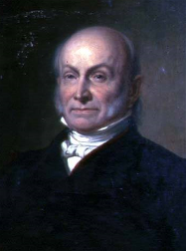
On March 4, 1825, 185 years ago, John Quincy Adams was inaugurated as our sixth President. The son of John and Abigail Adams, John Quincy Adams had already carved out a distinguished career as a diplomat and world statesman. He contributed to the signing of the Treaty of Ghent on Christmas Eve, 1814 that officially ended the War of 1812 with Great Britain. In 1823, as Secretary of State in the Monroe administration, he wrote the Monroe Doctrine.
John Quincy Adams
________________________________________________________________

UGANDA CURRENCY
By Bill Myers (Part Two: The Banknotes)

In October 2009 I had the opportunity to travel to Uganda with the U.S. Army as part of Exercise Natural Fire. It was a multi-national exercise to improve the living conditions in Kitgum, in northern Uganda. I was part of the group that delivered medical care over six days to over 6,000 patients. Only basic medical care could be delivered, as we worked out of a clinic building that did not have electricity or running water.

I was pretty much restricted to staying at our base camp during the mission, and to staying at the hotel upon arrival and departure. But I was able to get out once on a shopping excursion and managed to collect some of the current Uganda coins and banknotes. What follows is Part Two of my finds.

The exchange rate was 1,700-1,800 shillings (sh) to the U.S. dollar, so a 1000 shillings note would still be worth less than $1.00. Uganda’s paper money is in the denominations of 1000, 5000, 10,000, 20,000 and 50,000 shillings.

The format of all the notes is the same with variations being in the ornamental design and vignettes featured. There are significant anti-counterfeiting measures. All of the notes have a foil strip on the face, with the denomination imprinted on it. The notes also have an imbedded security thread with the denomination on it, as well as an ultraviolet ink mark with the either the denomination or a design. All of the notes also feature a watermark. The three lower denomination notes have the head of a crested crane as the watermark and the two higher denominations have the crest of Uganda as the watermark.

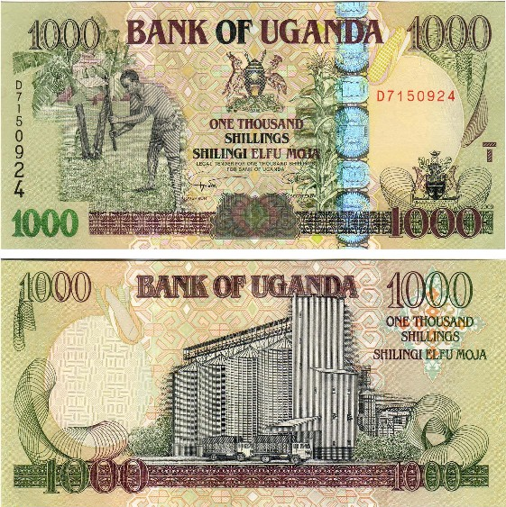

The face (top) and back (lower) of the 1,000 Shilling note of Uganda
[Magnify to 200% to see details.]

The two highest denomination notes also have a design below the watermark on the front and the back of the note that appears to be random designs, but when held up to the light both designs merge to become a single object . This feature requires that the printing line up exactly on both sides, making it harder to counterfeit. The serial number is printed in black ink vertically on the left of the face and the numbers increase in size as they descend. It is repeated in red ink horizontally on the right of the face, with all the numbers being the same size. The notes also increase in size as the denomination increases.

The 1,000 shillings note features a man with a hoe on the face and a grain elevator on the back. The 5,000 shillings shows Lake Bunyonyi and terraces on the face and the Kaawa Ferry on the back. The face of the 10,000 shillings features a stringed instrument and drums, with Owens Falls damn on the back. A crested crane is on the face of the 20,000 shillings note and an unidentified government building is on the back. The 50,000 shillings note has a monument statue on the face and natives harvesting cotton on the back. It took a bit of work, but I managed to obtain all of the notes in AU-CU condition.

_______________________________________________________________________________________________________________________
(Continued on page 4, column 1)

Modern Banknotes of Uganda
(Continued from page 3, column 2)

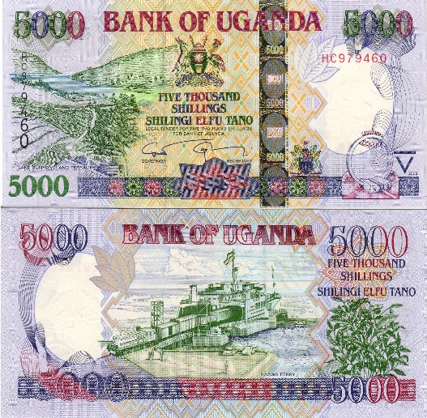

A 5,000 Shilling Banknote of Uganda
[Magnify to 200% to see details.]

There were soldiers from Rwanda, Kenya, Tanzania
and Burundi participating in the mission with us, so I was also
able to obtain 500 and 1,000 franc notes and a 20 franc coin from Rwanda, a 1,000 shilling note from Tanzania and a 20 shillings coin from Kenya.

Whenever and wherever I travel, I always try to find a way to take advantage of the opportunity to include numismatics in the trip.
___________________________________________________________________________________________________________

More Club news and Show Concerns
(Continued from page 1, column 1)

For any organization to survive its members must share responsibility. We need to have a show chairperson or show committee in place by the March, 2010 meeting at the latest if we are to secure a viable date, seek dealers and adequately publicize the event. An organization cannot rely on the same few individuals year after year and expect it to sustain itself indefinitely.
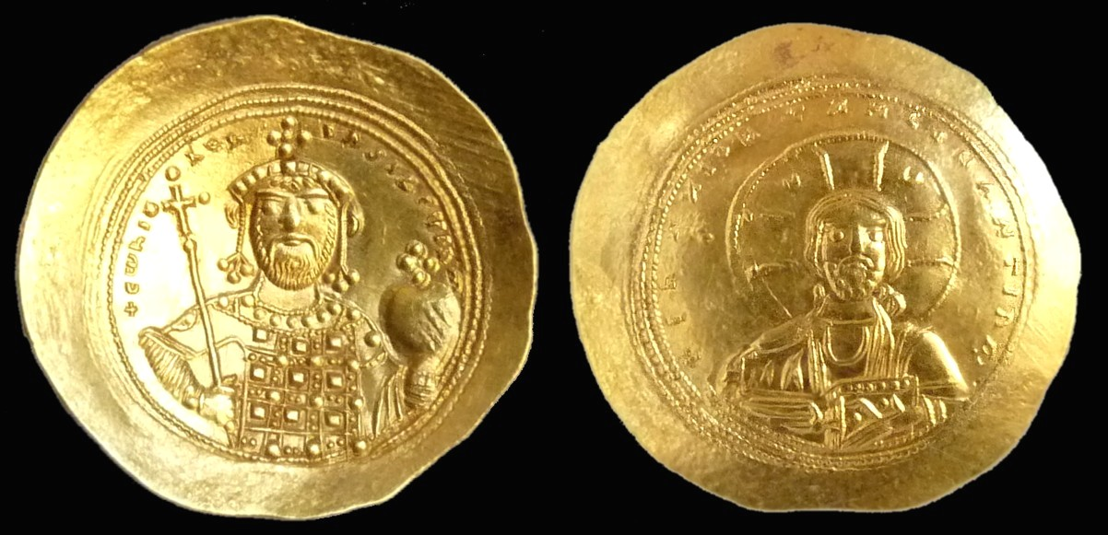

A Byzantine Gold Nomisma of Constantine IX
The Emperor at let, Jesus at right [Magnify to 200%]

At the Dec. 3 meeting there were two Show & Tells. As the program for the evening was on “Christian Symbols on Byzantine coins” Jim Barry brought in a cup shaped Byzantine gold coin showing the Emperor Constantine IX on the obverse who ruled from 1042-1055 and Jesus on the reverse. The coin was about the size of our $5.00 gold piece and very attractive.

Arno Safran displayed first a US 1959 Proof Set housed in a five piece Lucite holder which featured three silver coins including the long obsolete Franklin half. The mintage was 1,149,291. Despite being half a century old, Arno reported the current value was a pitiful $19.00 or about the same as a contemporary 1 oz. silver eagle. He also displayed a choice AU 1739 Mexican Pillar dollar (8 Reales) of Philip V. Despite being 270 years old, the coin came from an old horde and is not considered rare. However it did circulate as legal tender in the colonies and the federal US in the amount of $1.00 until 1857.

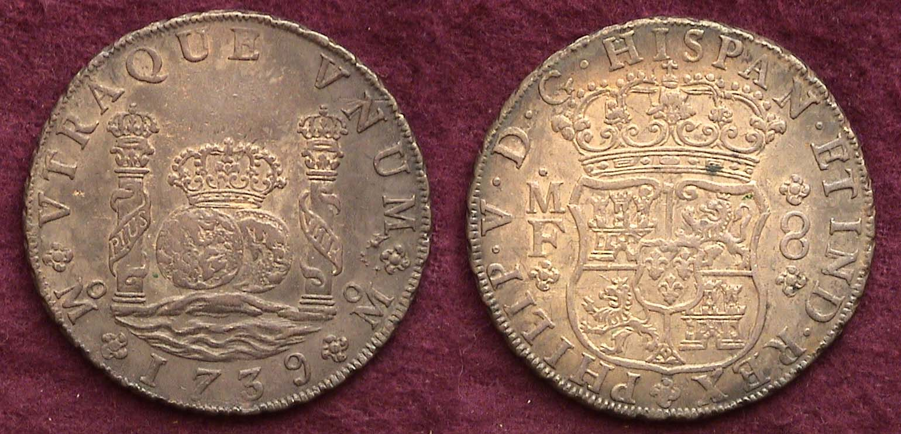

A 1739 8 Reales Pillar dollar of Philip V of Spain
It was struck at the Mexico City Mint. The coin was legal tender in the colonies and the Federal US until 1857. [Magnify to 200%]

The program: VP Jim Barry played portions of an ANA DVD video entitled ‘Christian Symbols on Byzantine Coins” presented by the late Chris Connell. The speaker displayed examples from his collection showing portraits of Byzantine emperors on one side and various depictions of Jesus on the other. Also shown were symbols that included portraits of Mary as well as astronomical signs. Our next program will be another ANA DVD; this one on ‘Consumer Awareness’ presented by former ANA President and 2010 Red book editor, Ken Bressett.

Prize winners at the Dec. 3 meeting were Austin Kuhl who won the silver eagle door prize. The 50/50 drawing was won by recently joined member Art Ludwig. Congratulations gentlemen. The next meeting will be held on January 7, 2010. We will need a couple of members to arrive early to help Glenn Sanders set up. Please look over the new 2010 meeting calendar atop page 1, column 1 and Happy New Year everybody!
____________________________________________________________________________________________________________________

Club Dinner on Dec. 10, another Delightful Affair

The following Thursday, Dec. 10, some 24 members and 5 guests attended the annual pre Christmas diner at the Hound’s Lake Country Club. It was another enjoyable club event made all the more rewarding by good food, drink and conversation among friends and numismatic colleagues. Several area dealers and club members donated numismatic prizes which were awarded members during the expanded 50/50 type drawings held at the end of the meal. The donors included Tony Fulmer of Aiken Gold and Silver, Larry Lucree of the Augusta Coin Exchange, Wayne Damron of Clein’s Rare Coins, Pat James of Coins, Stamps & Currency, Steve Yano of North Augusta Silver & Gold, also members Glenn Sanders, Jim & Helen Barry, John Attaway and the Maxwell Law Firm. Thanks to all who gave. The recipients really appreciated the proof sets and commemorative issues they won in the drawings.
_______________________________________________________________________________________________________________________
Some Club 2009 Holiday Dinner Pics

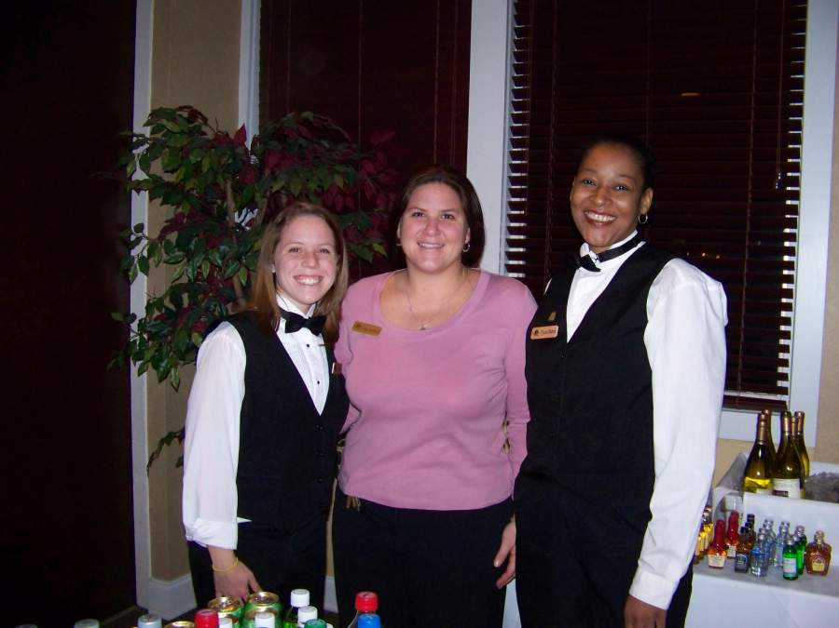

Our hosts and servers, Midge, Julie and Trish

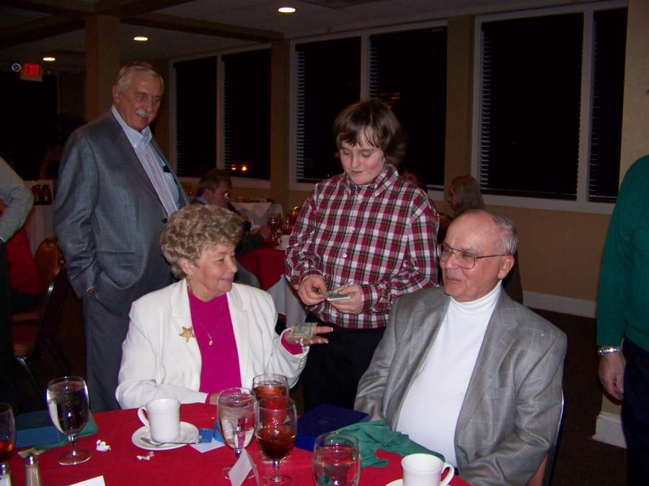

Young Numismatist Austin Kuhl seen presenting prizes to
Elsie and Roger Worpell. Member Dick Smoot looks on.

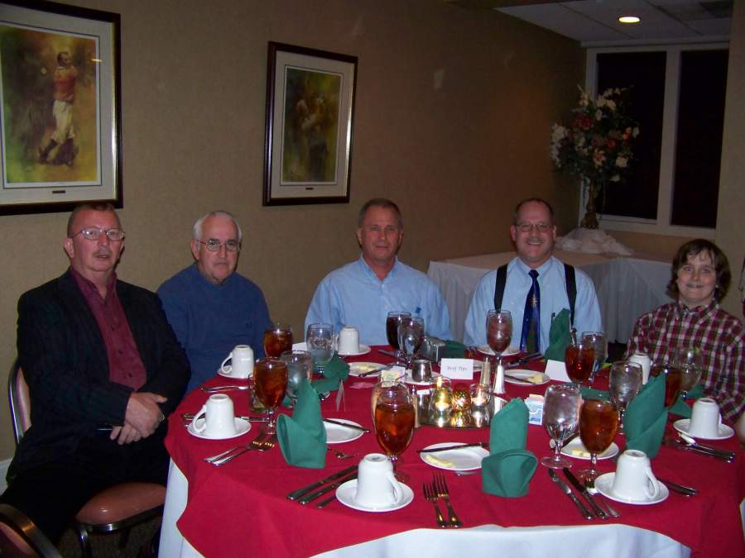

From Left to right: members Howard Black, Club Auctioneer and Sgt. in Arms, Glenn Sanders, Immediate past President, Willie Simon, President, Steve Kuhl and son Austin Kuhl

(All pictures courtesy of Helen Barry.)
More dinner photos appear on our club web site www.sjcsracc.org

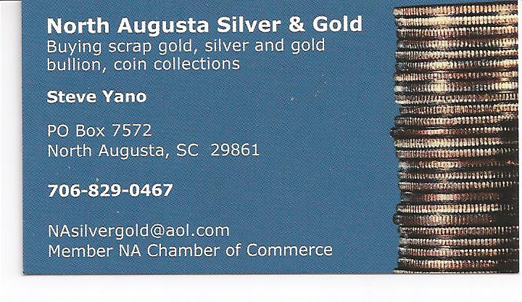

Kindly patronize our advertisers
