Pres. Willie Simon
V .P. James Barry
Sec. Helen Barry
Treas. Pat James
Sgt. in Arms: J.J. Engel
Committees:
Programs: James Barry
Show Chairman: JJ Engel
Newsletter: Arno Safran
E-Mail: arnosafran@comcast.net
The Stephen James
CSRA Coin Club of Aiken
P.O. Box 1739
Aiken, SC 29802
Web site: www.sjcsracc.org
The SJ CSRA CC Now Meets on the 2nd Thursday of the Month at the Cedar Creek Community Center in Aiken, SC

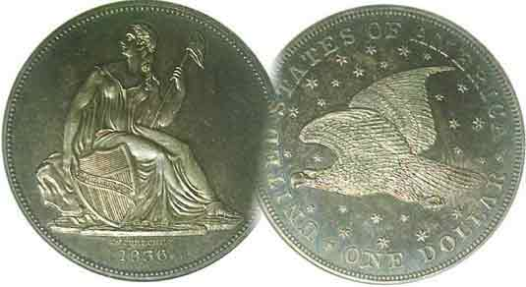

Volume 7, Number 2 the Stephen James CSRA Coin Club, Founded in 2001 February, 2008
Monthly Newsletter
F.U.N. Show in Orlando, Florida Very Active
Our next meeting this month only is on the 1st Thursday Feb. 14 at 7:00 PM

2007 Club Meeting Schedule
Jan. 3 Apr. 10 July 10 Oct. 9
Feb. 14 May 8 Aug. 14 Nov. 13
Mar. 13 June 12 Sep. 11 Dec. 4 dinner

_____________________________________________________________________________________________________________________________

Hobby’s Future Starts off Well at FUN Show

Our first meeting of 2008 was pushed up one week to Jan. 3 in order to give members an opportunity to attend the FUN Show in Orlando; FL (Jan. 10-13). FUN is the acronym for Florida United Numismatists. Due to its location at the beginning of each year, the FUN Show often acts as the bellwether for the numismatic hobby and industry. Next to the annual summer World’s Fair of Money Show sponsored by the American Numismatic Association (ANA) at a different city each year, the FUN show is the largest held on the East coast. According to all accounts from dealers and collectors alike, this year’s FUN was one of the most active and well attended in memory.

During the four day FUN show, the bourse was constantly crowded. In some instances it was difficult to get close enough to a dealer’s table because there were so many persons leaning over checking out coins. The prices realized at the major auctions continued to break records for those especially rare and desirable US and foreign coins and bank notes that only the well healed collector could afford.

At FUN there seemed to be something for everybody including our fellow members. Jim Barry found a beautiful Greek silver Didrachm struck circa 305 B.C. Helen Barry added some Conder tokens (late 18th century British Trade tokens) to her collection. Dick Smoot acquired a stunning gold coin for his type set and Arno Safran came across a 1940 Proof Set at an old friend’s table to complete his turn of the decade series from 1940 to 2000. Bill Myers continued to discover more unusual marvels for his collection (See addendum on page 4, column 1). Bill was also a featured speaker and exhibitor at the FUN show. He received two awards; one for his PowerPoint presentation on “AAFES Pogs” and another for one of his two exhibits.
_____________________________________________________________________________________________________________

Club News

At our January 3 meeting Treasurer Pat James reported a balance of $901.57. V.P. Jim Barry showed a National Geographic Video on the S.S. Republic which sunk in 1865 during a hurricane off the South Carolina coast.
_________________________________________________________________________________________________________________
(Club News continued on page 4, column 1)

Is Now the Time to Buy Gold?
By Arno Safran

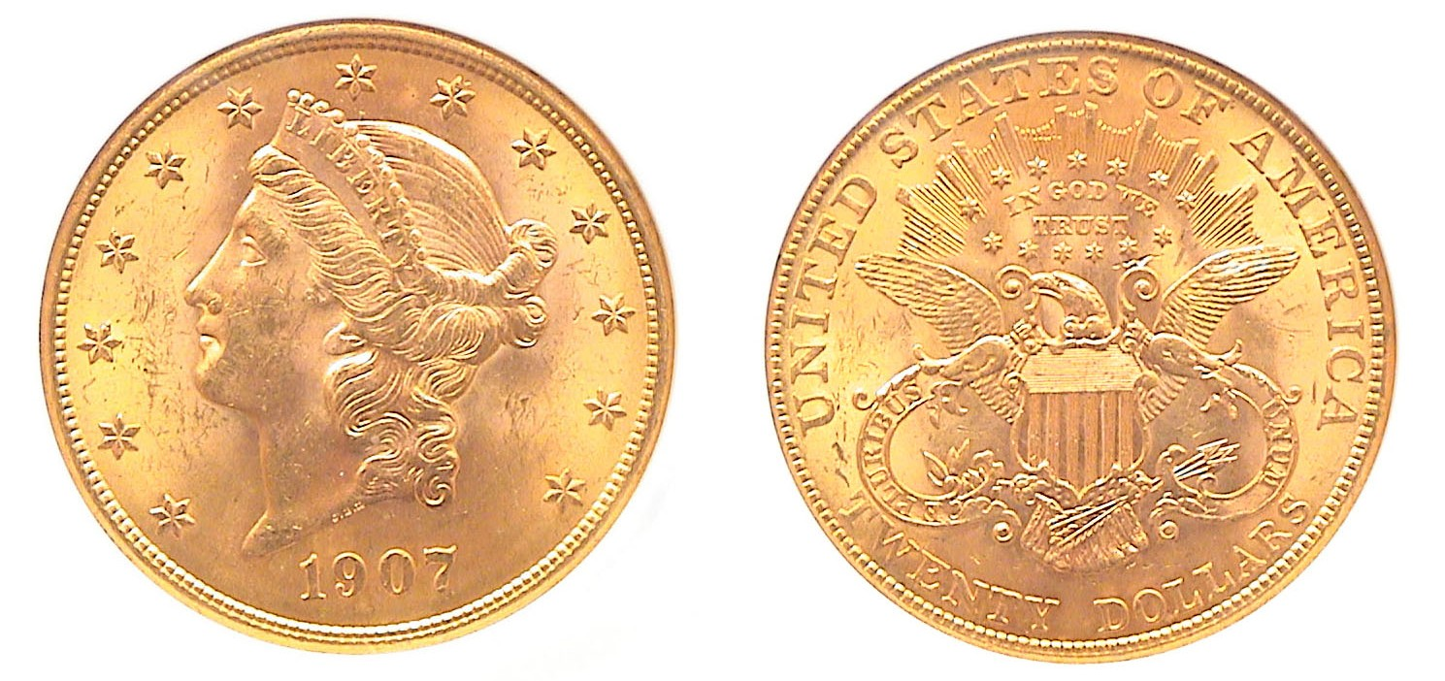
A 1907 Coronet Liberty $20.00 Double Eagle
graded MS-63 by NGC. This was the last year for this type.
Many of these 34 mm large cartwheels received scuffs and scrapes, not to mention cuts and bruises from banging up against each other in the mint sewn bags where they were stored.
[Magnify page to 200% to view these observations.]

For years gold languished around the $400 an ounce mark even as recently as January, 2005, but during the last three years it has risen steadily beyond the old 1980 record to its current exalted position at around the $900 mark. People buy gold as a hedge against instability in the financial markets. Here at home one concern has been the shrinking value of the US dollar against the major word currency. The British pound has risen to almost $2.00 against the dollar. The Canadian dollar, once valued at $0.75 recently hit $1.10. The continuing rise in oil prices is another concern which directly impacts the value of gold. Silver has also risen to around $17.00 an ounce.

Back in January, 2005, a 1907 $20.00 gold Liberty containing 90% gold such as the coin pictured above was bid at $800 in the Coin Dealer Newsletter, (CDN). The actual bullion value was $382.50. At the time, the cost represented $417.50 over melt. Now with gold at almost $500 more, the numismatic value of the 1907 $20 Liberty is now $1,175 bid, a rise of $375 since 2005. The bullion value is $810 or just $365 above melt. With these statistics in mind, is this a good time to buy gold coins? Are the conditions the same as those that affected the high price of coins back in 1986? Some recent history of the coin market may help provide some answers to these questions.
__________________________________________________________________________________________________________________________
(Continued on page 2, column 1)
Is Now the Time to Buy Gold?
(Continued from page 1, column 2)
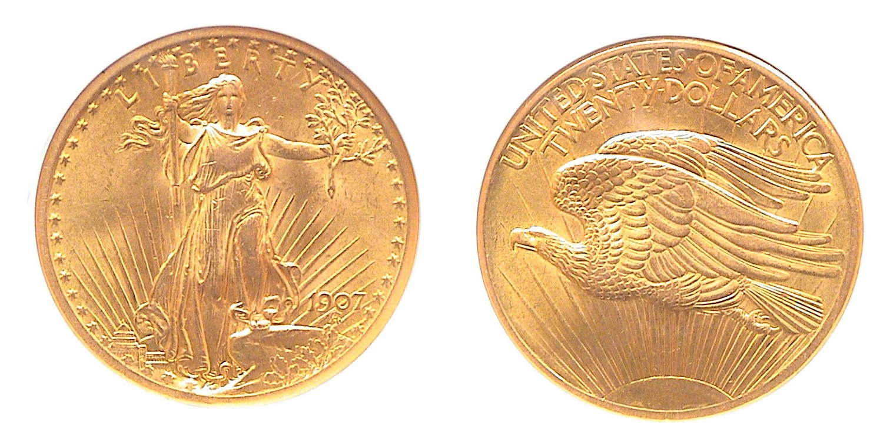
A 1907 $20.00 Saint Gaudens Double Eagle with Arabic numerals
The mintage was 361,667 and represents a second type for this denomination struck in 1907. The coin was graded MS-62 by NGC.
For transitional date collectors, obtaining both types is a desired goal but with gold prices so high, are they still affordable?
[Magnify page to 200% to better view better the details of the design.]

In January, 1986, before third party certification began, a common date Saint-Gaudens grading MS-63 was bid in CDN at $1,200. At the time, gold was only $327.50 an ounce. The main reason for such outrageously inflated pricing was due to heavy industry promotion directed at investors, persons with little knowledge of the coin market. This had been going on with common date uncirculated Morgan dollars, the more common commemorative coins of 1892-1954 and the extremely common 1941-47 BU Walking Liberty halves in BU that had been saved by the roll. Dealers knew they could easily promote the gold coins as well since a number of these dates, especially among the $20 denominations, had mintages of well over a million. After the Hunt Brothers bullion hoarding crash which started around April, 1980, many collectors and investors alike were severely burned when it came time to sell their MS-65 graded coins to learn that at best they only graded MS-63 and at worst, just high end AU; (AKA “sliders”.) To attract new investors the industry had to find a way to guarantee a coin’s grade and they come up with certified grading. In mid 1986 the Professional Coin Grading Service (PCGS) was founded and began authenticating and grading coins submitted by dealers that were hermetically sealed in a plastic see-through holder. This was soon followed by NGC and ANACS. For a while these new safeguards by the numismatic industry strengthened the market. Prices started to rise again as more and more investors became attracted to the coin market.

Around 1989 thru 1990 the entrepreneurs attempted to line up some of the major Wall Street brokerage firms to encourage their clients to set aside a portion of their investment portfolio for “rare coins” but at the eleventh hour, these firms realizing that even certified grading was an art and not a science, balked. The result was that a large number of dealers who had paid inflated wholesale prices for many of the highly promoted common date silver and gold coins became over extended and the market crashed. Coin prices fell across the spectrum and the gold coin market dropped like a stone. The cause had nothing whatsoever with the price of gold which had been fairly steady at around $350 an ounce. By mid 1992, most investors had left the coin market. Many earlier US type and better date items including gold coins had fallen to now affordable levels. A $1,200 Saint now retailed for $525. With certified grading only in its sixth year, the MS-62 grade was still unlisted in the price sheets. A coin like the 1907 Saint shown at left might certify MS-63 since it had only a few tics and no serious scuffs or scrapes and was far better than a MS-60. Today the January 2008 CDN lists an MS-62 at $1,150 bid which is $340 above melt. Compare that with 1986 when the melt value was a scant $292.50 yet the dealer price was $1200 or $900 plus higher. In January, 2005 the spread was more favorable. A 1907 $20 Liberty was listed at only $429 and the same date Saint at only $555 in MS-62 with a melt value of $385. Imagine purchasing two magnificent coins like these for just $44 and $170 above melt value. That was the time to buy.

One can muse about all of the could have been situations but it is unlikely that gold will return to the 2005 levels in the foreseeable future anymore than gasoline will sell for $1.39.9 a gallon. The fact is there are still is a number of decent coin buys among late 19th and early 20th century gold type coins. These would include gold $1.00 coins and $2.50 Quarter eagles within the certified grade ranges of AU-58 through MS-61. The reader is advised to check the price listings not only to determine the highest affordable grade but at what point a huge price increase occurs to the next grade. For example with $10 gold Liberties the price jumps from MS-62 to MS-63 and with $10 Indians, from MS-61 to MS-62.

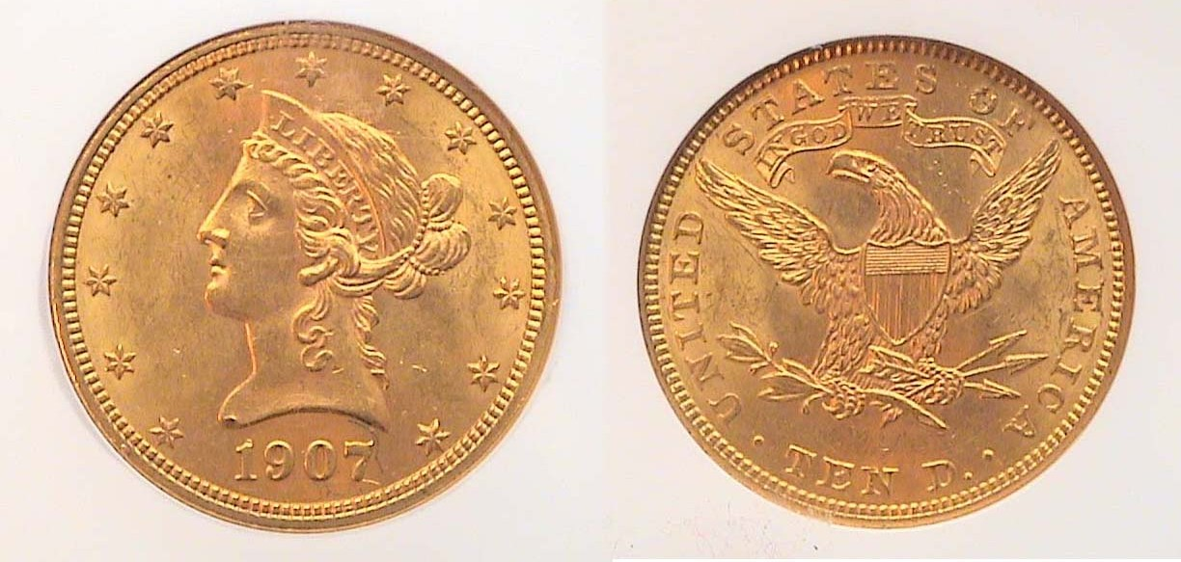

A 1907 $10 gold Liberty Eagle graded MS-62 by NGC

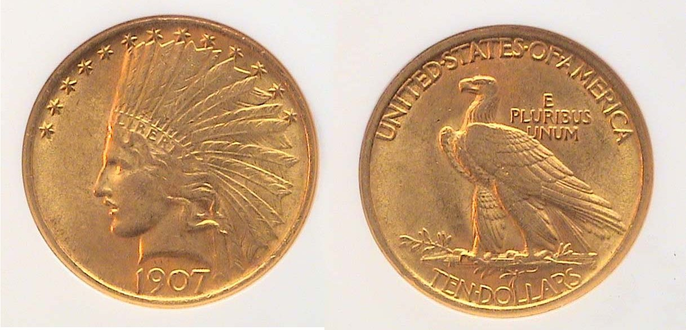

A $1907 $10 gold Indian Head Eagle graded MS-61 by NGC

While at the F.U.N. show some increases were enormous between single digit grades. Certified 1908 $5.00 Liberty gold half eagles were priced at $350 in MS-62, $1,000 in MS-63 and $1,800 in MS-64. In this case, the differences were easily observable. The 62 had lots of distracting marks; the 63 less and the 64 was gorgeous with blazing luster.
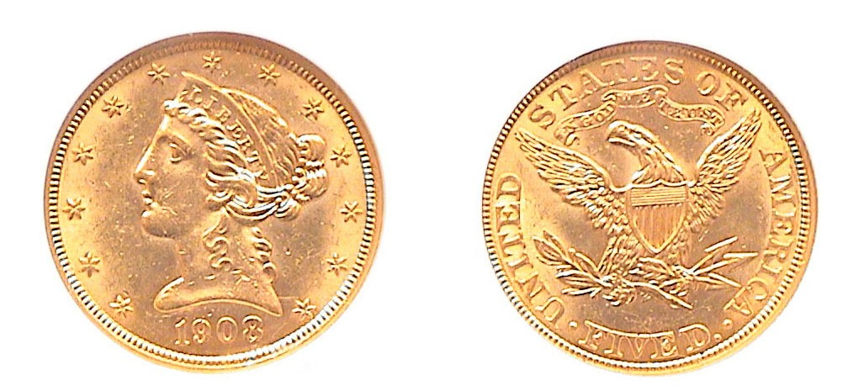
A 1908 $5.00 gold Liberty Half Eagle graded MS-62 by NGC
[When magnified to 500%, one will observe a number of surface bruises.]

WW II U.S. EMERGENCY NOTES
By Bill Myers NORTH AFRICA

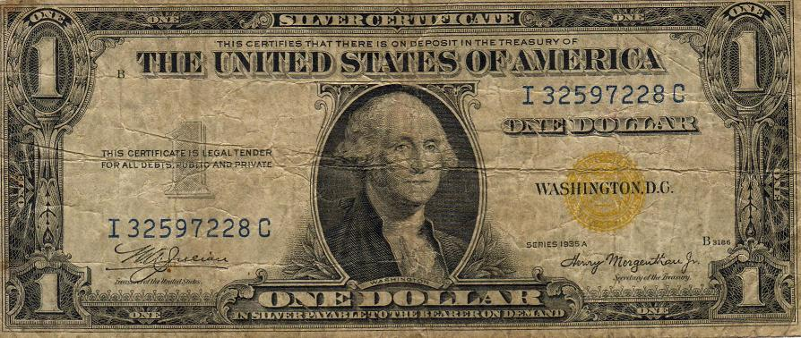

The face of the $1.00 North Africa Silver Certificate

Last month the Hawaii overprint notes were discussed. The North Africa Emergency Notes were the next to be issued.

A special issue of Silver Certificates was issued for the invasion of North Africa (Operation Torch) on November 8, 1942. They were also used in Sicily. The notes had a yellow Treasury seal, instead of the usual blue seal of that time. If a large amount of the notes fell into enemy hands, they could be declared valueless. All of the notes bear the signatures of Julian and Morgenthau and there are replacement (star) notes available, but these are more difficult to find and are expensive to purchase. All numbers given are Friedberg classification numbers. The $1 is series 1935A (2306), the face of which is shown above...

The $5 note is series 1934A (2307).

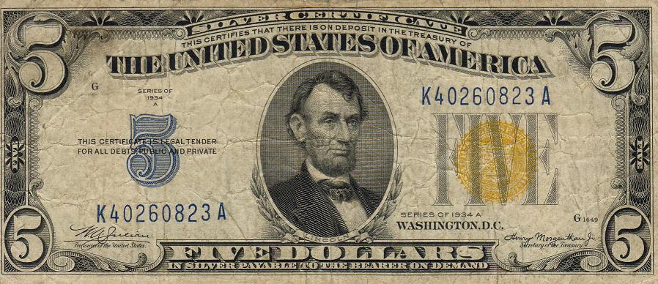

The face of the $5.00 North Africa Silver Certificate

The $10 note is series 1934 (2308), which is quite rare, and 1934A (2309). There is an interesting variation, as well. The North Africa $10 notes were made to look like the Federal Reserve Notes by making the yellow Treasury seal and blue serial numbers green and adding a fake Federal Reserve Bank seal. It is unknown why this would be done, as the notes are still legal tender. These are collectable as well.

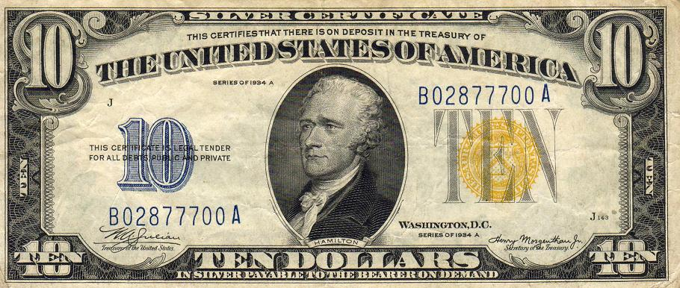

The face of the $10.00 North Africa Silver Certificate

I have completed my type-set of these notes, which show how World War II had far-reaching effects on our country, including its monetary system.

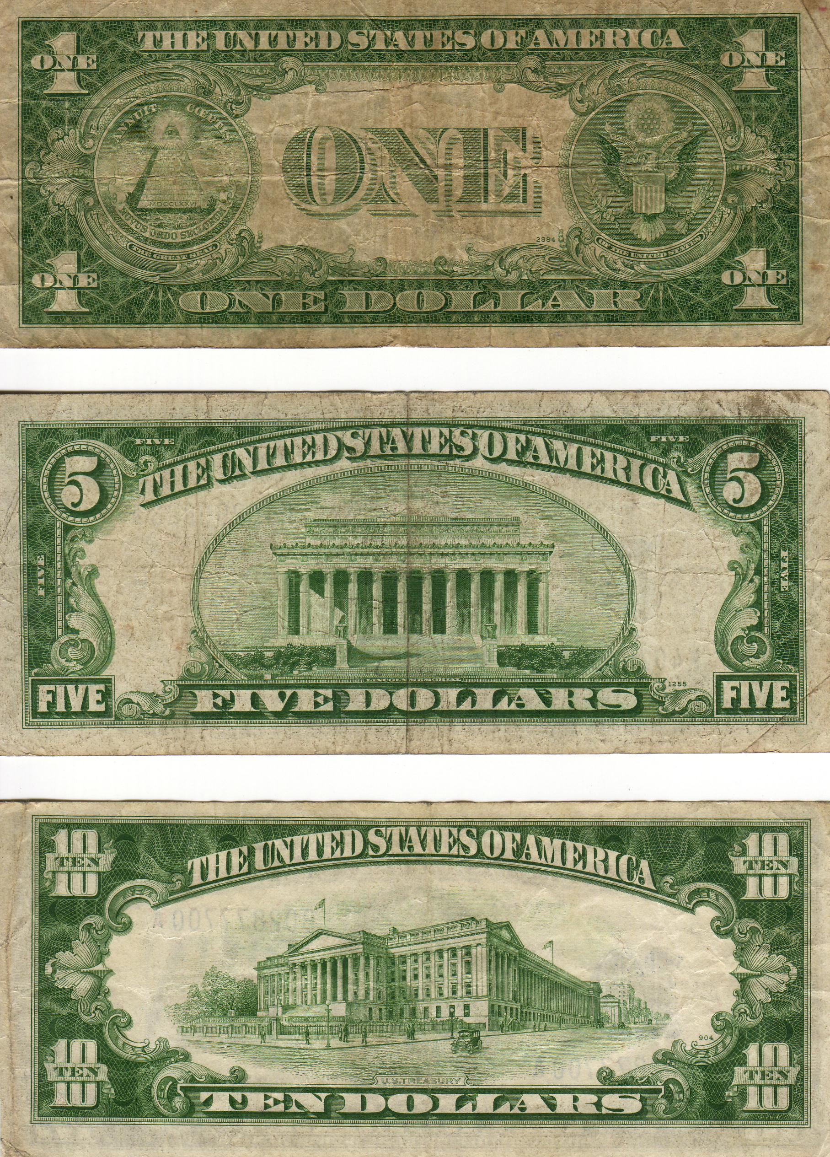

The backs of the three North Africa Notes

North Africa Emergency Notes Table

$1 | 1935A | Silver Certificate | Julian/Morgenthau | 2306
$5 | 1934A | Silver Certificate | Julian/Morgenthau | 2307
$10 | 1934 | Silver Certificate | Julian/Morgenthau | 2308
 | 1934A | Silver Certificate | Julian/Morgenthau | 2309

References:
Benford, Timothy. WWII Emergency Currency @ www.helium.com/tm/237996/invasion-prompted-emergency-currency
Friedberg, Arthur L. and Ira S. Paper Money of the United States, 12th Ed. The Coin and Currency Institute, Inc. pp 212-3.
Schwan, C.F., Boling, J.E. World War II Remembered – History in Your Hands, A Numismatic Study. BNR Press. 1995, pp 401, 430-1.
_____________________________________________

More Club News
(Continued from page 1, column 1)

The Video recalled the tragedy citing key persons abroad including the survivors and the not so fortunate. The S.S. Republic was also carrying a great deal of gold and silver coins which went down with the ship and the better part of the video told of the discovery of the sunken vessel in 2003 and the successful attempts at bringing many of the silver and gold coins to the surface. There was a large number of Coronet Liberty double Eagles brought up from the depths, many still appearing in close to uncirculated condition. Jim Barry earlier had brought in for his Show & Tell an 1861-O Liberty Seated half dollar that had been recovered from the S. S. Republic and was certified as such. The program lasted about 45 minutes and was thoroughly enjoyable. The club thanks Jim for bringing in the video.

The two prize winners at the January 3 meeting were Pat James who won the silver eagle door prize and Bill Myers who won the 50/50. Congratulations to both. Our next meeting will be on the second Thursday, Feb. 14. That’s also Valentine’s Day. Hope to see you there.
________________________________________________________________________________________________________________________

Addendum to “Who Wants to Be a Millionaire?”
By Bill Myers

In the November-December, 2007 issue of the SJ CSRA CC newsletter I wrote about large denomination notes. At the FUN show in January, 2008 I was able to obtain the Hungarian Szazmillio B,-Pengo note. It represents 100 million pengo, (100,000,000) and was the highest denomination note ever released. The face portrays of a woman with a head scarf at right and the back shows the Parliament House. In June, 1946, the year this particular note was issued, it was worth only 20¢ in US currency. It is a nice addition to my collection.

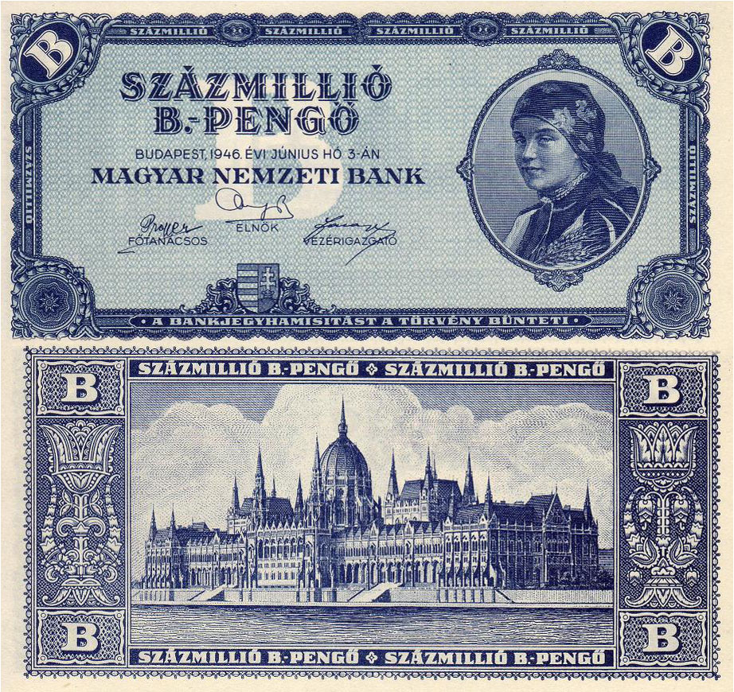

The Hungarian Szazmillio B,-Pengo note issued in 1946 Krause #136
_______________________________________________________________________________________________________

Coin of the Month
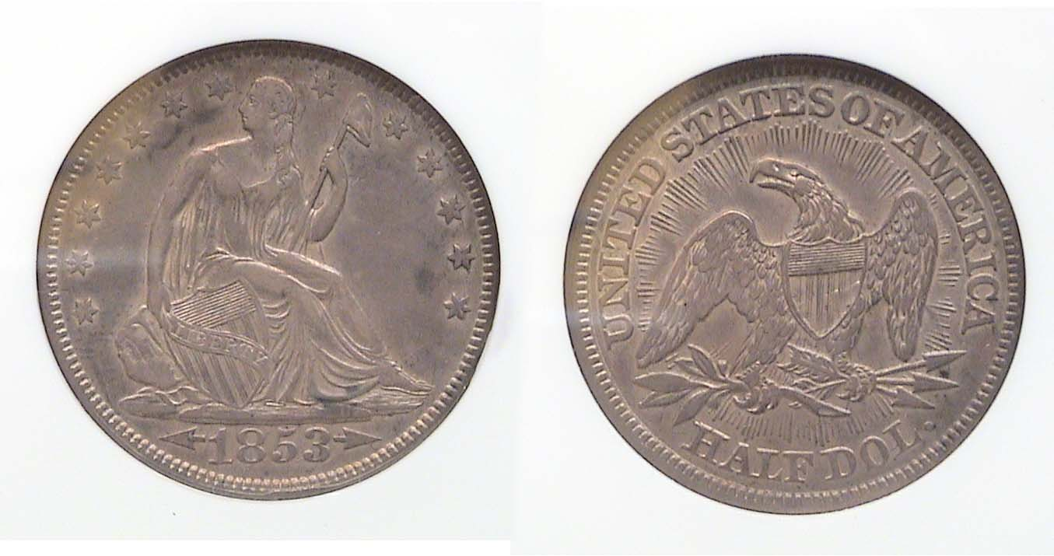
An 1853 Liberty Seated Half Dollar with arrows and rays
Graded XF-45 by NGC [Magnify to 200%]

To put a stop to the melting of US silver coins which had increased beyond face value the government authorized a reduction in weight. The half dollar was reduced from 13.36 grams to 12.44 grams. Arrows were placed along side the date and rays were inserted above the eagle on the reverse to indicate the change. Despite the mintage of more than 3.5 million in Philadelphia alone, the demand was extremely high as a one year type. An XF example is modestly priced however.

Kindly Patronize Our Dealers
