The Stephen James
CSRA Coin Club of Aiken
P.O. Box 11
New Ellenton, SC 29809
Web site: www.sjcsracc.org
The SJ CSRA CC of Aiken, SC meets on the 1st Thursday of the month at the Aiken Public Library

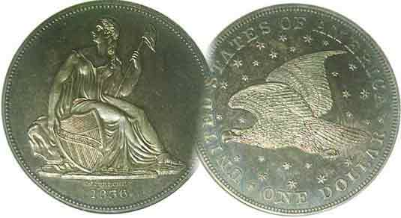
Pres. Steve Kuhl
V .P. Pat James
Sec. Jim Mullaney
Treas. Chuck Goergen
Sgt. in Arms: Glenn Sanders
Programs: Pat James
ANA Representative: Jim Barry
Photos: Helen Barry
Publicity: Pat James
Newsletter: Arno Safran
E-Mail: arnosafran@comcast.net
Auctioneer: Glenn Sanders
Web site: Susie Nulty (see above.)

2013 Club Meeting Schedule
Volume 12, No. 2 the Stephen James CSRA Coin Club, Founded in 2001 February, 2013
Monthly Newsletter
2013 FUN Show, One of the Best!
Our next meeting will be held on Thursday, Feb. 7, 2013 at the Aiken Public Library

Jan. 3 Apr. 4 July ? Oct. 3
Feb. 7 May 2 Aug. 1 Nov. 7
Mar. 7 June 6 Sept. 5 Dec. 5

______________________________________________________________________________________________________

Attending Large Shows is one of the Best Way For Collectors to Hone their Collecting Skills

If you enjoy collecting coins, you probably attend monthly meetings of your coin club, visit local coin shops and go to your club’s annual show. You may even browse the internet by surfing web sites where coins are sold such as EBay or dealers you have found on line. But have you ever attended a regional coin show such as the South Carolina or Georgia Numismatic Association annual Numismatic Convention?

One of the largest annual coin shows in the nation, if not the world, is the FUN show; an acronym for Florida United Numismatists, the state organization that puts on this annual event. It is usually held in early January during the first or second week of the year at the Orange County Convention Center in Orlando, Florida. The drive from the CSRA is between 7 and 8 hours which usually involves at least two overnight stays in an Orlando hotel. Dealers come from all of the United States and other parts of the world displaying coins, paper money, tokens and medals ranging in value from ten-cents to over $10,000. There is a saying, that if you cannot find what you are looking for at the FUN show, it probably doesn’t exist.

For this reason, the show is something of a Mecca for serious collectors who either save up for the big event or bring in items they wish to sell in order to add those more desirable pieces to their collections. This stratagem worked for a collector I knew some years ago who specialized in collecting early US half-dimes struck from 1794 thru 1805, early Draped Bust dimes, coined from 1796 thru 1807 and the early US $2.50 gold quarter-eagle produced from 1796 thru 1807 as well. He not only collected them by date but by die variety. He told me the only way he could afford these coins was to “sell in order to buy” and with the increase in the price of better date US coins, I have applied a similar approach in recent years.
__________________________________________________________________________________________________________________________

The transitional dates of the $1.00 Gold series
By Arno Safran

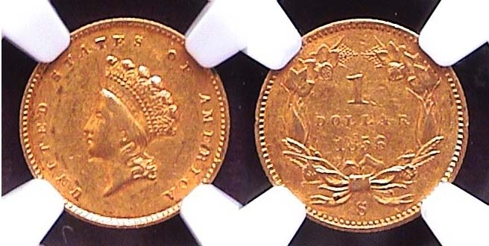

An 1856-S Type 2 $1.00 Gold piece graded XF-45 by NGC (CAC)
[Use 3-power magnifying glass or magnify page to 500% to view details]

There are a number of transitional dates that can be found among the tiny $1.00 gold pieces beginning with\ the very first issues produced in 1849. This was the first US coin intended for circulation with the date placed on the reverse.

With the discovery of gold at Sutter Mill in California in 1848, the value of our silver increased in relationship to gold with the result that as early as 1849, the silver in our silver coins rose above their face value. Soon silver coins were being taken out of circulation and sold for melt. The large Liberty Seated dollar did not circulate very much but now, the lower silver denominations were beginning to disappear from circulation. In 1849 the government authorized a new $1.00 gold coin.
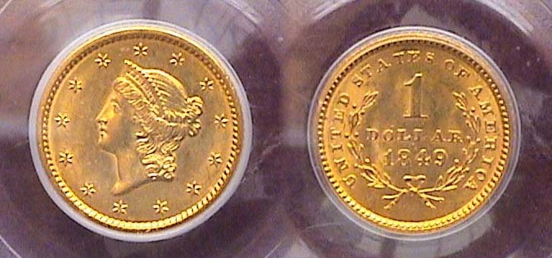
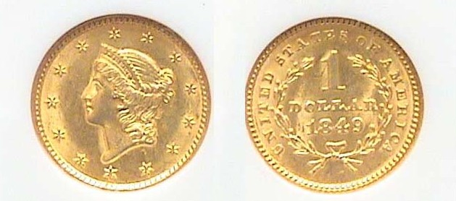

1849 gold $1.00s with open wreath at left & closed wreath at right
[Use 3 power glass or magnify page to 500% to view details]

Chief Engraver James Barton Longacre created a new gold coin that was just 13 mm in diameter. The obverse portrayed a Coronet stylized Bust of Liberty facing left surrounded by thirteen stars. The reverse bore a simple open wreath with the legend UNITED STATES OF AMERICA surrounding it. Inside the wreath was the a large numeral 1 and the word dollar underneath with the date positioned below. Later that same year the wreath was closed near the top. The coin was struck at all four Mints, Philadelphia 688,567, New Orleans, 215,000, Dahlonega, only 21,000 and Charlotte, just 11,634. The budget-conscious collector will find the P Mint issues the least costly.
______________________________________________________________________________________________________________________
(Continued on page 2, column 1)
The Transitional dates of the $1.00 Gold series
(Continued from page 1, column 2)

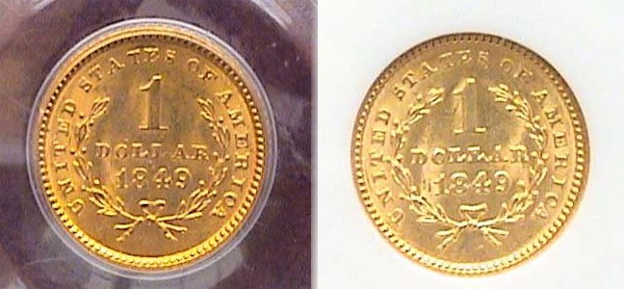

Enlarged images of the 1849 gold $1.00s showing
the scarcer open 3 reverse at left and closed 3 reverse at right

In 1854, the new Mint Director, James Ross Snowden asked Longacre to enlarge the $1.00 coin and alter its design. This resulted in an increase in the width of the tiny gold coin from 13 mm to 15 mm along with a proportionate thinning of the planchet thickness. Longacre had made numerous sketches earlier using the Indian Headdress concept and chose “a Crouching Venus”, based on a sculpture housed in the Philadelphia Museum of Art for the obverse. This would later come to be known as the “Indian Princess” rendition of Miss Liberty. For the reverse, he replaced the simple wreath with a more ornate one composed of several flora (similar to the later and more popular 1856-58 Flying Eagle cent reverses.) By the time all of the specifics were worked out for the new type, the Philadelphia Mint had already produced 855,502 of the Type 1 coins. Later that same year, the Philadelphia Mint would strike another 783,943 of the Type 2 gold dollars thereby providing a major transitional date paring.

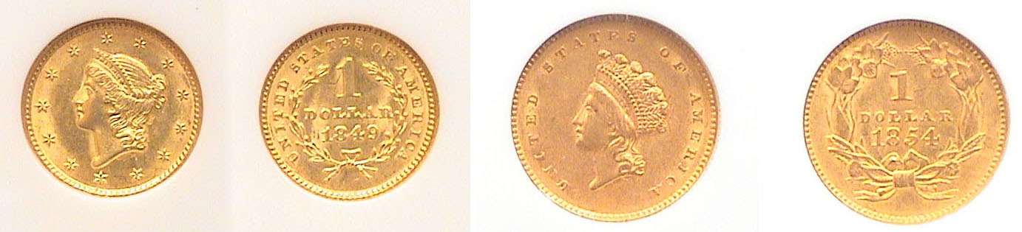

1854 Type 1 (small size) and Type 2 (large size) Gold $1.00s
The Type 1 was graded MS-63 and the Type 2, AU-58 both by NGC.
[Use 3 power glass or magnify page to 500% to view details]
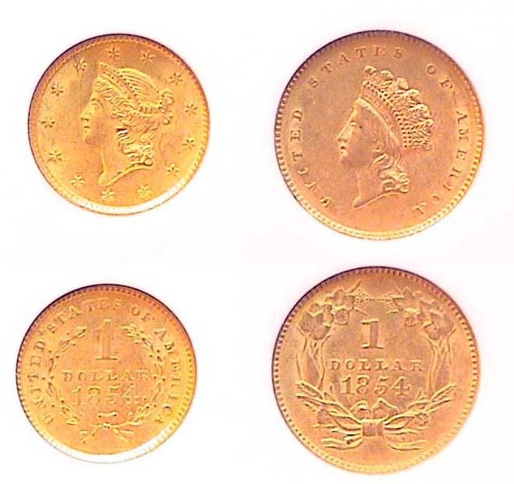
1854 $1.00 Gold Type 1 1854 $1.00 Gold Type 2
Enlarged Enlarged
While somewhat costly, both 1854 types are available to collectors. The 1854 Type 1 is moderately priced up through MS-61 with most specimens of the 1854 Type 2 gold dollar surfacing in NGC-58 holders at about twice the cost. Due to the cost, certified specimens are highly recommended.

As it turned out, the Type 2 gold dollars proved to be a disaster. The coins simply did not strike up well. In 1856, Mint Director Snowden once again asked Longacre to go back to drawing board to correct the problems the Type 2 incurred. Longacre didn’t have to go far. He merely selected the obverse design, which portrayed a slightly larger and more regal headdress that he used for his 1854 $3.00 gold piece originally authorized to make it easier for the post office to sell 100 3¢ postage stamps. The new type was aesthetically more attractive as well while solving previous minting concerns.

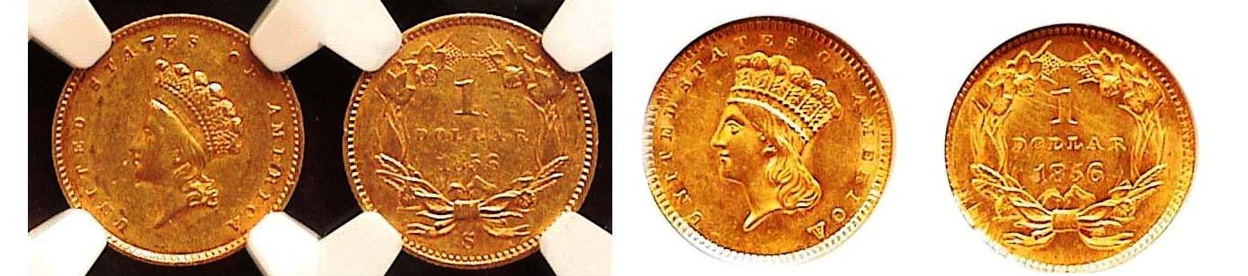

1856-S $1.00 gold Type 2, (left) and 1956-P $1.00 gold Type 3 (right)
[Use 3 power glass or magnify page to 500% to view details]

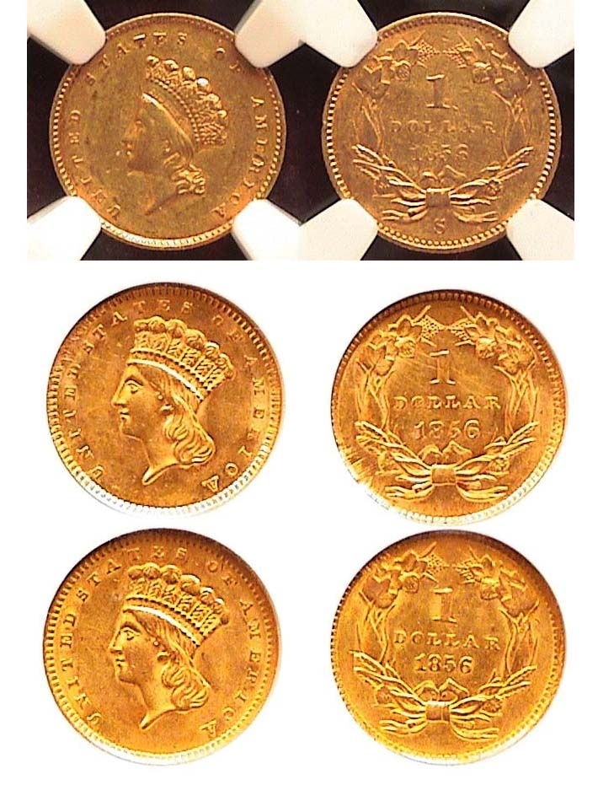
Just a bare handful of 1,460 Type 3 gold dollars were struck at the Dahlonega Mint but the Philadelphia Mint went all out coining a whopping 1.7 million. However, only 24,600 of the previous Type 2 dollars had already been struck at the San Francisco Mint, which today, presents a serious challenge for the transitional date collector. As for the plentiful 1856-P Type 3 issues, there are two versions of the 5 in the date, one slanted, the other in an upright position thereby creating a minor transitional sub-type for the 1856 Type 3s.

At right, enlarged images of the 1856-S Type 2 and the two 1856-P Type 3 $1.00 Gold pieces

The most difficult transitional date to acquire of the three gold dollar types is the 1856-S Type 2. Both the 1856 slanted and upright 5 Type 3s were acquired at the 2009 FUN Show but it took four more years to locate an acceptable specimen of the scarce 1856-S Type 2, which was found at the 2013 FUN show at the very first table upon entering the bourse room. Such unexpected finds heighten the pleasure of coin collecting.
_____________________________________________________________________________________________________________________________

Club News

The Jan. 3, 2013 meeting was called to order by President Steve Kuhl at 6:45 PM. Sgt. In Arms Glenn Sanders reported the attendance figures noting four guests in addition to the member total. He also informed the membership of upcoming shows that included the FUN Show in Orlando, the Low Country Show in Charleston Feb.1-3, the Charlotte Show the following weekend, Feb. 8-10 and three day show coming up in Spartanburg at the end of February. Thanks, Glenn. Treasurer Chuck Goergen reported a healthy club treasury balance of $2,415.20. Thanks, Chuck!

President Kuhl indicated that our own club show has been set for Saturday, Sept. 7 in conjunction with Aiken Makin’ Day at the H. Odell Weeks Recreation Center located on Whiskey Road across from Home Depot. He also mentioned that the annual elections of officers for the club’s 2013-14 fiscal year will occur at the march 7 meeting, the fiscal year to begin in April when dues of $12.00 per adult member will be due.

There were four Show & Tells at the Jan. 3 meeting. Chuck Goergen brought in the key date 1916-D Mercury dime housed in a PCGS holder. It was only graded AG-3 (“About Good”) but it had the eye appeal of a higher grade coin, appearing very original with even wear. Dick Lasure brought in a Civil War token picturing the Flag of Our Union. These bronze “penny”-size tokens were almost all struck in 1863 during the coinage shortage resulting from the Civil War and represented either political opinions or advertisements. Jim Barry displayed an attractive Roman copper piece known as an Az. He described it as a coin of Agrippa, one of Augustus’ leading generals minted by Caligula. Last but not least was a an outstanding display of US commemoratives (1892-1954) by guest Don Watson described by member Mac Smith.

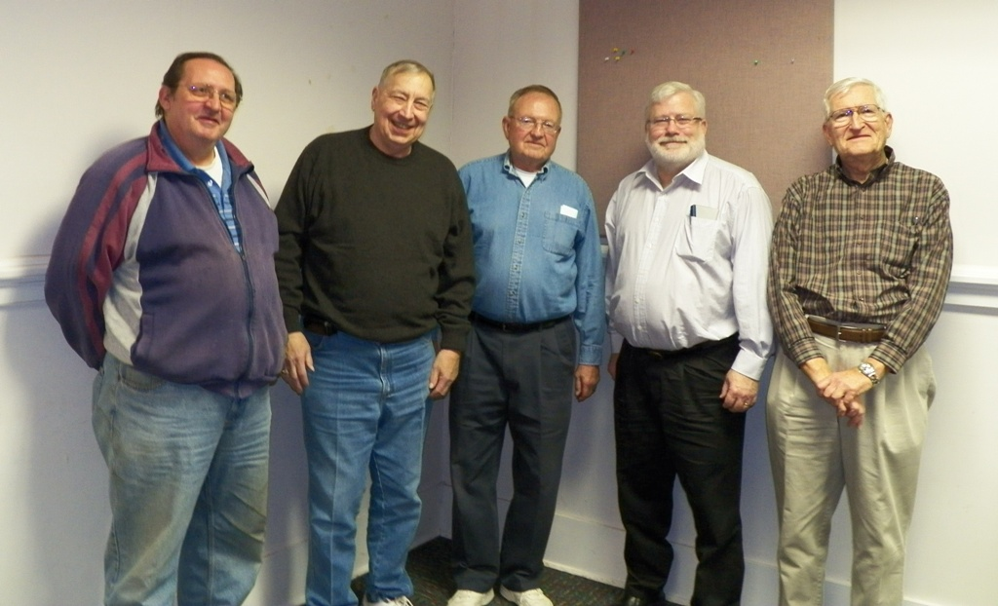

Show and Tell Exhibitors at the January, 3, 2013 meeting
From left: Don Watson, Mac Smith, Dick Lasure, Chuck Goergen & Jim Barry

The Program: Arno Safran gave a PowerPoint presentation on the US Coins of 1800.

At our Feb. 7 meeting VP Pat James has arranged for member David Amey to present a program on “The Anatomy of a Banknote”. David is an experienced Numismatist, Collector and Dealer specializing in Foreign Coins and Banknotes.

The Prize Winners at the Jan. 3 meeting were Arno Safran who won the 1957 Proof Franklin half-dollar and James Mullaney who won the 50/50. Our next meeting is scheduled for

Thursday, Feb. 7 at the Aiken Public library, starting time 6:45
PM, early arrivals 6:15. Please bring in any new Show & Tell acquisitions acquired at recent shows. There will also be our regular monthly auction conducted by our redoubtable auctioneer, Glenn Sanders.
_____________________________________________________________________________________________________________________________

Kindly Patronize Our Advertisers

