The Stephen James
CSRA Coin Club of Aiken
P.O. Box 11
New Ellenton, SC 29809
Web site: www.sjcsracc.org
The SJ CSRA CC of Aiken, SC meets on the 1st Thursday of the month at the Aiken Public Library

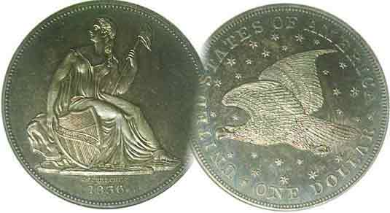
Pres. Steve Kuhl
V .P. Pat James
Sec. Jim Mullaney
Treas. Chuck Goergen
Sgt. in Arms: Jim Sproull
Programs: Pat James
ANA Representative: Jim Barry
Photos: Helen Barry
Publicity: Pat James
Newsletter: Arno Safran
E-Mail: arnosafran@comcast.net
Auctioneer: Glenn Sanders
Web site: Susie Nulty (see above.)

2013 Club Meeting Schedule
Volume 12, No. 6 the Stephen James CSRA Coin Club, Founded in 2001 June, 2013
Monthly Newsletter
With Gold softening, try better date US Gold type
Our next meeting will be held on Thursday, June. 6, 2013 at the Aiken Public Library

Jan. 3 Apr. 4 July 11 Oct. 3
Feb. 7 May 2 Aug. 1 Nov. 7
Mar. 7 June 6 Sept. 5 Dec. 5

______________________________________________________________________________________________________

After a long hiatus going back to the mid 1990s when gold seldom rose above $400 an ounce the yellow metal began to rise in 2006 and move from a gradual increase in 2007 to an energetic one starting in 2008. In mid 2011 gold reached its peak at around $1,900 an ounce before falling back slightly around the $1,650 level for the next year and a half. Today gold is trading just under $1,400. Most of the speculators who were active buyers of bullion items have taken to the hills, but unlike the bullion crashes that followed the Hunt Brothers silver and gold boom of 1979-80 and the early 1990s, which caught many dealers overextended, this recent drop in gold bullion has been gradual with the result that many coin dealers have had enough capital to restock their inventories with obsolete type, better known today as ”collector coins”.

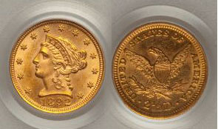

An 1892 $2.50 Liberty Quarter Eagle (18 mm in diameter)
[Use 3x glass or magnify page to 200%]

For those who like gold coinage, there are a number of underrated dates starting with the Liberty $2.50 denomination. For example, an 1892 $2.50 quarter-eagle has a paltry mintage of just 2,440 yet is listed at just $375 bid in AU-58 according to the latest Coin Dealer Newsletter Quarterly II. An 1889 $5.00 half eagle with a mintage of 7,520 is listed in AU-58 at only $530 in the Coin Dealer Quarterly III. With the $10.00 Eagle denomination one should look for an 1893-O. With a mintage of 17,000, it is listed at the common date price of $875 in AU-58 from the same source. Finally, among the $20 Liberty double eagles, the 1889, with a mintage of 44,070 grading AU-58 is listed at $1,650 along with the rest of the common dates.
____________________________________________________________________________________________________________________________

Collecting the Coins of 1943: 70 Years Ago
By Arno Safran

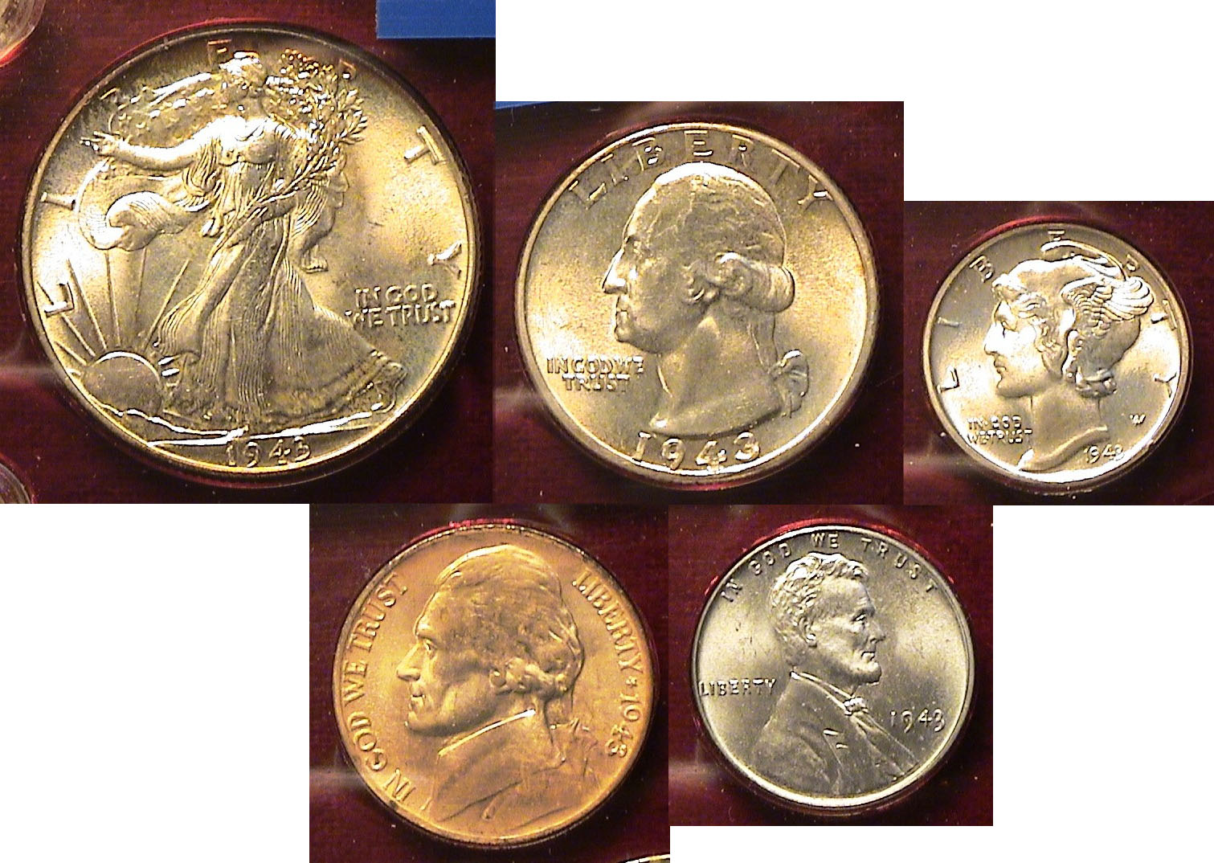

The obverses of a Brilliant Uncirculated 1943-P Year Set
[Use 3x glass or magnify page to 200%]

Seventy years ago, the United States was in the midst of World War II battling the Axis Powers on two fronts, North Africa and the Pacific. The year marked a big turn in the course of the conflict.. In early February of 1943, the US Marines soundly defeated` the Japanese at Guadalcanal and in the Western theater of war, the allied forces under General George Patton and Field Marshall Montgomery finally overcame Marshal Erwin Rommel’s Nazi Afrika Corps in North Africa after a series of year long brutal battles.

At home, the war effort was in high gear. Americans were buying War Bonds instead of cars and handling rationing along with imposed wage and price controls. Victory gardens were` spreading throughout the land and many women were working in munitions factories building ships, fighter planes and other weaponry for our nation’s troops.
As part of the war effort, our coinage also underwent some interesting modifications. In 1942, the alloy in the 5¢ piece was changed from nickel (needed for the war effort) to 56% copper, 35% silver and 9% manganese. In 1943 the copper was removed from the cent and replaced by zinc coated steel.
___________________________________________________________________________________________________________________________
(Continued on page 2, column 1)
Collecting the Coins of 1943: 70 Years Ago
(Continued from previous page)

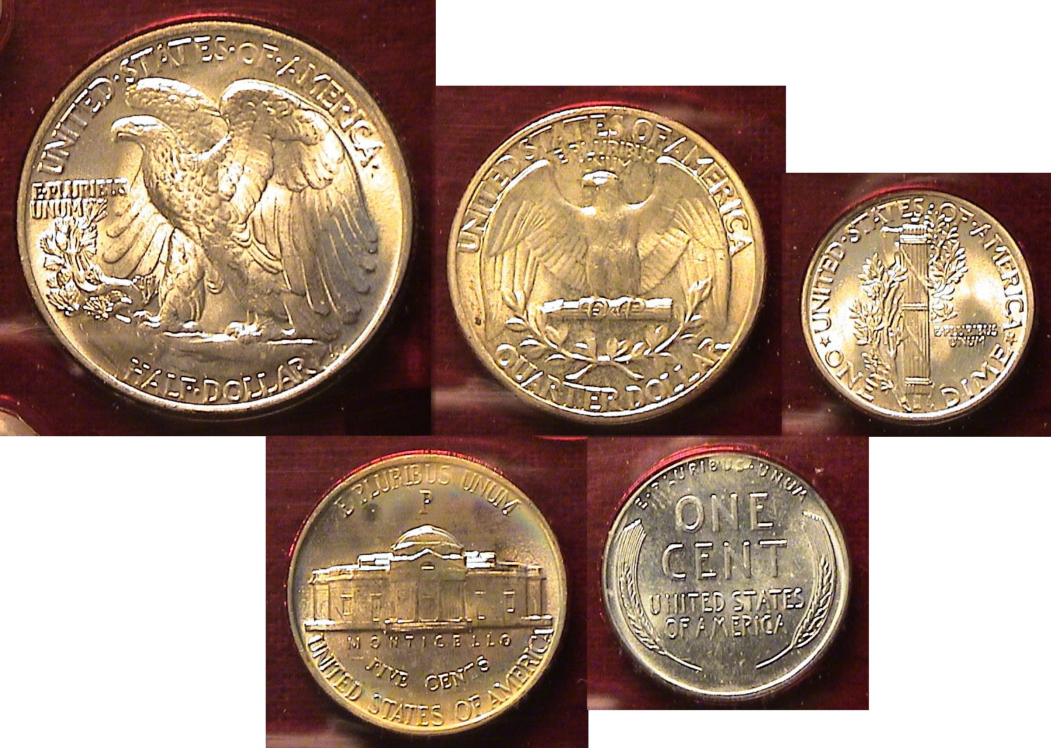

The reverses of a Brilliant Uncirculated 1943-P Year Set
[Use 3x glass or magnify page to 200%]

From a collector’s vantage point, assembling a complete set of 1943 dated coins from all three Mints averaging as high as MS-64 should pose little difficulty price-wise as the mintages were huge. The set boasts such obsolete coins as the Mercury dime and the Walking Liberty half dollar and the strikes on these coins were especially sharp that year. The five piece 1943-P year set has the highest mintage, excellent strikes and extremely lustrous finishes and would probably be the least costly for a collector to assemble.

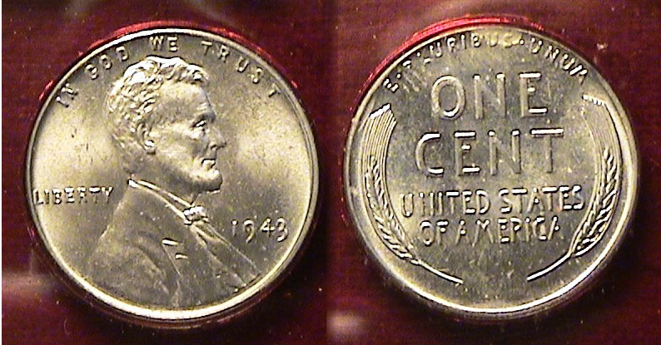

A 1943-P Steel Lincoln cent
[Use 3x glass or magnify page to 200%]

In 1943, The Philadelphia Mint struck 684,628,670 zinc-coated steel cents. Although this was a large number, it was by no means a record. A very small number of bronze pieces along with a few silver specimens somehow escaped the eye of Mint checkers and those few that have surfaced are currently valued at around $200,000 if found in mint-state. One of the problems with the steel cents was their vulnerability to corrosion. Despite the huge mintages in all three Mints, a majority of specimens suffered from environmental damage, which is why superior MS-65 or better specimens, despite their current low $8.00 retail value may be worth certifying if acquired ”raw”.

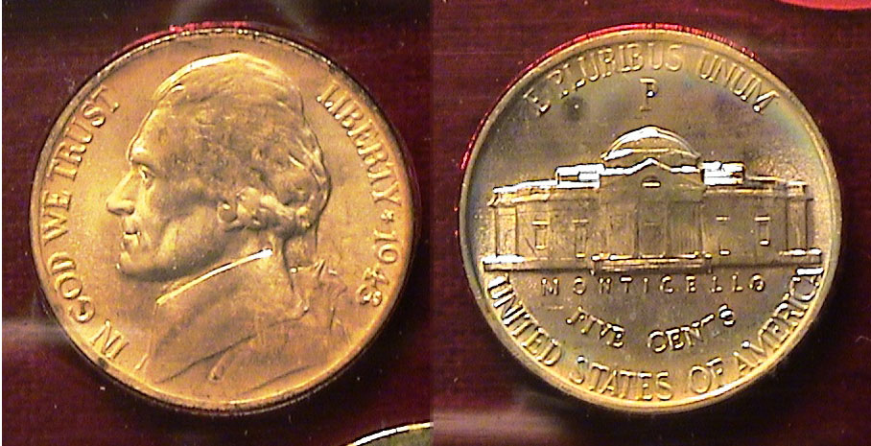

A 1943-P “War” nickel
[Use 3x glass or magnify page to 200%]

The 1943-P Jefferson nickel shown is no “gem” but the coin does exhibit virtually full steps, and except for a small corrosive circular spot on the reverse, might grade MS-63. This specimen was inserted into the Lucite holder years ago and somehow the corrosive elements developed over time. Since more than 271 million “war” nickels were struck at the Philadelphia Mint in 1943, the price for a replacement grading MS-65 would retail for around $20.00 according to the 2014 Red Book.

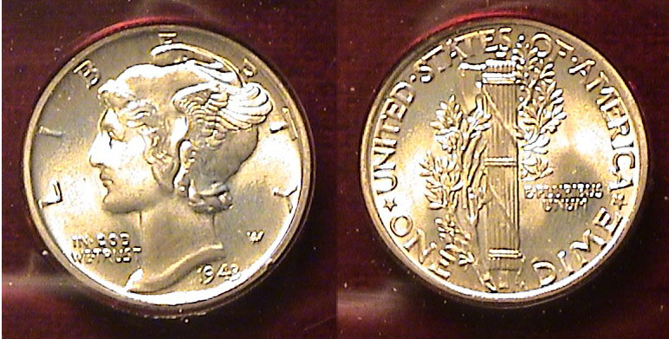

A 1943-P dime with fully split bands possibly grading MS-66
[Use 3x glass or magnify page to 200%]

The two most important coins of the 1943-P set are the Mercury dime and Walking Liberty Half dollar, both for their beauty and in this particular set, their grade. The mintage for the 1943-P dime was a record 891,710,000 pieces, the largest for the entire series (1916-45). Like the 1938-D Buffalo nickel it was also the best-struck date for type, so finding one without fully split bands on the reverse would in itself, be an anomaly. According to the latest Coin Dealer Newsletter, the coin is listed at just $42.00 grading MS-65 with fully split bands.

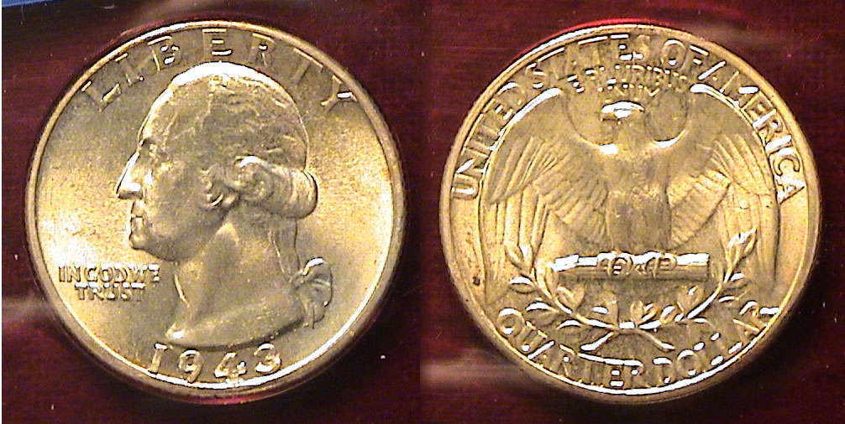

1943-P Washington Quarter grading MS-64
[Use 3x glass or magnify page to 200%]

In 1943, 99,700,000 Washington quarters were struck at the Philadelphia Mint, more than twice the total of the Denver and San Francisco Mints combined. Still, this was short of the record 102 million produced at Philadelphia the previous year. According to the 2014 Red Book, MS-63 specimens are listed at just $10.00 retail with MS-65s priced at $40.00. For some reason, the MS-64 column has been removed from most of the current retail sources. The Coin Dealer Newsletter, which publishes dealer Bid and Ask prices for rare coins, something akin to wholesale, lists a 1943 quarter grading MS-65 at the reduced bid price of $32.00 and one grading MS-64, at just $11.00 bid; in other words, not very much. After the Statehood quarter series was introduced in 1999, hoards of new collectors entered the numismatic marketplace. The old standard reverse design was rendered obsolete attracting new interest in the Washington quarter series. Once silver began to rise in price, the precious metal in the pre 1965 dated quarters rose proportionately but with the plethora of new reverse designs on national themes going beyond the state series and a drop in the silver value, the attraction of Washington quarters from 1941 -1964 have receded somewhat along with price values.
__________________________________________________________________________________________________________________
(Continued on page 3, column 1)

Collecting the Coins of 1943: 70 Years Ago
(Continued from previous page)

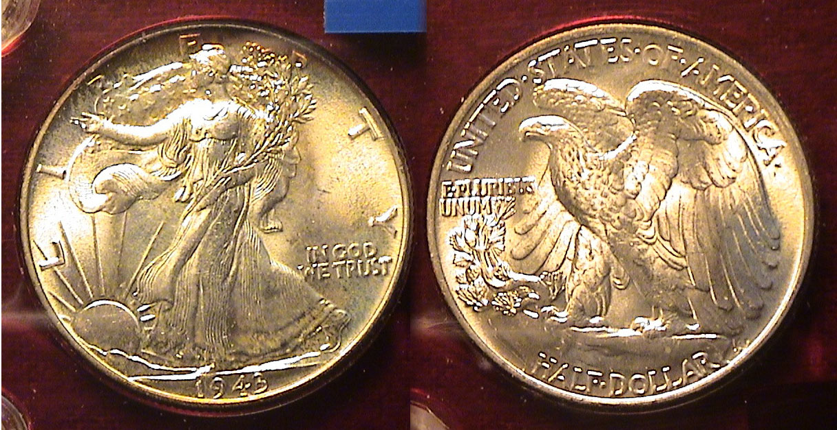

A 1943-P Walking Liberty Half-Dollar, the crowning jewel in the set
[Use 3x glass or magnify page to 200%]

When it comes to the design of the Walking Liberty half-dollar, (1916-1947) the artistry of Adolf Weinman’s engraving skills is arguably equal to that of the great Augustus Saint-Gaudens of the $20.00 double eagle, (1907 thru 1933). Why else would these two remarkable examples of coinage art reappear in 1986 with the striking of the silver and gold eagles respectively. During its tenure, the Walking Liberty half dollar was not struck in every year at all three Mints. Between 1920 thru 1933, the denomination was produced at the Philadelphia Mint just twice, in 1920 and 1921 and at Denver, three times, 1920, ‘21 and ’29. The San Francisco Mint struck the lion’s share, 1920, 21, 23, 27, 28 and ‘33. No halves intended for circulation were produced in 1922, ’24 thru ’26, also from 1930 thru 1932, but after 1934, the Walking Liberty half dollar was coined in Philadelphia every year thru 1947, the end of the run.

In 1943, the Philadelphia Mint struck a record 53 million Walking Liberty halves, the largest in the history of the denomination up to that point in time. The record would stand through the entire Franklin half series (1948-63) until 1964 when 273 million 1964-P Kennedy silver halves were produced. The 1943-P Walking Liberty half issue was also among the best struck of the series yet is moderately priced thru MS-64 where it is currently bid at $62.00 according to the Coin Dealer Weekly Newsletter. While the US coins of 1943 are common in all grades up thru MS-65, the set displays an artistic memento of a historically significant year in US and World History.

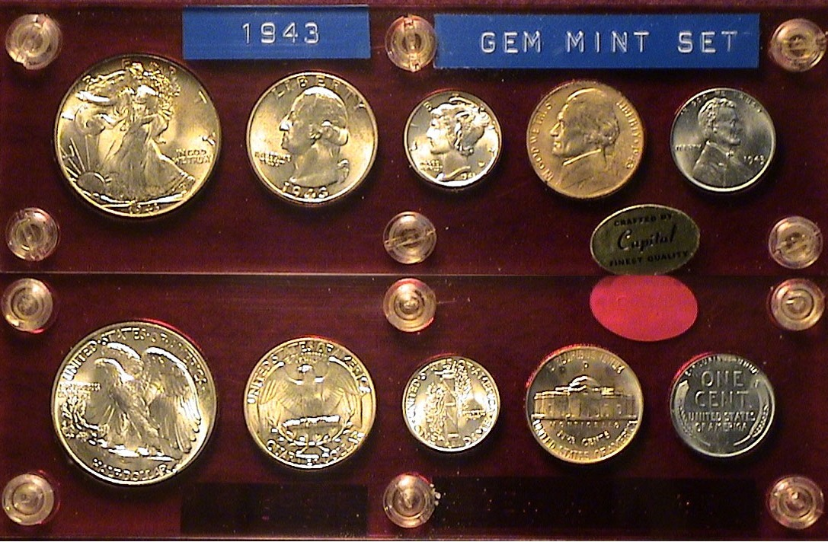

A BU 1943-P Year set housed in a Capital Lucite holder
[Use 3x glass or magnify page to 200%]
__________________________________________________________________________________________________________________

Club News

As President Steve Kuhl was unable to attend, Vice President Pat James presided at the May 2 meeting. Sgt. In Arms Jim Sproull announced the attendance at 17 members and 2 guests and reported on the upcoming area club coin shows for the month. Thanks, Jim! Secretary Jim Mullaney’s Minutes from the April 4 meeting were waived as is the custom, a copy to be placed on file. Pat thanked the Secretary nevertheless for his efforts on behalf of the club. Treasurer Chuck Goergen reported a balance of $1,831.01 after expenses and receipts from the previous month. Thanks, Chuck! Ms. Pat reported on the September 7 club show, a work in progress. She also mentioned that the 2014 edition of A Guide Book Of United States Coins (AKA, the Red Book), is now available at $8.00 to club members. This is about one-half the newsstand price and worth its weight in gold, silver, nickel, copper and cupro nickel to any serious collector of US coins.

Show & Tell: There were three Show & Tells. Mac Smith reported on his latest acquisitions from EBay, 1,000 Buffalo nickels for the price of $16.00. While these were heavily circulated most had readable dates and enough detail including such better dates as the 1913-S Type 2, 1913-D, Type 2, 1914-S, 1917-D, 1918-D, 18918-S and 1919-S. Mack also displayed the better date 1871 Shield nickel.

Member Todd Starbuck brought in a number f Kennedy half dollar anomalies certified MS-66 by NGC. These included the 1964 full hair silver issue, also the weak hair variety along with the 1982 with and without the initials of engraver Frank Gasparro. Shortly after their release in 1982, word of the “no initials” spread bringing the price for the 1981 clad 50c lacking the FG to $8.00 per coin.

Arno Safran displayed four early US type quarters he had re-holdered by ANACS from their old smaller white holders to the new large and more attractive hermetically sealed certified plastic ones. He displayed an 1806 Draped Bust quarter graded Fine-12, an 1819 large Capped Bust quarter, B1, an R5 variety grading VF20, an 1825/4/2 25c, (formerly !825/3, a commoner variety) graded XZF-40 and an 1835 B-6, R4+ reduced size Capped Bust quarter also XF-40. He explained that all of the pieces appeared ‘original” (i.e., without evidence of cleaning and believed they would have received the same grades from PCGS or NGC.

The Program: John Attaway gave a PP presentation on the Banknotes of Edgefield County and Aiken County including a portion of North Augusta once known as the City of Hamburg. Most of the banknotes John displayed were one sided and signed but the bank President and cashier and saw considerable circulation. An interesting aspect of the program was how these banknotes tied in with early rail and coach travel from Charleston to North Augusta and Augusta, GA during the first three-quarters of the 19th Century. John also described some of post Civil War events that led to some unsettling sociological conditions of the period. The club thanks John for sharing with us the information on these aspects of 19th Century CSRA and the bank notes of that bygone era.
___________________________________________________________________________________________________________________

Pics from the May 2 meeting
Taken by Helen Barry

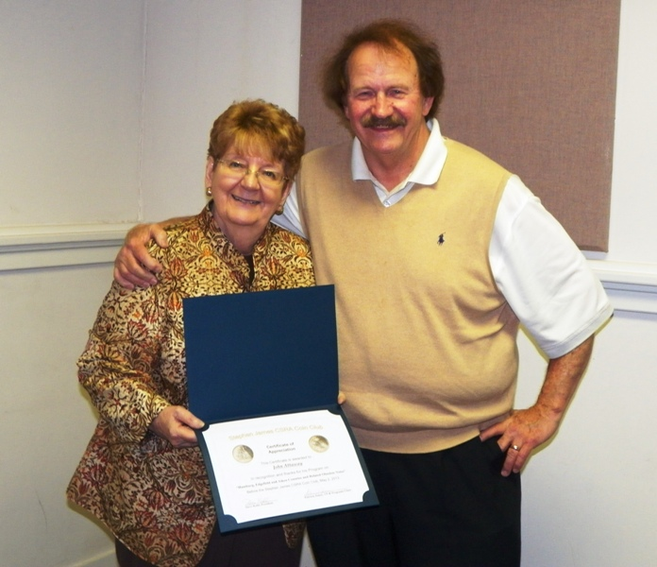

Pat James presenting speaker John Attaway
with a Certificate of Appreciation

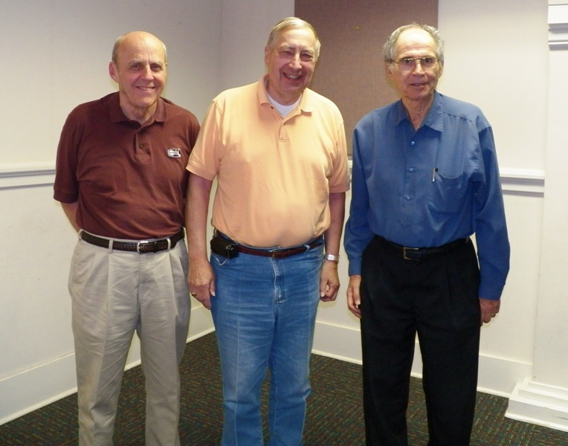

Show and Tell participants (from left to right)
Todd Starbuck, Mac Smith and Arno Safran

The prizewinners at the May 2 meeting were Jim Mullaney who won the door prize, a 1957 Proof Franklin half-dollar and Pat James who won the 50/50 drawing - $16.00. Congratulations, Pat and Jim. Our next meeting is scheduled for Thursday, June 6 at the Aiken Public Library. Our speaker for the evening will be our own Chuck Goergen who will present a PowerPoint program on “Ancient Roman Republican Coinage: An Overview”. The meeting starts at 6:45 PM but members usually gather at least one-half and hour earlier. Please bring in something for Show & Tell and auction.
____________________________________________________________________________________________________________________________

Do you have a coin you would like to sell or a coin or coin you would like to acquire?
If so, please e-mail the information in 40 words or less to the editor at arnosafran@comcast.net at least two weeks before the following meeting.
______________________________________________________________________________________________________________

Kindly Patronize Our Advertisers

