The Stephen James
CSRA Coin Club of Aiken
P.O. Box 11
New Ellenton, SC 29809
Web site: www.sjcsracc.org
The SJ CSRA CC of Aiken, SC meets on the 1st Thursday of the month at the Aiken Public Library

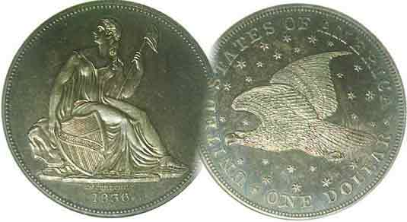
Pres. J.J. Engel
V .P. Pat James
Sec. Jim Mullaney
Treas. Chuck Goergen
Sgt. in Arms: Jim Sproull

Programs: Pat James
ANA Rep.: Glenn Sanders
Show Chair: Board members
Photos: Steve Kuhl
Publicity: Pat James
Newsletter: Arno Safran
E-Mail: arnosafran@comcast.net
Auctioneer: Jim Sproull
Web site: Susie Nulty (see above.)

2019 Club Meeting Schedule
Volume 18, No. 6 the Stephen James CSRA Coin Club, Founded in 2001 June, 2019
Monthly Newsletter
Our next meeting is Thurs. June 6, at the Aiken Public Library, starting time 6:45 PM

SJ CSRA CC Coin & Currency Show Set for Sept 7
Jan. 3 Apr. 4 July 11 Oct. 3
Feb. 5 May 2 Aug. 1 Nov. 7
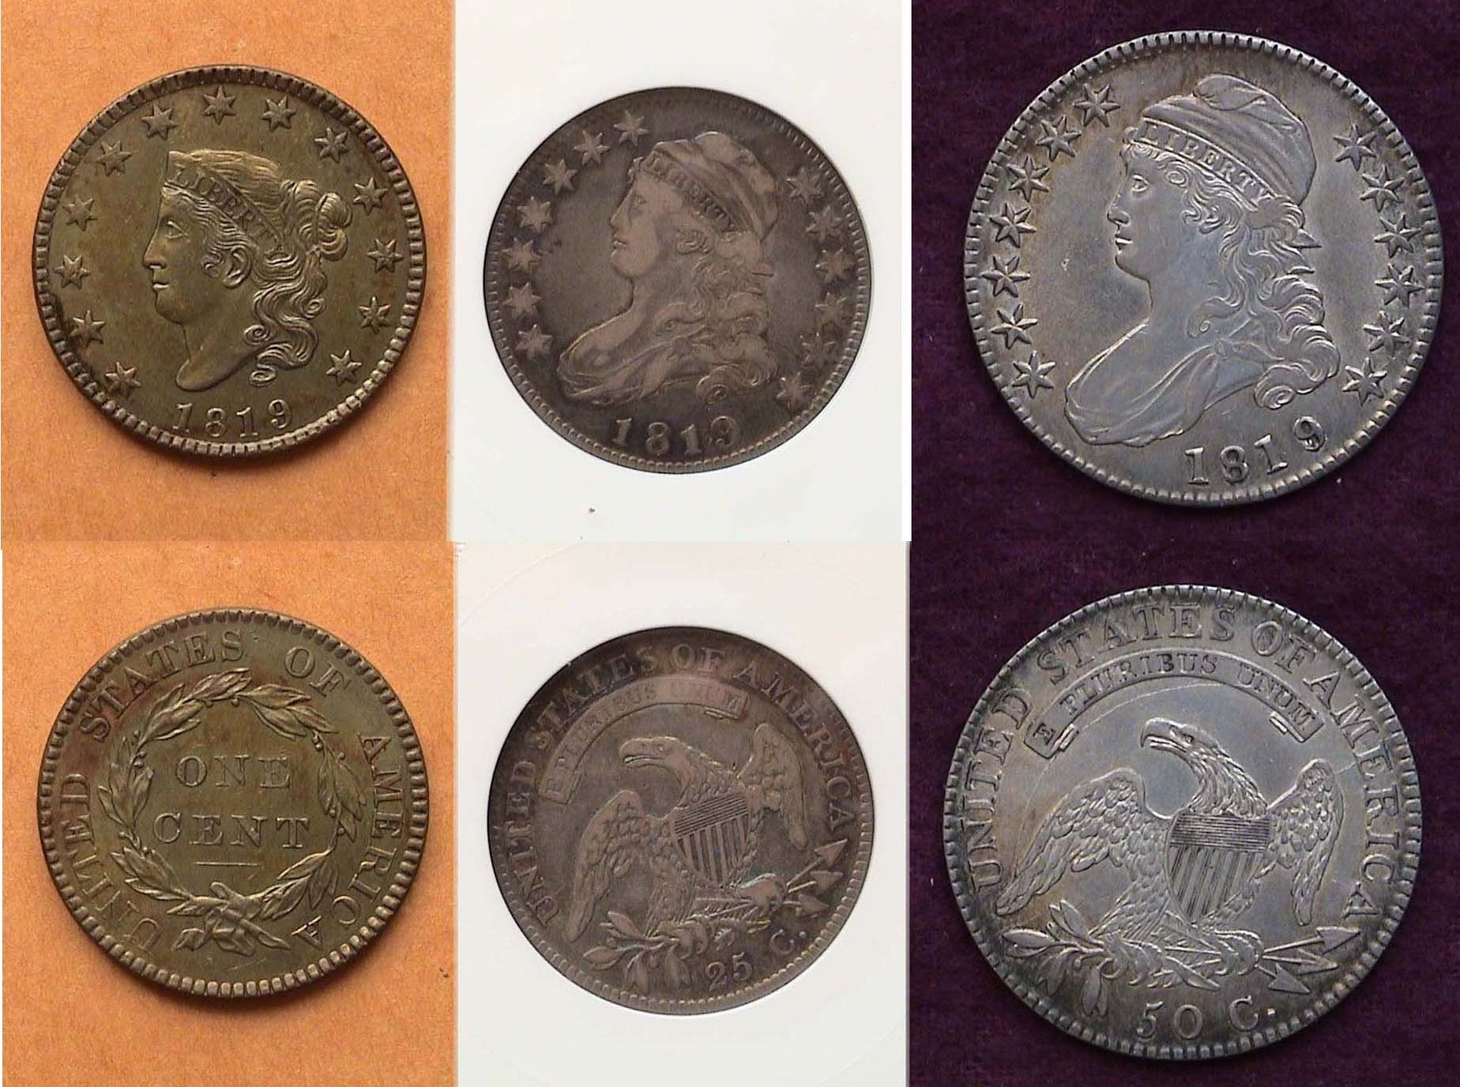
Mar. 7 June 6 Sept. 5 Dec. 5

Current Club Show Flyer Creative & Attractive
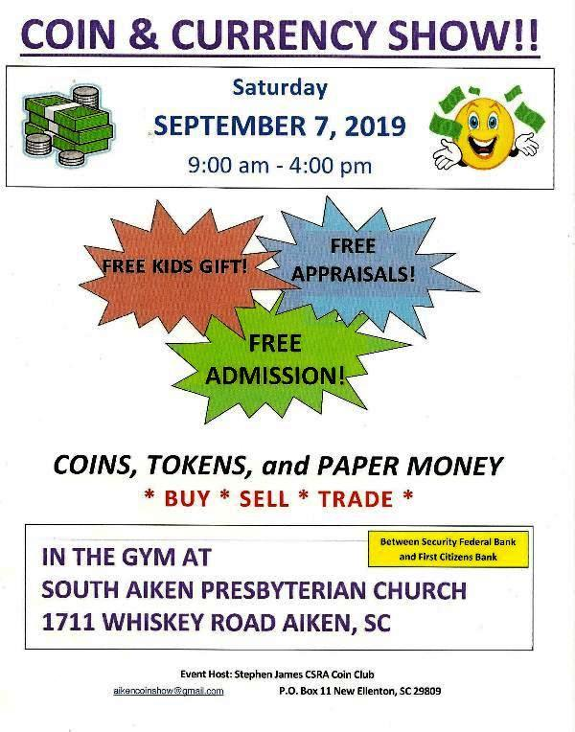

Directly is the flyer for our Coin and Currency show scheduled for Saturday, September 7, 2019. Our annual fund raiser will be housed at a new facility, the South Aiken Presbyterian Church located across the street near the previous H. Odell Weeks Recreation Center. From all accounts, the interior is both spacious and attractive. While the event is three months away, it is important that members spread the word to family and friends as well as possible patrons by tacking the flyer on bulletin boards where it is permissible to do so. Ads have already been placed in both Numismatic News and The Numismatist, the American Numismatic Association’s monthly journal.
_____________________________________________________________________________________________________________________
The Collectible US Coins of 1819, (200 Years Ago)
By Arno Safran

The 1819 Coronet large cent, Caped Bust quarter and half-dollar
[Enlarge page to fill monitor screen to view details.]

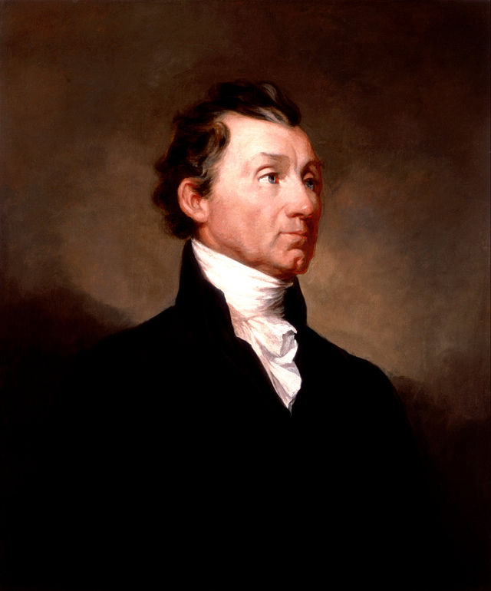
1819 was not a good year for President James Monroe. Our country’s fifth president was facing the political crisis of his life as a major recession known as “Panic of 1819” had brought about our nation’s first major recession. Up to that point in time, the American economy actually prospered, this despite the War of 1812 and its aftermath that was a period of economic growth. In 1819, the

James Monroe
newly re-charted 2nd Bank of the United States began to call in the debt acquired by the mid-western state banks which had recklessly printed currency not backed by “specie” (i.e., silver or gold coin) with the result that when the debt was called in by the Federal banking facility, the state banks failed. This created a downward spiral which affected not only the borrowers but large numbers of the general population who lost their jobs as well. That same year, the Philadelphia Mint struck only four of the ten denominations, the large cent, quarter and half-dollar. also the $5.00 gold half-eagle.
The Collectible US Coins of 1819, (200 Years Ago)

(Continued from page 1, column 2)

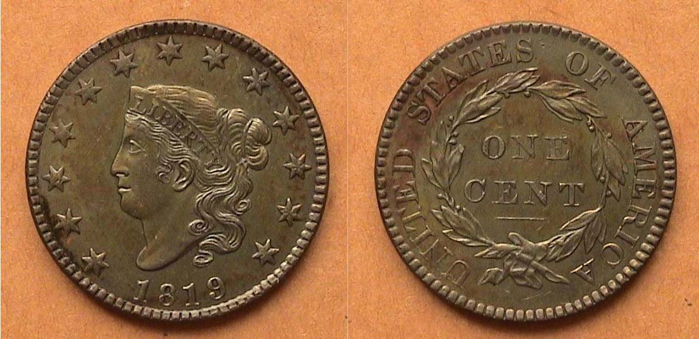

An 1819 Coronet Large cent, N-8, R1, virtually a Brown UNC.
[Enlarge page to fill monitor screen to view details.]

Of the four US coin denominations struck in 1819, the Coronet large cent type (1816-39), with a reported mintage of 2,671,000 received the largest number and it is considered a common date. Of the ten known varieties, the first two are over-dates, the rest, considered normal dates. Five are, listed as R1s, (very common), three as R3s, less so but not scarce and two as R4s, scarce but not rare. The N next to the die variety number stands for the late Harold Newcomb, a dealer and attributor who specialized in what is referred to as “the middle dates” series.

The coin shown above is very well struck with nice coppery color. The 1819 cent was one of the five dates discovered from the famed Randall Hoar in the mid 19th century, contained in a bucket that included many mint state specimens, some in full red, others similar to the coin shown and still others badly corroded, the prime reason why number of cents from 1816 thru 1820 are available at a reasonable cost in high grades.

As with a number of dates in this series, there are numerous sub-types varieties featuring over-dates along with large and small date or large and small date obverses along with large and small lettering reverses.

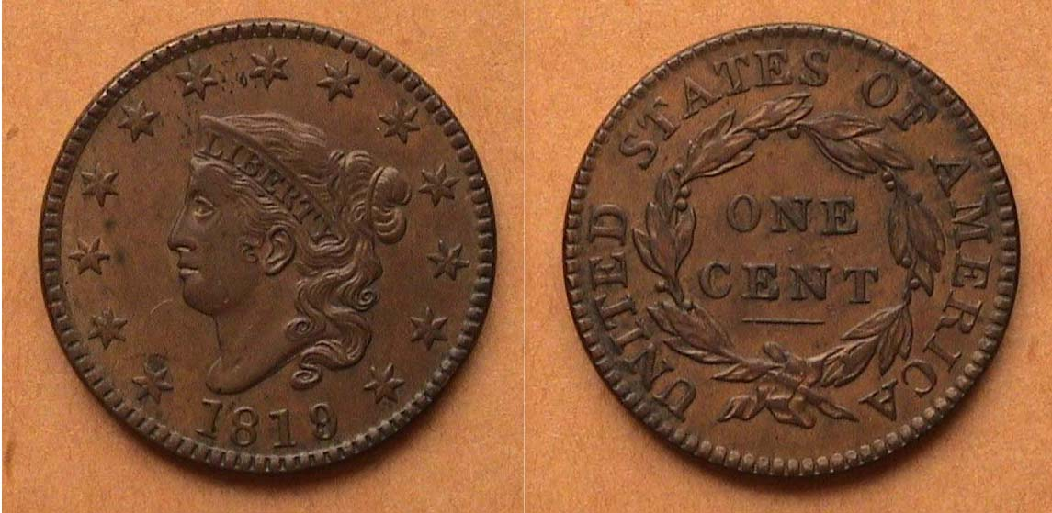

1819 Coronet Large cent, N-1, R1, lg. over-date graded AU-50
[Enlarge page to fill monitor screen to view details.]

The is the first variety of two over-dates struck of e Coronet large cent in 1819. The anomaly is barely visible even with magnification. It was graded AU-50. See detail below!

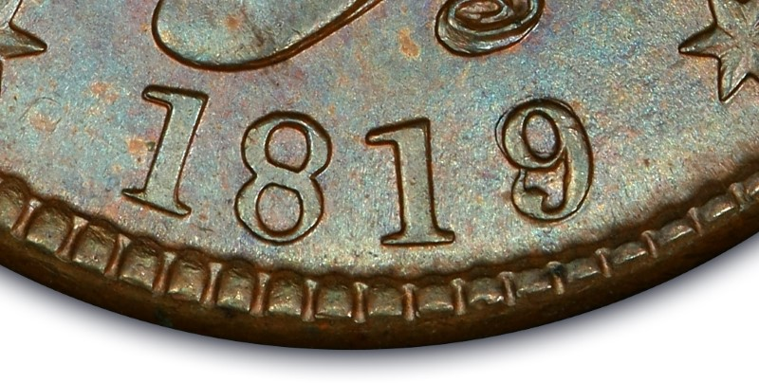

Detail showing over-date 9/8 in date
Courtesy of PCGS COINFACTS
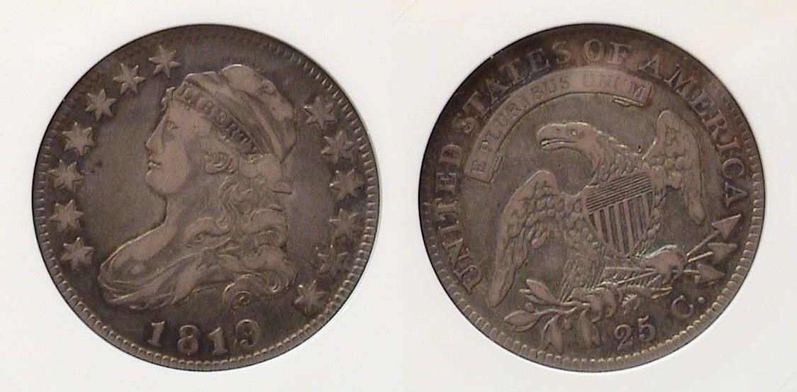
An 1819 large size Capped Bust quarter B1, R5 graded VF-20
[Enlarge page to fill monitor screen to view details.]

. The design type of the large size Capped Bust quarter was created by Asst. Chief Engraver John Reich and first coined in 1815, then suspended until 1818 when 361,174 with that date were struck with ten known die varieties, the largest recorded for the series that ran through 1828. The reported mintage for the 1819 quarter dollar was 144,000 with just four varieties and the coin shown is the first and scarcest of the four, catalogued as a R5 (with R1 being the most common and R8 being extremely rare.) While the 1819 dated quarter is not considered very scarce, let alone rare, it usually surfaces in the lower grades up through VF-20, the grade shown and as such, the coin still appears somewhat attractive at an affordable price.

The most recent study of the Capped Bust quarter series was published in 2008 by numismatic scholar Steve M Tomkins. He did a tremendous amount fresh research on the series which went far beyond the original Browning book on the same subject yet Tomkins retained the variety attribution letter B for the purpose of clarity.

Unlike the half-dollar which was 32.5 mm in diameter and had a lettered edge, the large size Bust quarter was 27 mm in diameter with a reeded edge. In the first four decades of the United States Mint, annual mintages were based on federal warrants with the actual date being almost superfluous. As a result, a coin such as the 1824/2 Bust quarter could show a mintage of 24,000 when in reality, only 16,000 were actually struck according to Tomnkins..

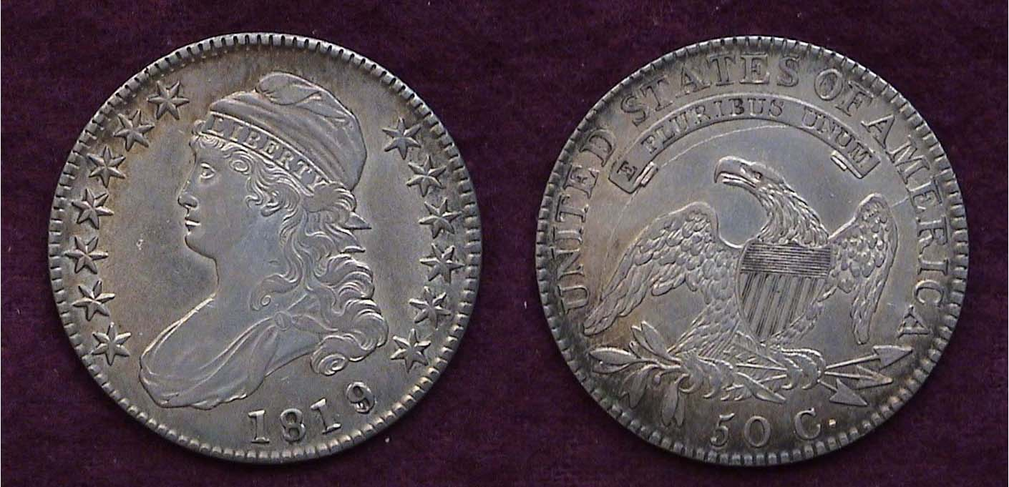

An 1819/8 Capped Bust half-dollar, O-103a, R4 graded AU-50
[Enlarge page to fill monitor screen to view details.]

The reported mintage for the half-dollar denomination in 1819 was 2.208,000, the second largest for that year behind the large cent. There are fifteen known die varieties for the date with the first six, O-101 thru O-106 being over-dates. Of the six over-dates, the O-103 is considered the scarcest listed as a R-4 on the rarity scale. The O stands for Al Overton, a dealer and author of the original first three volumes of United States Early Half-Dollars (1794-1836). The coin was originally acquired at the F..U.N. Show held in Orlando back in January, 2006.
_________________________________________________________________________________________________________________________
(Continued on page 3, column 1)
The Uncollectible US Coin of 1819, (200 Years Ago)
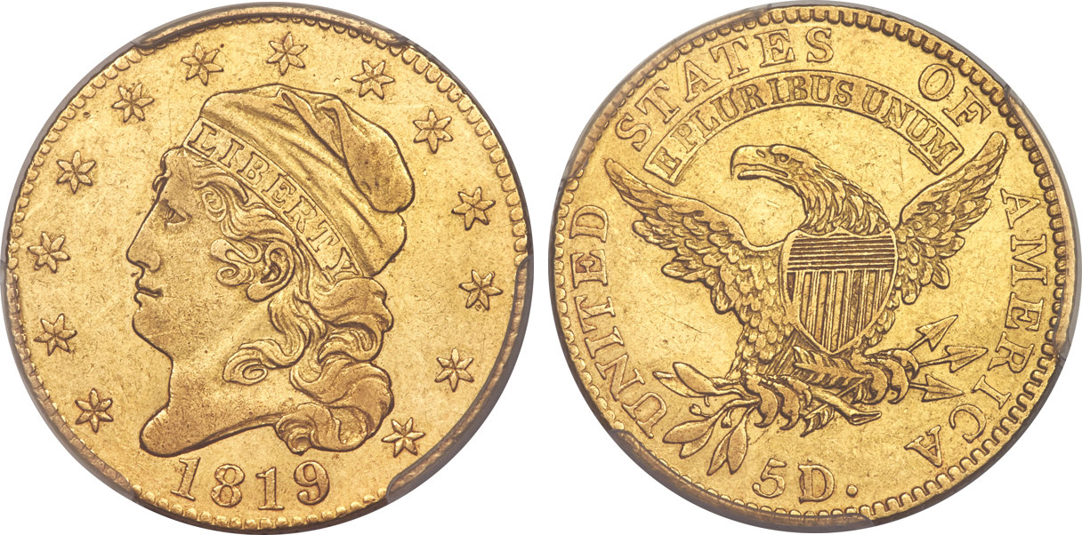

An 1819 $5.00 gold half-eagle graded XF-45 by PCGS
(Courtesy of Heritage Auctions Archives)
[Enlarge page to fill monitor screen to view details.]
Despite grading only XF-45, the coin realized $52,545
At the ANA Convention held in August, 2017 in Denver, CO

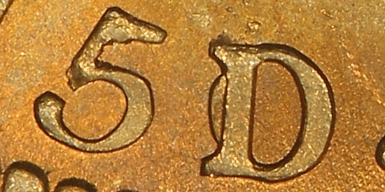
Most early US gold coins dated from 1795 thru 1834 are scarce to extremely rare depending on the date of course but also due to an entirely different set of circumstances, the continual fluctuation in gold prices vis-a-vis the European markets. As a result, when the gold in a $5.00 half-eagle increased in value above a coin’s actual face value, the coin would be taken out of circulation by bullion merchants and shipped to Europe for their higher worth thereby reducing its availability for later generations of collectors. This was particularly troublesome for collectors interested in acquiring an 1819 quarter eagle for their collection, but with the exception of the 1813 and possibly the 1814/3 issues, this particular US type series is fraught with rarities despite their reported mintages. On the reverse of the coin, most 1819 half-eagles display the denominator at the bottom of the reverse as 5D over 50.

The 1819 $5.00 gold half-eagle was 25 mm in diameter just slightly smaller than the capped bust quarter shown on the preceding page. Both coin types can appear fairly attractive in extra-fine. What isn’t attractive is the price one has to pay especially for the gold half-eagle in the same grade. The XF-45 graded coin shown atop cost the winning bidder $52,445. While still beyond the discretionary income of most collectors, a collector desirous of obtaining a more affordable similar example of series, the earlier 1807 or 1811 Capped Bust $5.00 gold half-eagle sells for $7,500 in XF-45 and while that too is expensive for most, nobody ever said, early US gold coins were collectible. . For most numismatists, it’s just a dream.
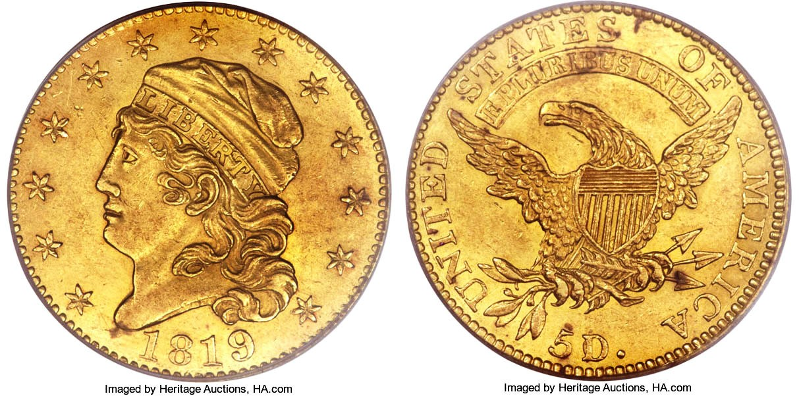
An 1819 gold half-eagle graded MS-62 by PCGS
(Courtesy of PCGS’COINFACTS and Heritage Auction Archives)
The coin realized $184,000 at a Heritage Auction
held at the FUN Show in January, 2004

And as long as we’re collectively dreaming, if you won the “power ball” drawing, you might just be able to afford the magnificent MS-62 specimens of this 1819 gold half-eagle that sold for $184,000 at the 2004 FUN show.
While it is unlikely that any of us reading this will ever add the 1819 dated $5.00 half-eagle to our collection, it is possible to acquire the cent, quarter and half-dollar and as the reader can tell from viewing those three denominations atop page 1, column 2, the images of the coins form an attractive collectible set.
More on the “Panic of 1819”

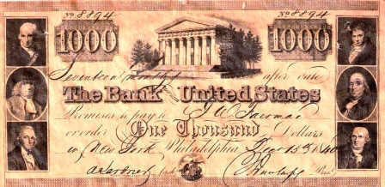

A $1.000 promissory note issued by
the Second Bank of the United States

As for President James Monroe’s dealing with the “Panic of 1819” and how it affected his chances of reelection efforts in the following year, 1820, that too tells an interesting tale. After the War of 1812, Henry Clay, Speaker of the House, with the support of Congressman John C. Calhoun of South Carolina, incorporated some of the economic ideas of Alexander Hamilton, our first United States Sec. of the Treasury into an economic program which came to be known as “The American System”. The three parts concept was to 1) allow the federal government to be in control of the economy and not the individual states, 2) to create a national bank, also adding tariffs to foreign products and 3) to provide sufficient funds backed by “specie” to subsidize the building of new roads and canals. This economic philosophy became a component of James Monroe’s so-called “Era of Good Feeling” which actually began after the War of 1812 ended with the signing of the Treaty of Ghent on Dec. 24, 1814 by President James Madison’s representative John Quincy Adams and ended after Andrew Jackson became president in 1829.

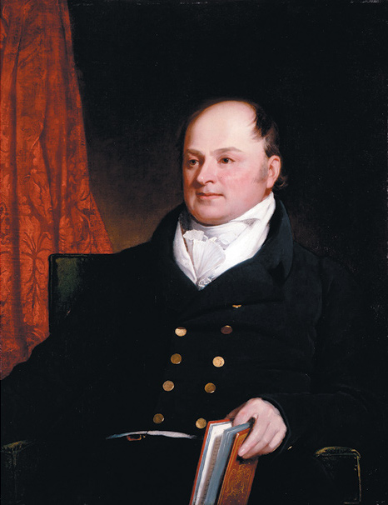
The ”Panic of 1819” was caused by the greed and corruption of these basically noble ideals when the state banks allowed investors and builders to overextend their loans not guaranteed by “hard money” but by promissory notes that turned out to be worthless when the issuing bank failed. Eventually. President Monroe, the Congress, along with the Banking and business community reached agreements to find a way to forgive the debts that caused many citizens to go bankrupt and restore some semblance of authority regarding the transaction of the nation’s business. In the election of 1820, President Monroe was reelected for a second term unopposed although the famous Doctrine of 1823 that bears his name, was actually written by John Quincy Adams, his Secretary of State. John Quincy Adams
______________________________________________________

STEPHEN JAMES CSRA COIN CLUB
Regular Meeting May 2, 2019,
Aiken County Library

President J.J. Engel called the regular meeting of the club to order at 6:45 p.m.
Jim Sproull reported that there were 15 members present. Jim announced information concerning several upcoming coin shows in the vicinity.
Ken Bailey won the members’ door prize, a 2019 Silver Eagle.
A motion was made by Chuck Goergen, seconded by Arno Safran, and passed to dispense with the reading of the April 2019 meeting minutes. A copy will be on file with the other club records, and a copy will appear in the club newsletter.
The treasurer’s report for May showed a balance of $1,703.10.
Pat James provided an update on preparations for the club’s coin show in September .
Arno Safran reminded the members of the meeting of the Augusta Coin Club at 7 p.m. on the third Thursday of the month (April 18) at the Sunrise Grill, West Town Market Square on Washington Road in Martinez, Georgia.
Show & Tells: Several members including Robbie Ogden, Chuck Goergen, John Kolmar, and Arno Safran presented items in the Show and Tell. Robbie Ogden shared a medallion for Amen Corner at the Augusta National Golf Course. He described how the 11th, 12th, and 13th holes on the course have played host to some of the most gripping moments in Master’s history. Chuck Goergen shared a denarius from the Roman Republic made in 48 BC. The obverse of the coin is the head of a Gallic captive believed to represent Vercingetorix. John Kolmar shared an interesting error coin from 1942 where a Jefferson Nickel was struck on a penny planchet. The obverse of the nickel is on one side of the coin and the images from the obverse of a Lincoln cent are on the other. Arno Safran shared a year set from 1990, including an Eisenhower Centennial Silver Dollar.
Arno Safran presented a PP program on Collecting the Coins of the Gay -90s in the Age of Electricity.
This program provided information on the events of numismatic interest in the 1890’s, including the replacement of the Liberty Seated design with the Barber design for minor silver coins. The 1890’s also saw the first American commemorative coins for the Columbian exposition in Chicago. Arno described some of the strides made in the 1890’s in the modernization of American cities, especially in electrification and the start of the development of subway systems.
Following the monthly auction, the meeting was adjourned at 8:35 pm.
Respectfully submitted,
Jim Mullaney, Secretary
____________________________________________________________________________________________________________

Kindly Patronize our Advertisers

