The Stephen James
CSRA Coin Club of Aiken
P.O. Box 11
New Ellenton, SC 29809
Web site: www.sjcsracc.org
The SJ CSRA CC of Aiken, SC meets on the 1st Thursday of the month at the Aiken Public Library

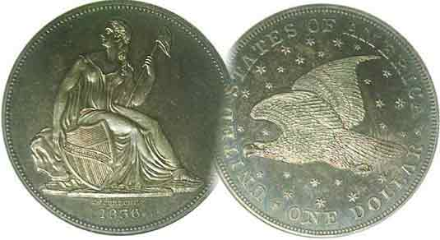
Pres. J.J. Engel
V .P. Pat James
Sec. Jim Mullaney
Treas. Chuck Goergen
Sgt. in Arms: Jim Sproull

Programs: Pat James
ANA Rep.: Glenn Sanders
Show Chair: Board members
Photos: Steve Kuhl
Publicity: Pat James
Newsletter: Arno Safran
E-Mail: arnosafran@comcast.net
Auctioneer: Jim Sproull
Web site: Susie Nulty (see above.)

Our upcoming will be held at Jim Mullaney’s Barn as well as “Zoom” on Thursday, June 3 at 6:45 PM

2021 Club “Zoom” Meeting Schedule
Volume 20, No. 6 the Stephen James CSRA Coin Club, Founded in 2001 June, 2021
Monthly Newsletter
Some US Year sets are challenging, the BU US Coins of 1936 are not!
Jan. 7 Apr. 1 July 1 Oct. 7
Feb. 4 May 6 Aug. 5 Nov. 4
Mar. 4 June 3 Sept. 2 Dec. 2

The Mexican Equivalent of the Morgan Dollar

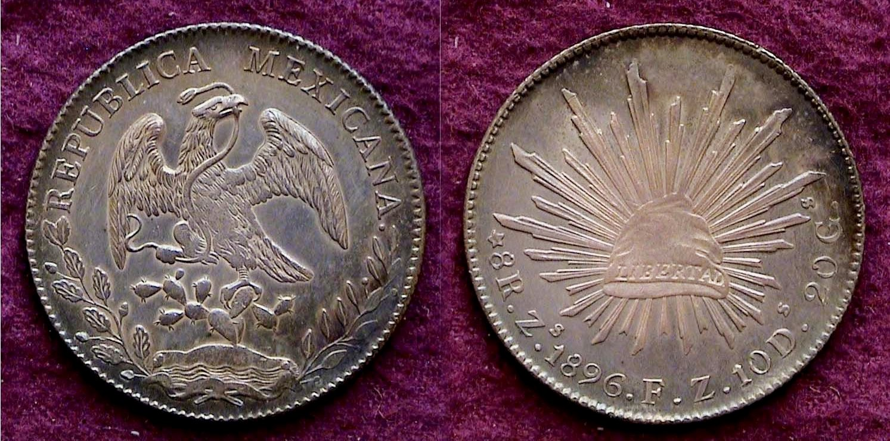

An 1896 Mexican Peso, KM-377-13 struck at the Zacatecas Mint
[Enlarge photo to 150% to fill monitor screen for better clarity.]

After would-be dictator, Augustan Iturbide was deposed and exiled, the Mexican government in 1824 struck a new silver dollar-sized Eight Reales type at the Mexico City Mint. The obverse displayed a hooked neck eagle facing right gripping a small size snake in its mouth perched on a bed of cactus while the reverse portrayed a Phrygian Cap emblematic of “freedom” with a series of feather-like rays emanating outward. By 1825, this coin was being struck at all twelve Mexican mints including the Zacatecas Mint located in north-western Mexico south of Guadalajara. By the late 19th century, massive quantities were being struck at virtually all the state mints with 4,226,000 struck at the Zacatecas Mint in 1896, its penultimate year. The design reappeared in 1898 with some minor modifications continuing to be coined until 1909.

The strikes of the later year examples of this popular coin design improved presumably as a result of the Steam press having replaced the screw press with he result that a coin similar to the example shown above is not only sharply struck and striking to the eye, but far less expensive to own since it is a very common Mexican type coin.
__________________________________________________________________________________________________________________
Collecting the US Coins of 1936 (85 Years Ago)
By Arno Safran

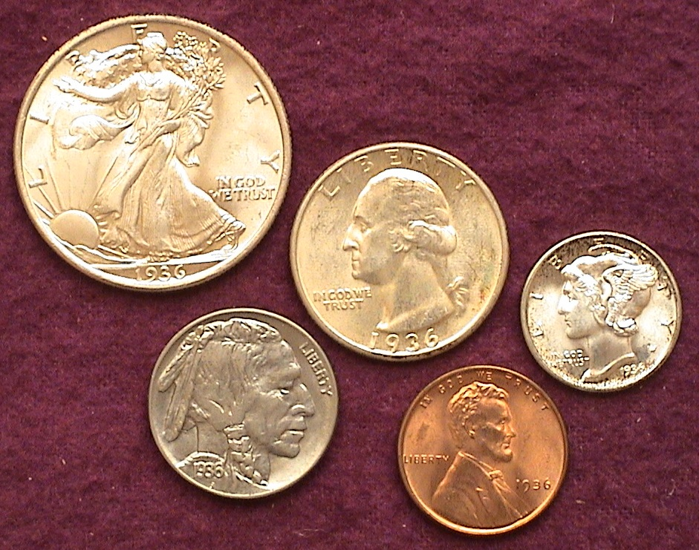

The obverses of an BU set of 1936 US coinage
[Enlarge photo to either 150% to fill monitor screen for better clarity.]

Our club was founded twenty years ago and for those charter members still with us who may have celebrated their 65th birthday back then, congratulations on reaching your 85th this year. If you have never acquired a United States year set from the year of your birth, the author has some good news for you. Despite the age of these five coins; most of them from the three mints are relatively affordable certified as high as MS-63 to MS-65, especially those struck at the Philadelphia Mint; like the coins shown directly above because record breaking mintages were recorded in 1936, especially the Philadelphia Mint issues.
The reason for this is that beginning in 1934, dealers started putting away rolls of mint state coins as soon as they left the mint. After 1935, no silver dollars were produced nor were there any gold issues struck.

The US 1936 BU set appearing above were all purchased “raw” by the author away back in the late 1970’s to the early 1980’s, then placed in a Capital Lucite plastic holder which were made for proof or business strike year sets.
________________________________________________________________________________________________________________________________
(Continued on page 2, column 1)
Collecting the US Coins of 1936 (85 Years Ago)
(Continued from page 1, column 1)

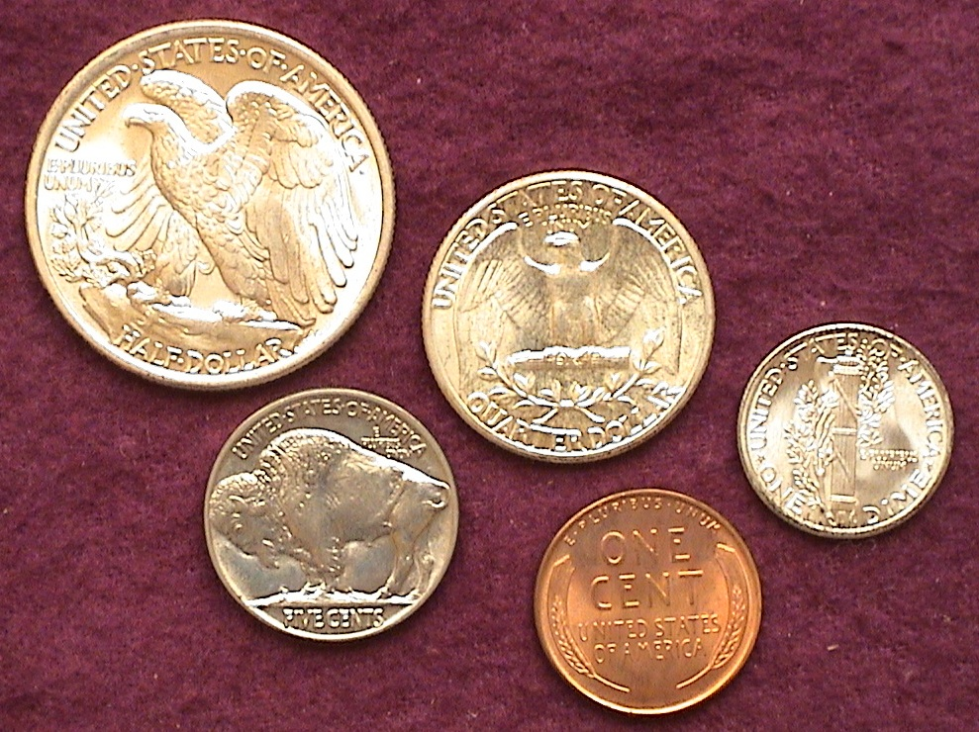

The reverses of an BU set of 1936 US coinage
[Enlarge photo to 150% to fill monitor screen for better clarity.]

Between 1870 and 1925, millions of immigrants emigrated to the United States in search of better living conditions. Most of these arrivals entered a work force that were already severely underpaid. From the 1880s through the early 1930’s the conditions and the wages for most Americans were already extremely low. In 1886, young women entering the factories of Chicago received a wage of just 3¢ an hour and worked 10½ hours a day, six days a week. Midway through the 1930s, with the Great Depression beginning to wane, more jobs becoming available at higher pay-rates primarily due to the unionizing of many of the factories in the larger cities of the north. As a result, our coinage began to increase with 1936 producing the largest amount of coinage for all five denominations since 1920. In 1936, all five denominations were struck at the Philadelphia, Denver and San Francisco Mints.

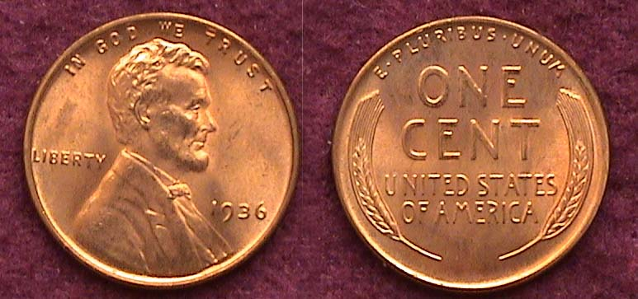

A 1936 Lincoln cent graded MS-65 Red by PCGS
[Enlarge photo to 150% to fill monitor screen for better clarity.]

In 1936, the Philadelphia Mint struck 309,632,000 Lincoln-Wheat-back cents which was a tad short of the record set in 1920 when 310,165,000 were coined. The example shown above was purchased “raw” for just $4.00 from a dealer set up at the South Carolina Numismatic Convention held in Greenville, SC in October, 2007. The collector had it certified several years later in 2015 along with a number of other inexpensive coins and it was graded MS-65 Red by PCGS which is valued at $26.00 today. There is a subtle double-die of this same date which isn’t anywhere comparable to the 1955 double die or even the 1972 double die Lincoln Memorial cent but can still bring big money such as $600 or more to one who finds a mint state example. Both the 1936-D and 1936-S Lincoln cents, despite substantially lower mintages, are considered common and affordable although they are more expensive than the extremely common 1936-P Lincoln Wheat back cent.
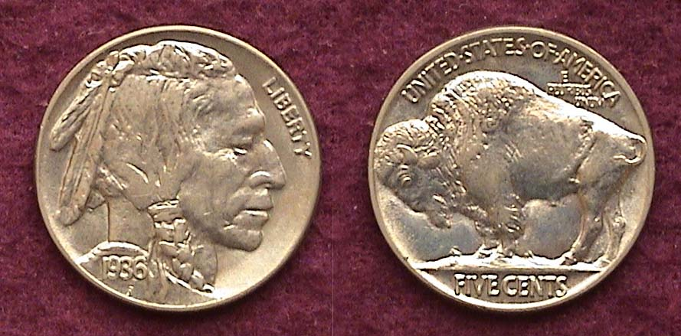

A uncirculated 1936 Indian Head/ Buffalo Nickel
[Enlarge photo to 150% to fill monitor screen for better clarity.]

In 1936, the Philadelphia Mint struck 118,997,000 Buffalo nickels, an all time record for that series. No other Buffalo nickel date comes close, so the coin is an extremely common date and affordable across the grading system. Upon enlarging the photo, one can observe the strong details of Engraver James Earle Fraser’s design on both sides of the coin. The author obtained the piece, “raw” graded MS-64 back in 1993 for $20.00 from a dealer who regularly set up at the club. The coin is mark-free in the spaces where the main designs do not intrude and is extremely attractive, but when the author submitted it to PCGS in 2015 for certification, unlike the other four coins that were all graded higher, the graders must have felt that the color--which appears somewhat grayish--was no better than a MS-62 which has a retail value of $35.00 today. It is said that “Beauty is in the eye of the Beholder” and the author prefers the grayish hue to the traditional silvery color on most nickels that lacks “presence” even though the coin turned out to be less valuable.

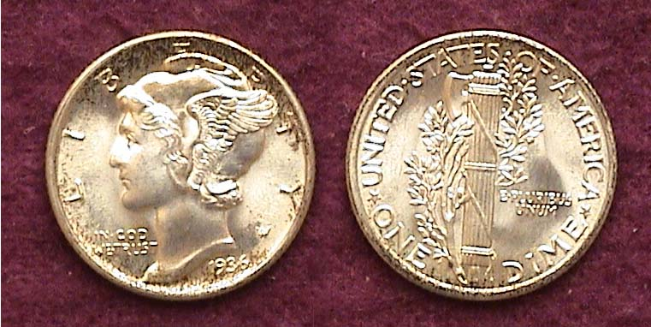

An uncirculated 1936 Mercury dime with fully split bands
[Enlarge photo to 150% to fill monitor screen for better clarity.]

In 1936, the Philadelphia Mint struck a record 87,500,000 Mercury dimes that would not be broken until 1941, when over 175 million were struck. As a rule, the Philadelphia Mint produced the best strikes and the 1936-P example is especially very sharply struck. The 1936-P Mercury dime shown above was obtained by the author “raw” away back in November, 1984 from a dealer who graded it MS-64 and charged him $24.00. In 2015, he decided to send it out along with a group of his commoner coins to both PCGS and NGC since they charged less for grading common dates Among them were the 1936 nickel, dime, quarter and half. The author was astonished to learn that PCGS graded the 1936 Mercury dime, MS-67 with Full Bands. As a result the coin’s value increased in value from $90 without full bands to $325.00; with some recent auction examples realizing as much as $432.00.

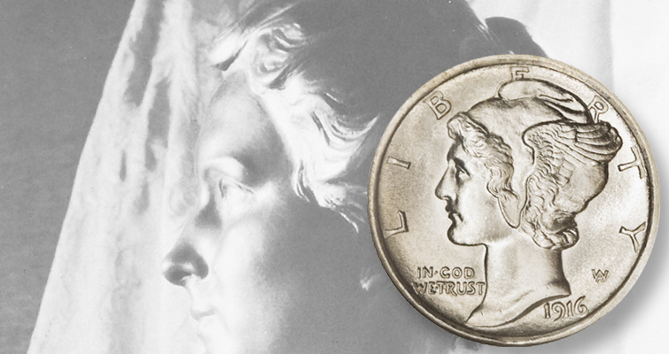
The Mercury dime was created by engraver, Adolf Weinman. Originally, the US Mint director referred to the new type as the “Winged Liberty” dime. Elsie Stevens, the young wife of the poet, Wallace Stevens is said to have been Weinman’s model. Elsie Stevens on the dime
(Continued on page 3, column 1)
Collecting the US Coins of 1936 (85 Years Ago)
(Continued from page 2 column 1)

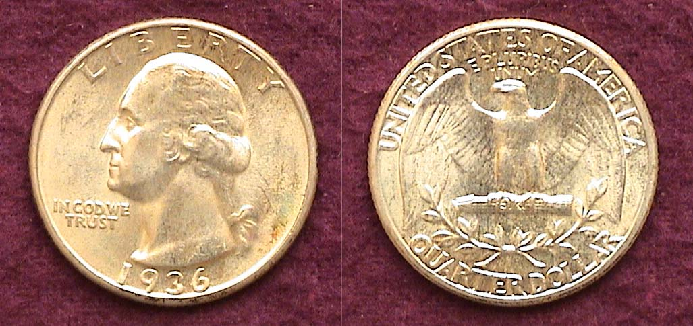

A 1936 Washington Quarter graded MS-65 by PCGS
[Enlarge photo to either 150% to fill monitor screen for better clarity.]

In 1936, the Philadelphia Mint set a new all time record for the twenty-five cent denomination with 41,300,000 Washington quarters being struck that year. The Denver Mint struck only 5,174,000 while the San Francisco Mint, just 3.828,000. Since the 1936-P Washington quarter is considered the most common date for the series of the 1930’s, it is listed at just $80 certified MS-65 whereas the 1936-D-in addition to its lower mintage circulated heavily and is considered the fourth rarest Washington Quarter of the entire series. As a result, a 1936-D quarter certified MS-65 it is currently valued at a whopping $1,000. While the 1936-S Washington quarter has the lowest actual mintage of the three, it did not circulate at the level of the ’36-D and its retail value certified MS-65 is currently listed at $250 according to PCGS’s COINFACTS.

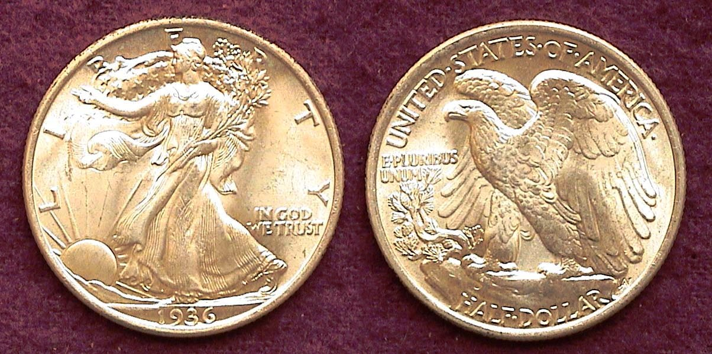

A 1936 Walking Liberty half-dollar graded MS-66 by PCGS
[Enlarge photo to 150% to fill monitor screen for better clarity.]

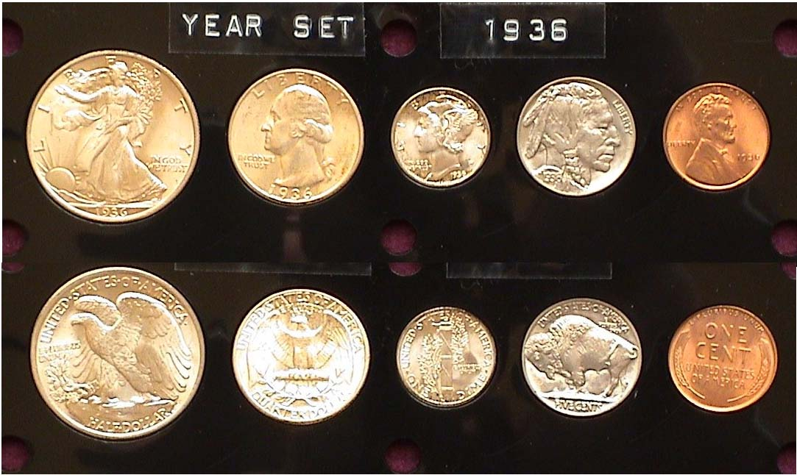
The author first stated collecting obsolete US coins in earnest in 1976, the year of our nation’s bi-centennial At the time he was a college professor at Trenton State College, today known as the College of New Jersey which is located in Ewing Twp.. between the capital city of Trenton and the college town of Princeton where the famed Ivy League college has stood since 1756. Princeton opened it’s doors to college students in 1746 in Elizabeth, NJ and was originally called “The College of New Jersey” which is what Trenton State College is called since 1992..

Back in 1976, there were a number of coin shops in the state of NJ as well as the surrounding suburbs of Trenton, nearby Philadelphia to the south and New York City, just 60 miles to the north; so it was fairly easy to drive into Manhattan where the famous “Stack’s” coin store was located on 57th Street between the Avenue of the Americas, (formerly 6th Ave.) and 5th Ave.
Upon entering Stack’s one day, the author spotted the 1936-P Walking Liberty half dollar shown. It was graded MS-65 and cost $150; a lot at that time for a coin that had a record mintage of 12,614,000 and was considered extremely common. However, when the author decided to send the piece out to PCGS some 37 years later along with the previous three denominations mentioned in the article, it too came back in a higher grade than he expected at MS-66, which today has a retail value of $275. The photo image shown on the lower portion of the previous column, really displays a “gem” example regardless of how common the date is. The Walking Liberty half-dollar was also designed by Adolf Weinman, and is considered our second most beautiful coin after the Saint-Gaudens $20.00 gold double eagle.

As for the 1936-D Walking Liberty half, it had a mintage of 4,250,200 and it is slightly more expensive than the 1936-P. The 1936-S WL half had the lowest mintage with just 3,884,000 but is a lot more expensive in the same grades than either the 1936-P or 1936-D, although it is not considered scarce, let alone rare in the way the 1936-D quarter is regarded.
All of the coins struck at the Philadelphia Mint during the 1930s are collectible in mint-state including the half-dollar, although, due to the lack of a slot for the denomination in the vending machines, along with the slightly cumbersome size of the 50c silver coin; the half-dollar as a usable coin began to wane. Let’s hope none of our members celebrating their 85th or even 75th birthdays this year are starting to wane and continue enjoying the hobby for many more years.
The US Coins Commemorating 1812
By Robert Sanborn

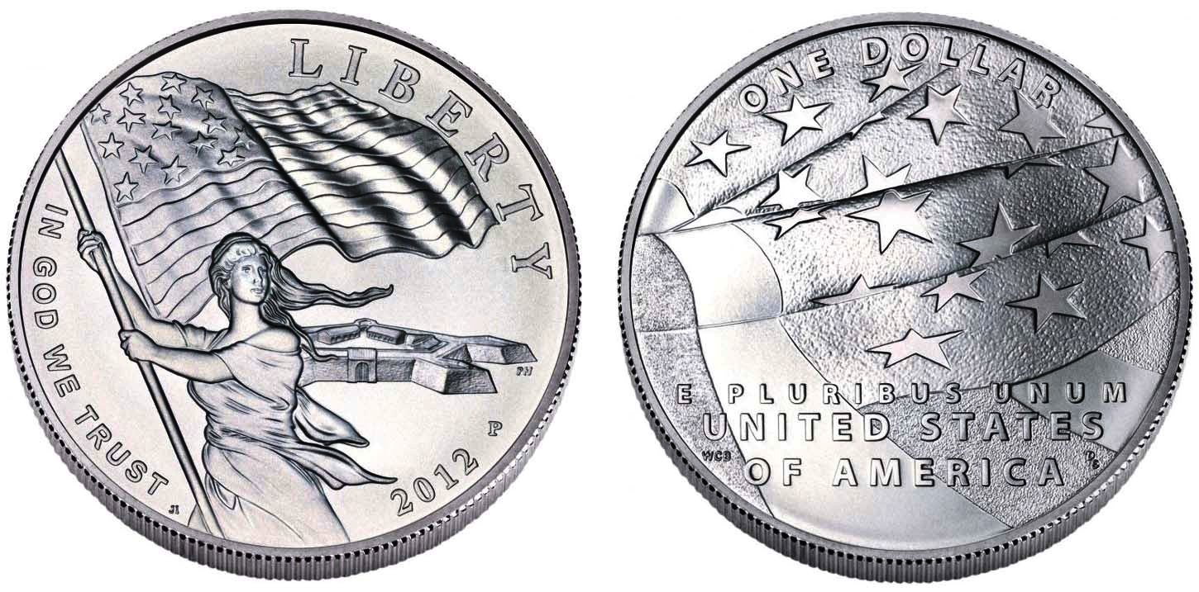
2012 US commemorate silver dollar for the War of 1812
[Enlarge photo to 150% to fill monitor screen for better clarity.]

As I get to read more about history of the US in my spare time, I have run across some stories about the War of 1812 and so began to wonder about coins commemorating that war since its 200th anniversary occurred in 2012, several years ago.

The War of 1812 was an odd war in that there were no real winners or losers except for maybe, Tecumseh. It was also a confusing war that had its beginnings as far back as the Revolutionary War in North America as well as the Napoleonic Wars taking place in Europe. More than likely, the primary cause of the war was the British navy practice of stopping American ships on the open seas and seizing men they claimed to be British. It was estimated that some 15,000 American sailors were pressed into the British Navy as a result. A terrific story of it can be found in Wikipedia. Another article that explored more interest in this war appeared in Coin World. What finally ended this war was the Treaty of Ghent. It was signed on Christmas Eve on December 1814, and ratified by the US Senate on February 17, 1815 and that actually ended the conflict.

This article and a great image was inspired from History.com. History buffs will note that Andrew Jackson’s huge victory over the British in the battle of New Orleans took place on January 8, 1815 after the treaty was signed but in those days back then, it took almost two months for news to travel across the sea. Another good commentary of the war comes from the National Park Service.
.
So, how did we commemorate the War of 1812? Not very well, and I am not surprised. By 1815, when the war ended, the economy in the US was pretty dismal. According to weekly numismatic magazine, Coin World, the wartime embargo had prevented the Mint from getting any new copper planchets after 1812, as cents and half cents were struck on planchets imported from Great Britain. This period, was also a time for the hoarding precious metals. The government struck gold and silver coins only for depositors in the denominations they requested. For example, if someone deposited $50 worth of silver, he could expect to receive exactly $50 in any silver denomination he chose. Gold deposits were paid out in gold coinage.

What did the average person use for money? Mostly, it was foreign coins, especially Spanish silver and Portuguese gold, all of which were accepted as legal tender in the United States until 1857. During that period, a Spanish dollar could be divided into eight “bits,” each one worth 12½ cents, a coin, slightly larger than a dime called a real, with two of them equaling a quarter which was worth “two bits”.
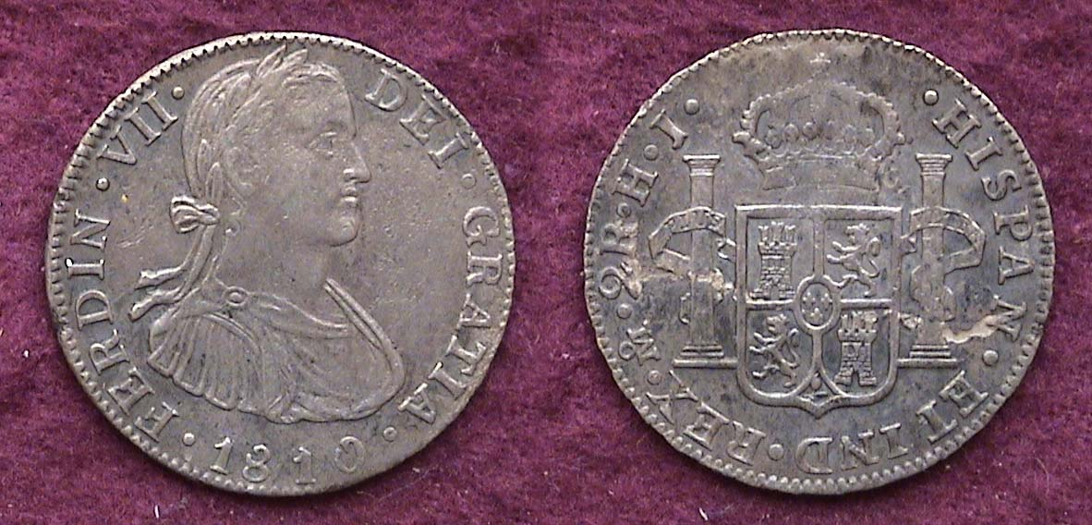

An 1810 quarter-size 2 Reales displaying King Ferdinand VII of Spain struck at the Mexican City Mint
At the end of the War of 1812, the Mint had no bullion from which to strike silver or gold coins and no copper planchets from which to strike cents. Mint activities slowly ramped up late in 1815, but only four denominations were coined: cents, quarter dollars, half dollars and $5.00 gold half eagles. The gold and silver coins with the exception of the half-dollar were struck in large numbers; the other denominations having become scarce to extremely rare.
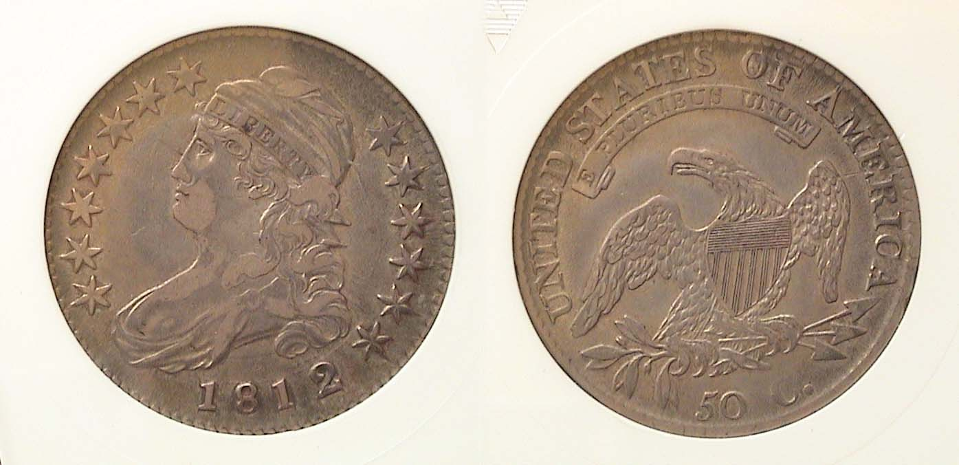
An 1812 Lettered Edge Capped Bust half-dollar
[Enlarge photo to 150% to fill monitor screen for better clarity.]

However, as we shall see, a lot of cents were struck in 1815, though none carry that date.

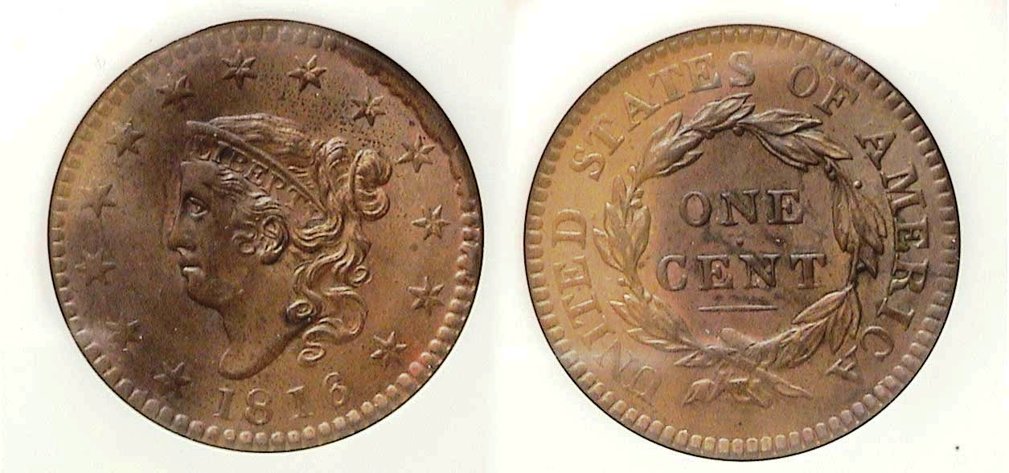T
The 1816 dated Coronet Large Cent was struck in December, 1815
[Enlarge photo to150% to fill monitor screen for better clarity.]

A little more than one hundred years later, in 1917, the United States became involved in yet another conflict, World War I. The Great War lasted from July 1914 to November 11, 1918, so we can forgive the mint for not creating coins to commemorate a war 100 years earlier. We come to 2012. And when I look at the US Mint’s website, there is only one. Searches for War of 1812 or even the year, 1812, come up with nothing.
(Continued on page 5, column 1)
The US Coins Commemorating 1812
(Continued from page 5, column 2)

To top it off for the USA, at least five bills to create commemorative coins have been submitted in the House but have never have gotten anywhere according to the online web site called, gov trac.us. When I search that site for “War of 1812” I get several bills regarding the Star-Spangled Banner and the release of a number of soldiers from the war. The coins that were created in 2012 are the “Star-Spangled Banner Commemorative Coin Program” and the link is here. What they did produce was a five dollar gold coin in both proof and uncirculated condition and a one dollar silver coin also in proof and uncirculated.

The Red Book shows that the 2012 Silver dollar was struck at the Philadelphia Mint and they produced 41,686 of them. (See the coin pictured at the beginning of this article on page 4). The Proof version was also struck at the Philadelphia Mint with 169,065 examples produced. These coins are 38.1 mm in diameter and weigh 26.73 grams and contain 90% silver and 10% copper. These were designed by Don Everhart who was the mint’s last sculptor- engraver. (An article about him appears in Coin World.)
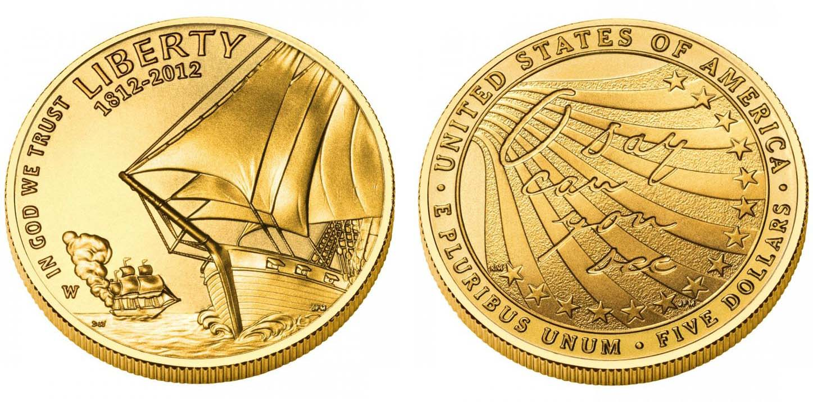
A 2012-W Star Spangled Banner gold $5.00 commemorative
[Enlarge photo to150% to fill monitor screen for better clarity.]

The five dollar gold coin was struck at the West Point Mint in New York State. They produced only 7,027 of the standard coins and 86,355 of the proof versions. These are 21.59 mm in diameter and weigh 8.359 grams. Their composition is 90% gold and 10% alloy. The obverse was designed by Donna Weaver and you can read a very interesting article about her included with the commemorative. The reverse was designed by Richard Masters and his bio is included as well.

As I found with doing research on the Wright Brothers, Numista is another terrific source of information. The first was from Belarus and I was to discover that that nation’s version of the War of 1812 was the commemorating the Napoleonic war between France and Russia on which they were caught in the middle. Unfortunately, there were a lot of wars going on at that time. You will hear of the “Heroes of the Patriotic War of 1812” which took place in Russia, The Mexican war of Independence from Spain 1810 to 1821. The Napoleonic War included a number of nations besides Russia which ran from 1803 to 1815. New Zealand has produced a terrific number of coins from 2012 that celebrate the part of the War of 1812 depicting the Russians.

Our dear friends to the north however have quite a few coins commemorating the War of 1812 even though at the time, they were on the side of the British being part of that country until July 1, 1867, when the passage of the British North America Act was signed, The Dominion of Canada was officially established as a self-governing entity within the British Empire. It wasn’t until the Canada Act, also called the Constitution Act of 1982, that Canada's constitution approved by the British Parliament on March 25, 1982, and proclaimed by Queen Elizabeth II on April 17, 1982, would make Canada a wholly independent country.

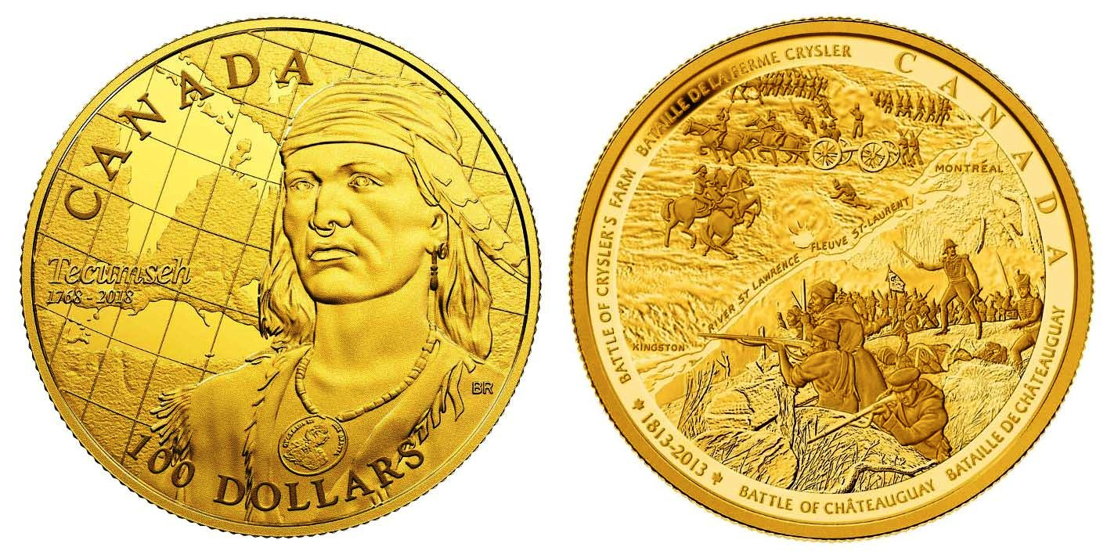

A 2013 Canadian $100 commemorative
of the Indian Chief Tecumseh on the obverse with scenes representing the 1813 Battle of the Thames
near Thamesville, Ontario, in October 1813 on the reverse
The coin had a diameter of 27mm.
[Enlarge photo to150% to fill monitor screen for better clarity.]

Between 2012 and 2014, the Royal Canadian Mint issued 35 different coins and sets commemorating the War of 1812. You can see them all here. Some were minted in quantities as low as 10. Above is one attractive example. For another very interesting read on the War of 1812, look at the published by the Smithsonian institute.

Robert Sanborn
___________________________________________________________________________________________________________________

STEPHEN JAMES CSRA COIN CLUB
Regular Meeting Thursday, May 6, 2021

The Club held the May meeting as our first hybrid meeting with people attending both in person and over Zoom.

President J.J. Engel called the regular meeting of the club to order at 6:54 p.m. There were 14 members and three guests, with two of the members attending over Zoom. A motion was made by Steve Kuhl, seconded by Chuck Goergen, and passed, to dispense with the reading of the April 2021 meeting minutes. A copy of the minutes will be on file with the other club records, and a copy will appear in the club newsletter.

Treasurer Chuck Goergen reported a summary of club expenditures last year.
Jim Sproull reported that the Augusta Coin Club’s annual Spring coin show is scheduled for May 14-15, 2021, at the Columbia County Exhibition Center in Grovetown, Georgia.
________________________________________________________________________________________________________________
(Club Minutes continue on page 6, column 1)
STEPHEN JAMES CSRA COIN CLUB
Regular Meeting Thursday, May 6, 2021
(Continued from page 5, column 2)

The May meeting was our first hybrid meeting combining online and in-person attendance. Jim Mullaney will be sending out information with better directions prior to the June meeting for those who had difficulty finding it. We will also be looking for air-conditioned options as we approach mid-Summer where the open barn may get too warm.

President Engel reminded members that the current annual dues of $15 for adult members were due and checks could be mailed to: Post Office Box 11, New Ellenton, SC 29809. Secretary Jim Mullaney said an email concerning dues will be sent to our membership. Pat James, VP and Program Chair, said that the educational program in June will be by Bob Moon from Greenwood, SC. Bob specializes in the field of National Currency and has published dozens of articles for Bank Note Reporter and Paper Money.
Rusty Cumberledge introduced himself as the representative for ANACS grading service for the Southeastern U.S. Rusty has had tables at our show along with Bill Orne for many years and just recently became associated with ANACS. Rusty described the services available from ANACS, along with various options for submitting coins for grading, including the option to do so at regular coin shows.

The Program:
Steve Kuhl introduced Will Gragg from Irmo, SC, the SCNA Numismatist of the Year. Will is active in both the Midlands Coin Club and the SCNA. Will gave our club a presentation on Courtesy Autograph Notes. These are banknotes that have real “live” signatures from the Secretary of the Treasury or US Treasurer (or both) above or near their printed signature. Will shared the many interesting facts about these notes, as well as photos and examples of unique notes. He included descriptions of different strategies for collecting these as well as characteristics that affected the value of a courtesy autograph note. Mr. Gragg donated an example of a courtesy autograph note to our club, which the club intends to auction in some manner in the future. We enjoyed hearing Will’s presentation on this unique aspect of money collecting.

The May 6 meeting also had the return of our normal auction, since many of us attended in person.
​ President Engel reminded the members that the next meeting would be on June 3rd , 2021, and adjourned the meeting at 8:15 p.m.

Respectfully submitted,
Jim Mullaney, Recording Secretary
____________________________________________________

Kindly Patronize our advertisers

