The Stephen James
CSRA Coin Club of Aiken
P.O. Box 11
New Ellenton, SC 29809
Web site: www.sjcsracc.org
The SJ CSRA CC now meets at the South Aiken Presbyterian Church at 1711 Whiskey Road

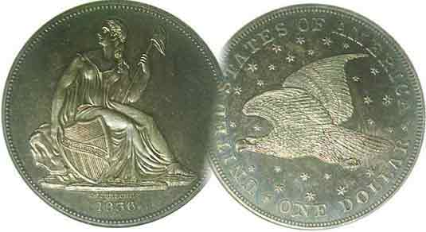
Pres. J.J. Engel
V .P. Pat James
Sec. Jim Mullaney
Treas. Chuck Goergen
Sgt. in Arms: Jim Sproull

Programs: Pat James
ANA Rep.: Glenn Sanders
Show Chair: Board members
Photos: Steve Kuhl
Publicity: Pat James
Newsletter: Arno Safran
E-Mail: arnosafran@comcast.net
Auctioneer: Jim Sproull
Web site: Susie Nulty (see above.)

Our next will be on Thursday, August 5 at 6:45 PM at the South Aiken Presbyterian church Gymnasium

2021 Club “Zoom” Meeting Schedule
Volume 20, No. 8 the Stephen James CSRA Coin Club, Founded in 2001 August, 2021
Monthly Newsletter
New Venue quite satisfactory for Club Meetings
Jan. 7 Apr. 1 July 1 Oct. 7
Feb. 4 May 6 Aug. 5 Nov. 4
Mar. 4 June 3 Sept. 2 Dec. 2

Club now meets in new Location

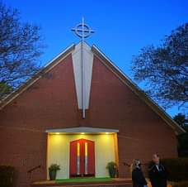

The South Aiken Presbyterian Church of Aiken

Last month, the Stephen James CSRA Coin Club held its first meeting at a new location.

Prior to the arrival of the Covid-19 pandemic we held most of its monthly meetings at the Aiken Public Library going back to the club’s inception in the early spring 2001. Just before the Coronavirus arrived a new Library director decided to terminate our automatic monthly meetings on the first Thursday of each month by deciding when we could meet on a month to month basis and efforts by some of our charter members citing that such a routine would make it virtually impossible for us to conduct our club’s activities under such circumstances fell on deaf ears.

Fortunately, through the efforts of former club President Steve Kuhl and other club members, we were allowed to start holding meetings at another commodious facility which coincidently housed our last coin show on Sept, 2019 with great success; the gymnasium of the South Aiken Presbyterian Church of Aiken with our July 1 meeting going off without a hitch.
Collecting Liberty Seated half-dollar sub-types
By Arno Safran

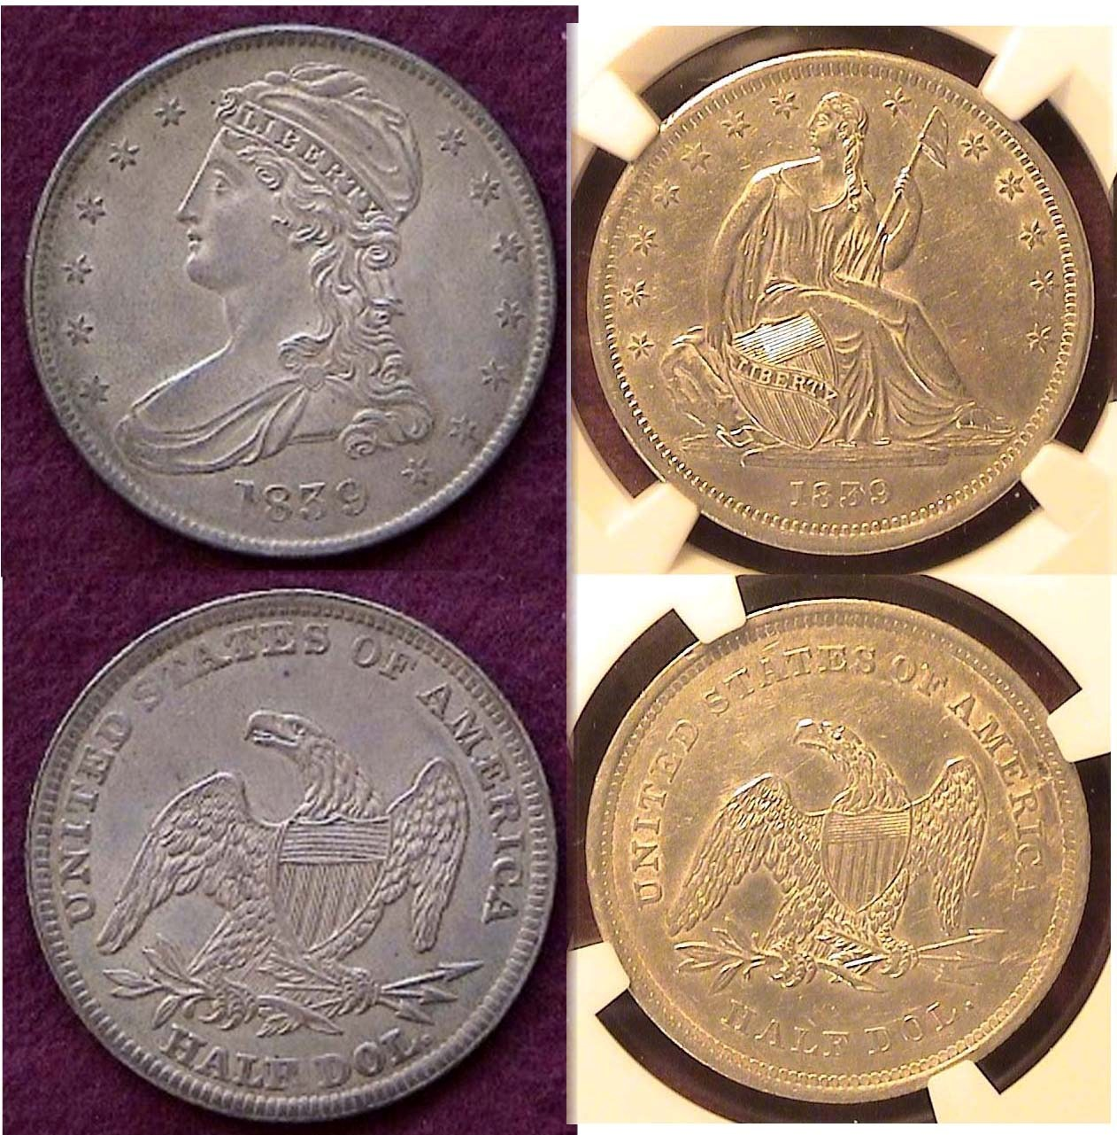

1839 Reeded Edge Bust half & Lib. Std. no drapery half-dollar
From the “old” to the “new”; although, not quite!
[Enlarge page to fill monitor screen or 150% to view details.]

Unlike the Barber series of silver coins which lasted a total of just twenty-five years, from 1892 thru 1916, the US silver coins that proceeded them--known as the Liberty Seated type--were struck from 1836 to 1891, a time-frame that lasted 56 years. Since last month’s issue was devoted to Barber quarters, the author decided to feature the main sub-types of the Liberty Seated Half-dollar series starting with the first date that the coin-type was issued; 1839. Shown above is the final year of the Capped Bust Reeded Edge type half-dollar mated with the new Liberty Seated type struck later in that year. The 1839 Capped Bust design on the left, was actually a modification of the original Lettered Edge Capped Bust half-dollar coined from 1807 thru 1836.

Two technological events occurred between 1828 and 1839 that brought about the design changes. One was the invention of the Close collar device, which when attached to the screw press was able to establish a specific diameter for each US coin denomination; the first occurring in 1828 with the dime. By 1840 each US denomination had their own specific diameter. The second event was the installation of the steam press in 1836 when the first Reeded Edge halves emerged along with Gobrecht’s Lib. Std. $1.00 first struck later in the year.
____________________________________________________________________________________________________________
(Continued on page 2,column 1)
Collecting Liberty Seated half-dollar sub-types
(Continued from page 1, column 2)
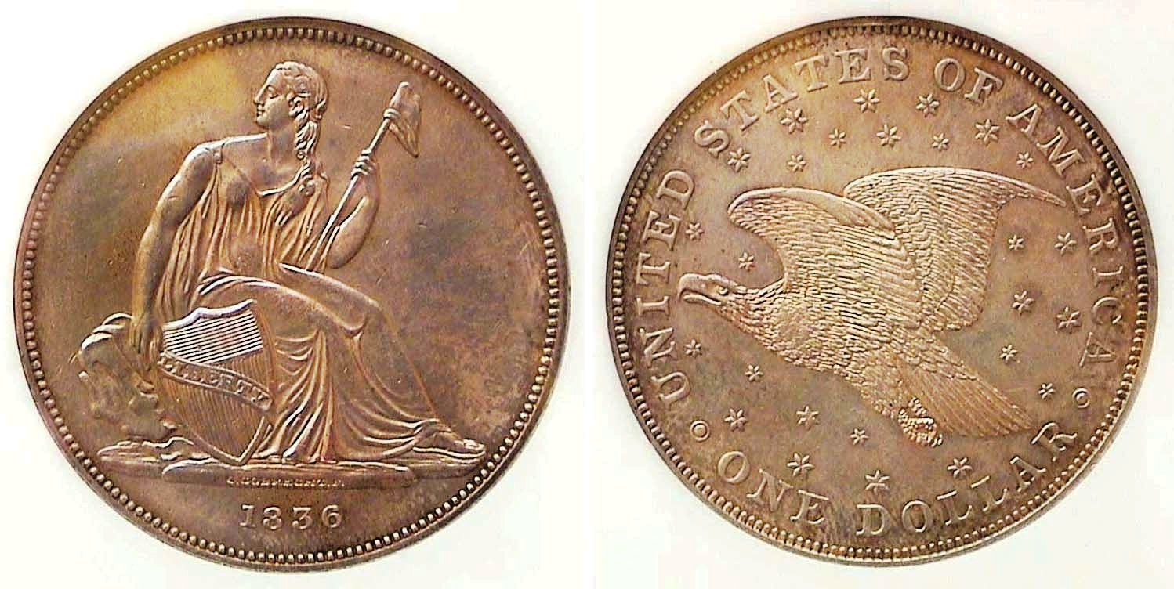
An 1836 Gobrecht silver dollar graded AU-58 by NGC
[Enlarge page to fill monitor screen or 150% to view details.]

After Robert Scot died in 1823, Christian n Gobrecht--who would later play an important part in designing the liberty Seated coinage--was hired to continue Scot’s duties. In 1824, Gobrecht was bypassed by William Kneass who was appointed as the 2nd official Chief Engraver of the US Mint. When Robert Maskell Patterson became the 6th Director of the US Mint in 1835, .he decided to replace our Bust coinage with a design akin to some of the Britannia types produced by Great Britain. He asked two major American painters, Thomas Sully and Titian Peale to make drafts for each side of a new dollar coin he intended to put back into circulation. From their suggestions, Kneass created his own sketch, but shortly afterwards, suffered a serious stroke, which is where Gobrecht comes back in to the picture engraving the two renowned painters’ concepts onto what would later become known as the Liberty Seated type. As the reader will observe, Gobrecht’s magnificent engraving of the first Liberty Seated dollar coin in which 1,000 were actually placed into circulation on Dec. 31, 1836 was regrettably, not the final Liberty Seated design to appear on the obverse nor would the majestic soaring eagle be seen on the reverse of any of the Liberty Seated denominations that followed. By 1838, stars were once again added and Reich’s pterodactyl type spread eagle returned to the reverse supposedly due to problems in striking.

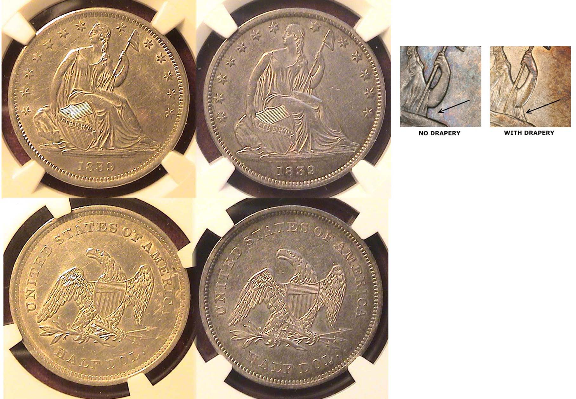
1839 Liberty Seated half-dollars with no drapery and with drapery
Graded respectively AU-53 and AU-55 by NGC
[Enlarge page to fill monitor screen or 150% to view details.]

The first Liberty Seated halves were struck in 1839. Later in the year, slightly more drapery was added to the gown just under Miss Liberty’s elbow--perhaps due to propriety--while the rock she sits on was slightly reduced in size. (See detail, above right!) Since only 100,000 were minted of the no drapery type, compared with 1,972,400 struck with drapery, the earlier type is quite rare.
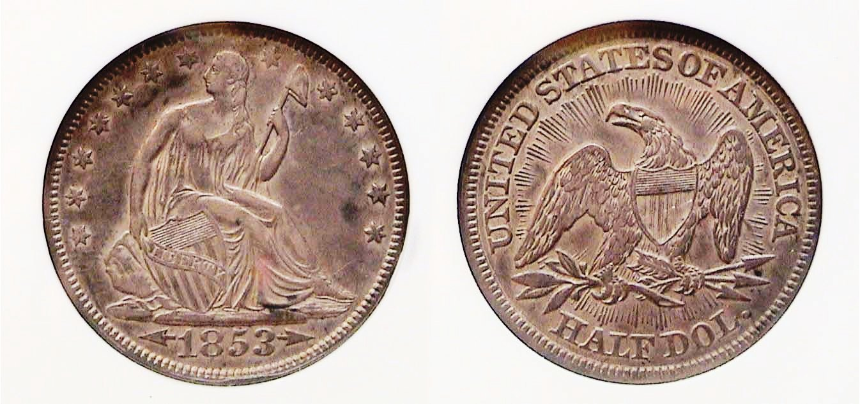

An 1853 arrows and rays Liberty Seated half-dollar
graded XF-45 by NGC
[Enlarge page to fill monitor screen or 150% to view details.]

Due to the discovery of gold in California in 1848, our silver coins became worth more than their face value. As a result, new coins were being taken out of circulation as soon as they left the mint during the early 1850s to be either be melted for profit here or sent to Europe for their greater silver value. By 1853, the coin shortage was becoming quite serious. So, on Feb. 21, 1853, Congress authorized a law reducing the silver content in our coinage. The weight of the half-dollar was reduced from 13.36 to 12.50 grams. In order to illustrate the weight reduction, James Barton Longacre--who had become the fourth Chief Engraver of the Mint upon the unexpected death of Gobrecht in 1844--added arrows around the date on the obverse on the half-dime, dime, quarter and half-dollar from 1853 thru 1855 to show the change in weight, but on the Liberty Seated quarter and half-dollar, Longacre also added rays emanating outward above the eagle on the reverse but only on the 1853 issues. These were struck in fairly large mintages with the 1853-P half having mintage of 3,532,708 and is considered very common date. Due to their popularity however, mint state specimens are priced considerably higher. Nevertheless, even an 1853 half with rays certified XF-45 is attractive as a collectible

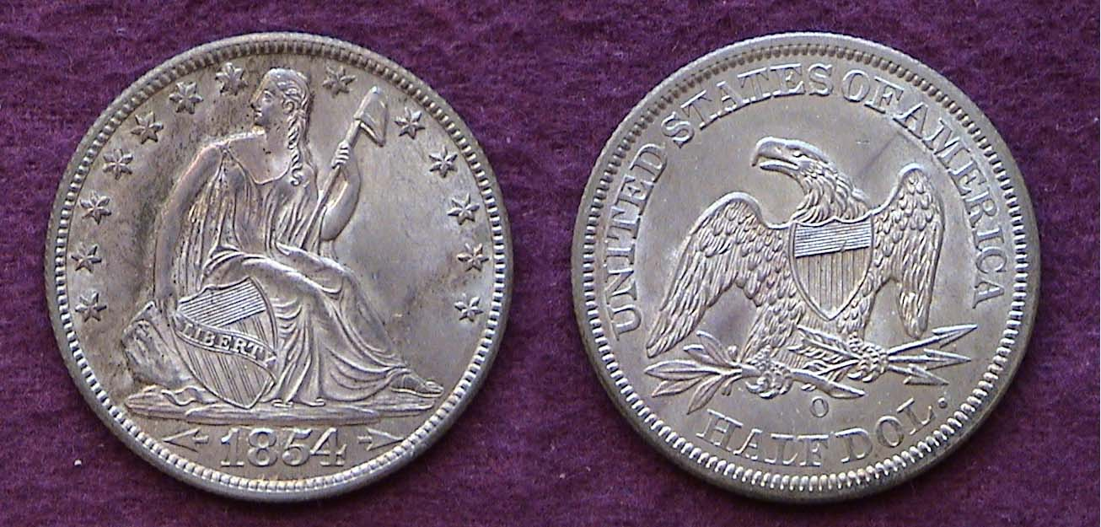

An 1854-O :ob. Std. 50c graded MS-62 by PCGS
[Enlarge page to fill monitor screen or 150% to view details.]

In 1854, the New Orleans Mint struck a total of 5,240,000 half-dollars and it is considered one of the more common dates of the series. Notice that the arrows aside the date remain but the rays are no longer on the reverse having been removed in 1854 and ’55. The coin shown was acquired away back in July of 1985 at one of the smaller coin clubs in New Jersey which held their monthly meetings on the second Thursday of the month. The author asked the dealer if he would hold it few of days since he got paid on a Friday. He said, he was doing a show that weekend and if I showed up before 12 noon, he would hold the coin for me. Route US-1 traffic in NJ is a lot heavier compared with the same federal route in South Carolina so when the author arrived at two minutes before noon, the dealer had a big grin on his face due to a number of requests he had for the coin.
(Continued on page 3, column 1)
Collecting Liberty Seated half-dollar sub-types
(Continued from page 2, column 2)

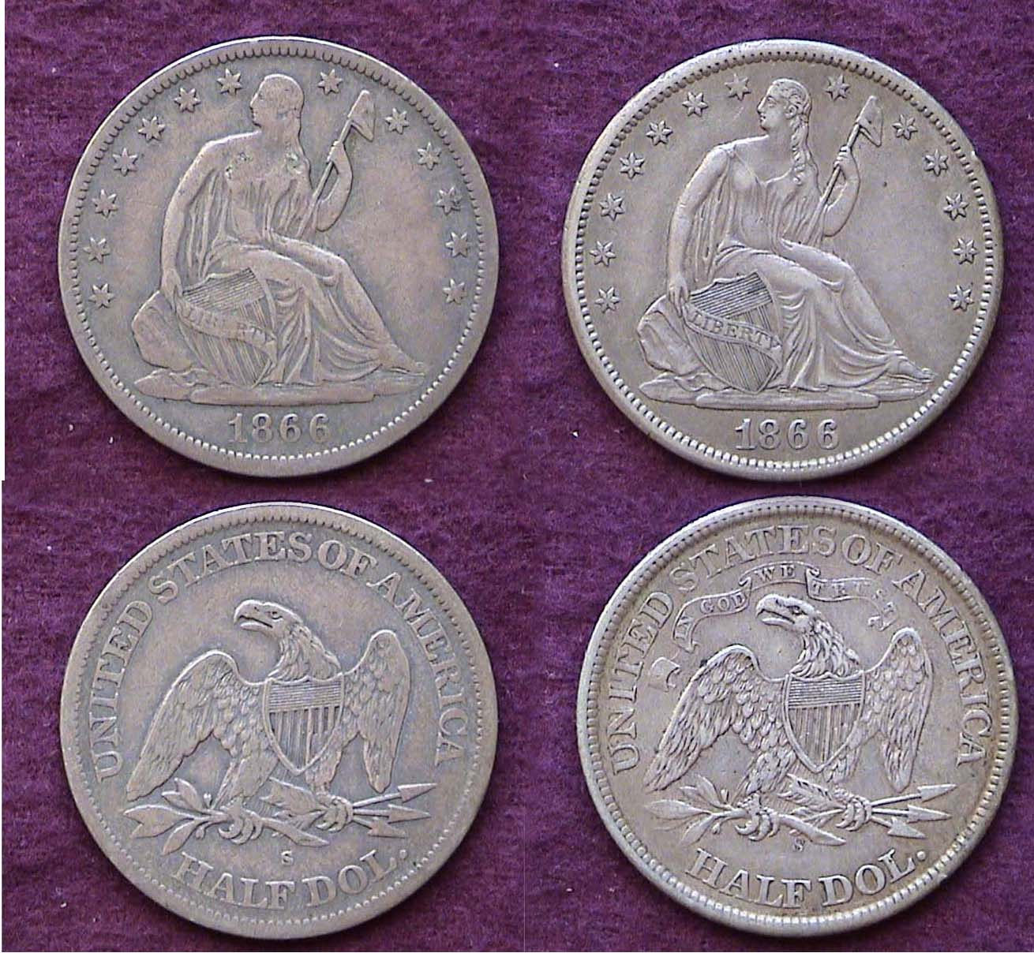

An 1866 Liberty Seated 50c with no motto and with motto
[Enlarge page to fill monitor screen or 150% to view details.]

Both these 1866 Liberty Seated halves are circulated but they make a wonderful transitional pairing. The lower grade coin at left--later certificated only VF-20 by PCGS--is quite scarce while the higher grade coin on the right, later certified in the higher XF-45- is fairy common.

In 1866, the motto IN GOD WE TRUST was inserted above the eagle on the reverse of the quarter, half and dollar denominations, but the San Francisco Mint received the news after they had already struck 60,000 coins without the motto compared with the 1866-S with-motto struck later with a mintage of 994,000. Years earlier, back in 1996, the writer had obtained the far more common with-motto version graded XF-45 for just $90.00 which is priced at around $350 today. The author--who was well aware of the rarity the 1866-S no motto-- spotted the one shown above from a dealer who specialized in Liberty Seated coinage at the ANA convention held in Baltimore back in 2003. The price was only $325. Since then, the price for the no motto variety has risen to over $1,350.

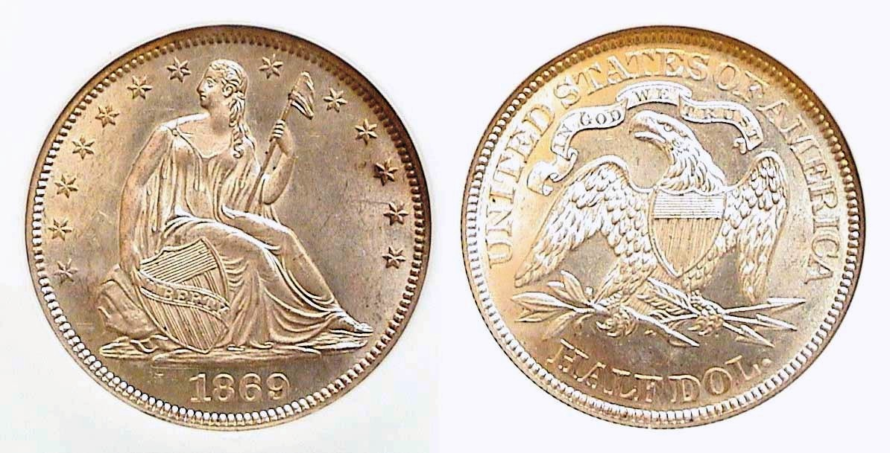

A lovely example of an 1869 Lib, Std. half-dollar certified MS-63
[Enlarge page to fill monitor screen or 150% to view details.]

Back on October 30, 2010, eleven years ago, the author with his wife attended the South Carolina Numismatic Association Convention in Greenville, S C. The city is lovely as are the restaurants, concert hall and the people you meet, The convention is always held in the final weekend of October and if you live in Aiken, it is only a one and a half hour drive to attend the show which is usually very enjoyable. It was at such an event that the author acquired the beautiful 1869 Liberty Seated half-dollar shown on the lower portion of column one of this page; a lovely well struck example. The Philadelphia Mint struck 799,300 pieces that year with 656,000 coined at the San Francisco facility; well below some of the more common dates surrounding it with mintages over a million pieces coined. Obtaining this lovely example of the 1869-P with motto half dollar was indeed a treat, especially since it has increased in value by over $800 in the eleven years since its acquisition. From 1862 through 1878 the New Orleans Mint remained closed; a casualty of the Civil War. It would not reopen again until 1879 when it produced only a limited number of gold cons and Morgan dollars at first, but no lower denominational coins until 1892, the year Barber silver coins first appeared.

The Liberty Seated halves of 1873

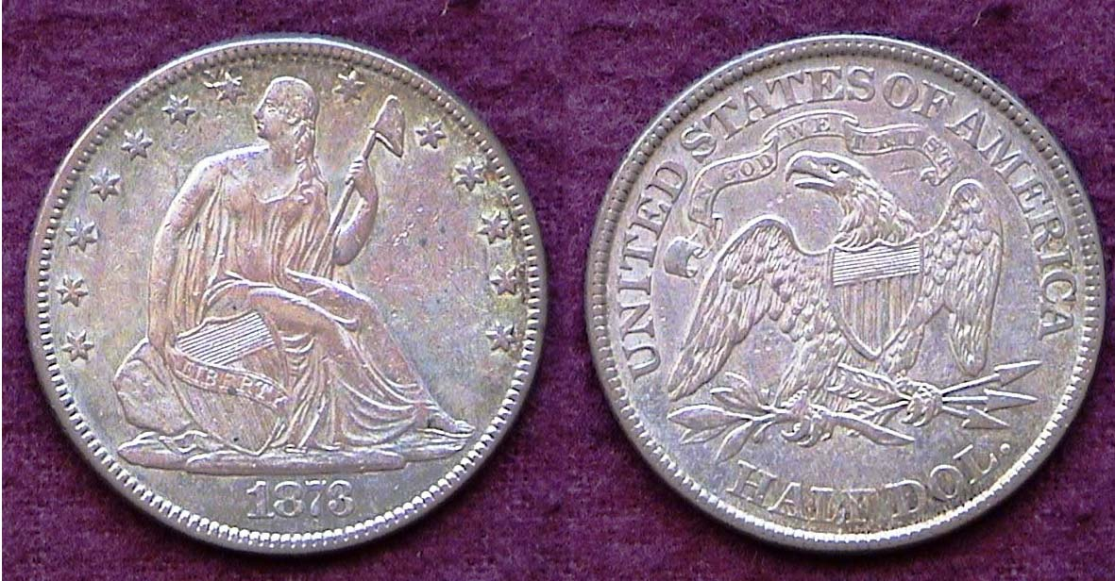

An 1873 Liberty Sealed half with no arrows and closed 3,
WB-104, R4 graded XF-45 by PCGS

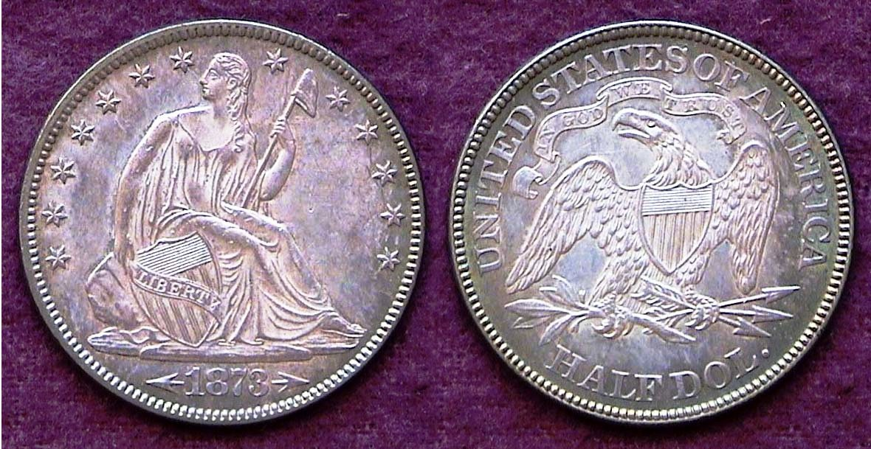

An 1873 Liberty Sealed half with arrows and closed 3,
WB-106, R3 graded AU-55 by PCGS

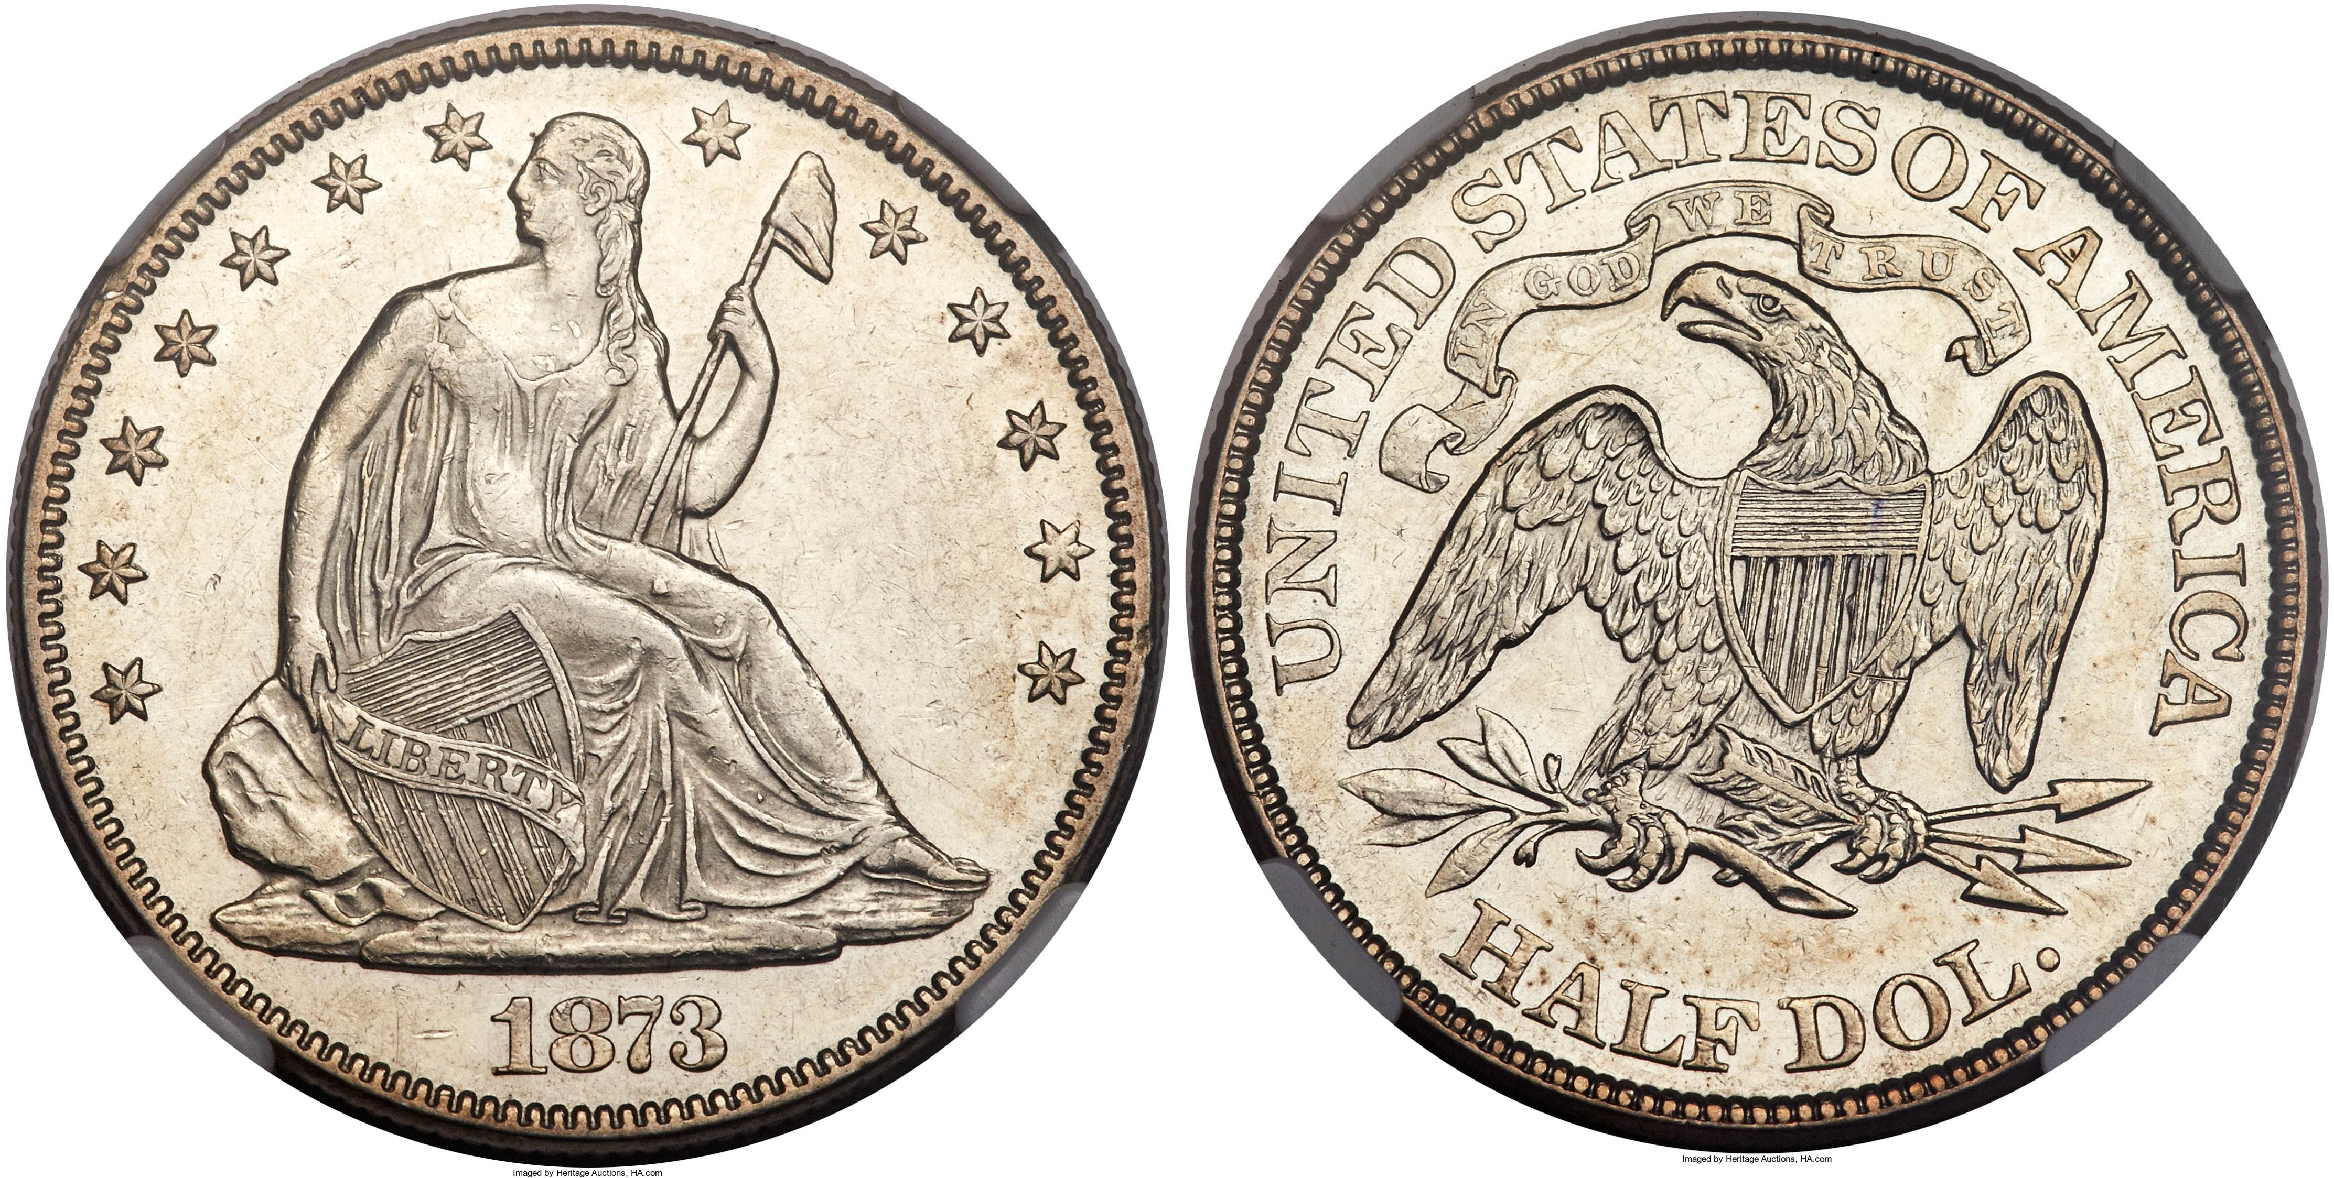

The very rare 1873 no arrows with open 3 in date graded AU-55,
(courtesy of Heritage Auction Archives)

If 1816 was the only year with just one coin appearing with that date, the coinage of 1873 represented the most, 17 including a large number of varieties and transitional dates. As for the Lib. Std. half-dollar denomination; in 1873, the weight was increased from 12.44 to 12.50 grams on the half-dollar and like 1853, arrows were placed around the date in both 1873 and 1874 to indicate the change. But, since the initial 3 in the date appeared closed, resembling an 8, the Mint also widened the spaces within the numeral three. 1873-P halves with no arrows showing an open 3 in the date are very rare today, however!
(Continued on page 4, column 1)
Collecting Liberty Seated half-dollar sub-types
(Continued from page 3, column 2)

The Bland Alison Act of 1878’s influence
on the Liberty Seated half-dollars

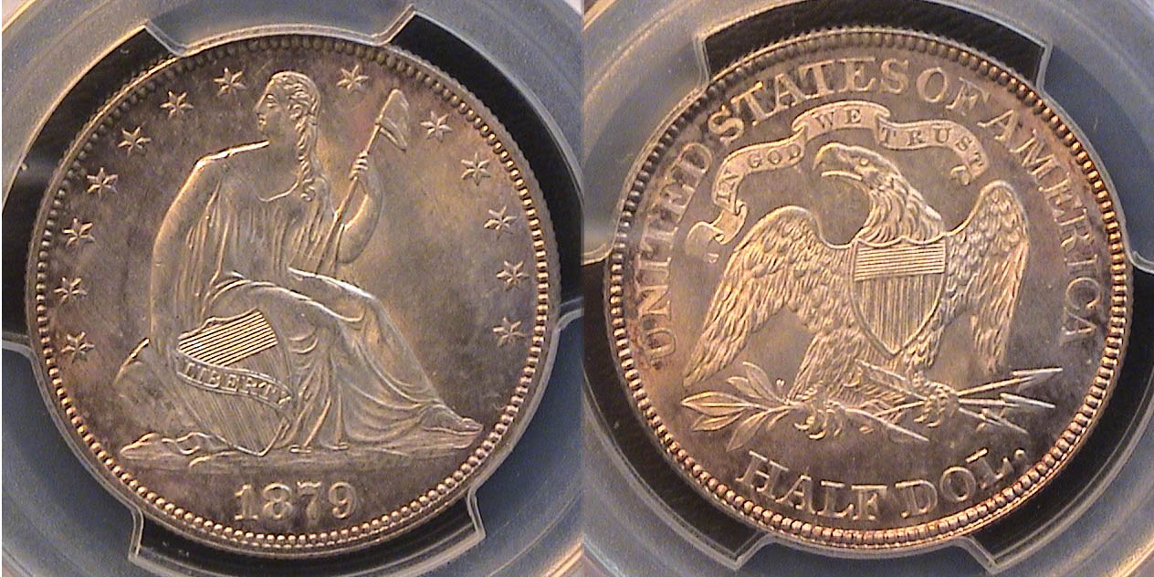

An 1879 Liberty Seated with arrows 50c graded MS-63 by PCGS
[Enlarge page to fill monitor screen or 150% to view details.]

Between 1874 and 1877, the only silver dollars struck for circulation was the Trade dollar of which no more than five of them were considered legal tender since the original function for their existence was to be used for trade with the orient, namely, China. This did not sit well with the large western silver mining companies, who wanted to increase their sales of silver. As a result, Congressman Bland of Missouri and Senator Allison of Iowa pushed through a bill in which two to four-million dollars would be struck in the shape of silver dollars by western miming companies, which is why so many Morgan dollars were coined between 1878 and 1904 due to the greater amount of their silver content at the expense of the quarter and half-dollar denominations, especially during the 1880s.
As a bone to collectors the Treasury allowed the Philadelphia Mint to strike a small number of Liberty Seated quarters and halves between 1879 thru 1890. During this period the number of business strike halves seldom rose above 5,000 with just 4,800 struck in 1879, but unlike the proofs, a far greater number of these circulated. The 1879 MS-63 Liberty Seated half shown above was saved but it was more costly than an 1879 proof although less expensive than the low mintage business strikes coined during the 1860s and early 1870s.

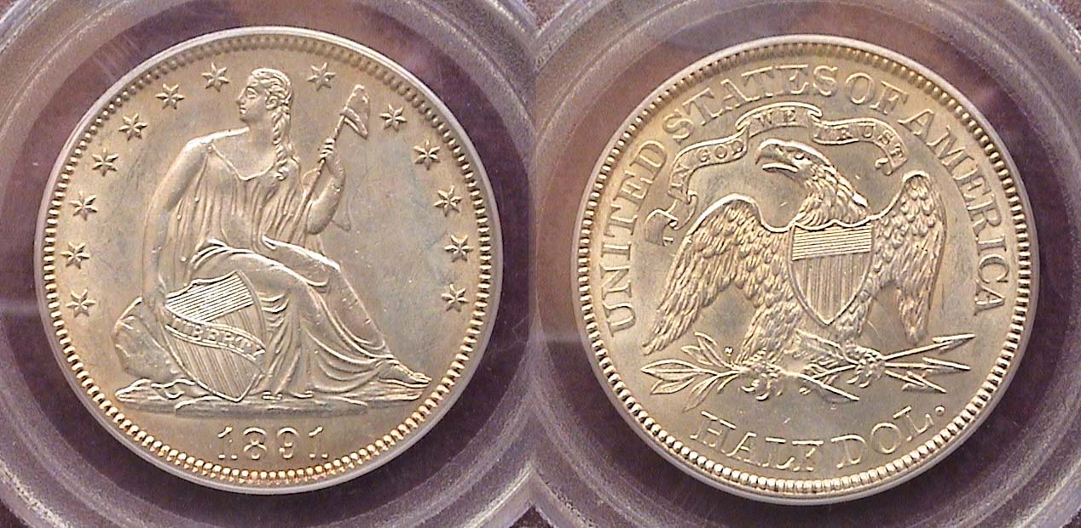

An 1891 Liberty Seated half-dollar graded MS-62 by PCGS
[Enlarge page to fill monitor screen or 150% to view details.]

In 1891, only 200,000 half-dollars were placed into circulation yet was the largest number since 1878-P and the entire 1879 thru ’90 group. The 1891 Liberty Seated certified MS-62 by PCGS shown directly above was acquired at the FUN Show back in Jan. 2009 but despite the lower uncirculated grade, it has the appearance of an MS-64 and quite possibly, if resubmitted in the current numismatic market, might be graded accordingly. The half-dollar was the only silver denomination that retained Gobrecht’s original Liberty Seated obverse design.
_______________________________________________________________________________________________________________________________

STEPHEN JAMES CSRA COIN CLUB
Regular Meeting Thursday, July 1, 2021

The Club held the July 1, 2021, meeting at the gym of the South Aiken Presbyterian Church
(SAPC). Former SJCSRA CC President and SAPC member, Steve Kuhl reserved the gym for the coin
club meetings on the first Thursday of the month for the foreseeable future (meetings will also be online
via Zoom). The site proved to be ideal for the coin club meeting which had 17 members in attendance.
There were also three members attending via Zoom.
President J.J. Engel called the regular meeting of the club to order at 7:00 p.m. The Board has decided to resume drawing for a member door prize at meetings, and Pat James won a 2017 ¼ oz silver
Mexican Libertad.

Sgt at Arms Jim Sproull reported the upcoming area coin shows are: Summer FUN Show 2021, in Orlando, FL the weekend of July 8th – 10th ; Low Country Summer Coin Show, in Ladson, SC July 30– August 1, 2021, the South Carolina Numismatic Association’s 49th Convention and Show October 29– 31, 2021, in Greenville, SC, and Camden Coin Show in Camden, SC on September 18, 2021.

A motion was made by Marion Engel and seconded by Willie Simon to dispense with the reading of the June 2021 meeting minutes. A copy of the June 2021 Meeting Minutes will be on file with the other club records, and a copy will appear in the club newsletter.
Treasurer Chuck Goergen reported the Club’s July 2021 bank balance was $1,104.29.

Old Business :
President Engel said the Board had selected the SAPC gym for future meetings, but he wished to thank Glenn Sanders, Sonia Hillman and Jim Mullaney for locating and proposing alternate sites. JJ said that in his last conversation with the Aiken Library staff they were very vague about when the coin club might be able to return to the Library for meetings.

New Business:
President J. J. Engel reported that the August meeting’s program would be on Hobo Nickels given by Kelsey Forde. On behalf of his church, SAPC, Steve Kuhl welcomed the Club to its new meeting site and also
spoke about the speakers at the SCNA Convention. At the SCNA Convention Steve will present his
program, South Carolina Blue Ridge Rail Road Scrip, which he presented to our coin club in March 2021. Steve also mentioned the SCNA gold coin raffle and great YN Program with YN exhibits which will be at the Convention in October. Steve also brought some ANA award-winning SCANNER publications to share with the members who might not be SCNA members who get their own copies.
_______________________________________________________________________________________

(The Minutes continue on page 5, column 1)

STEPHEN JAMES CSRA COIN CLUB
Regular Meeting Thursday, July 1, 2021
(Continued from the previous page)

Show & Tells:

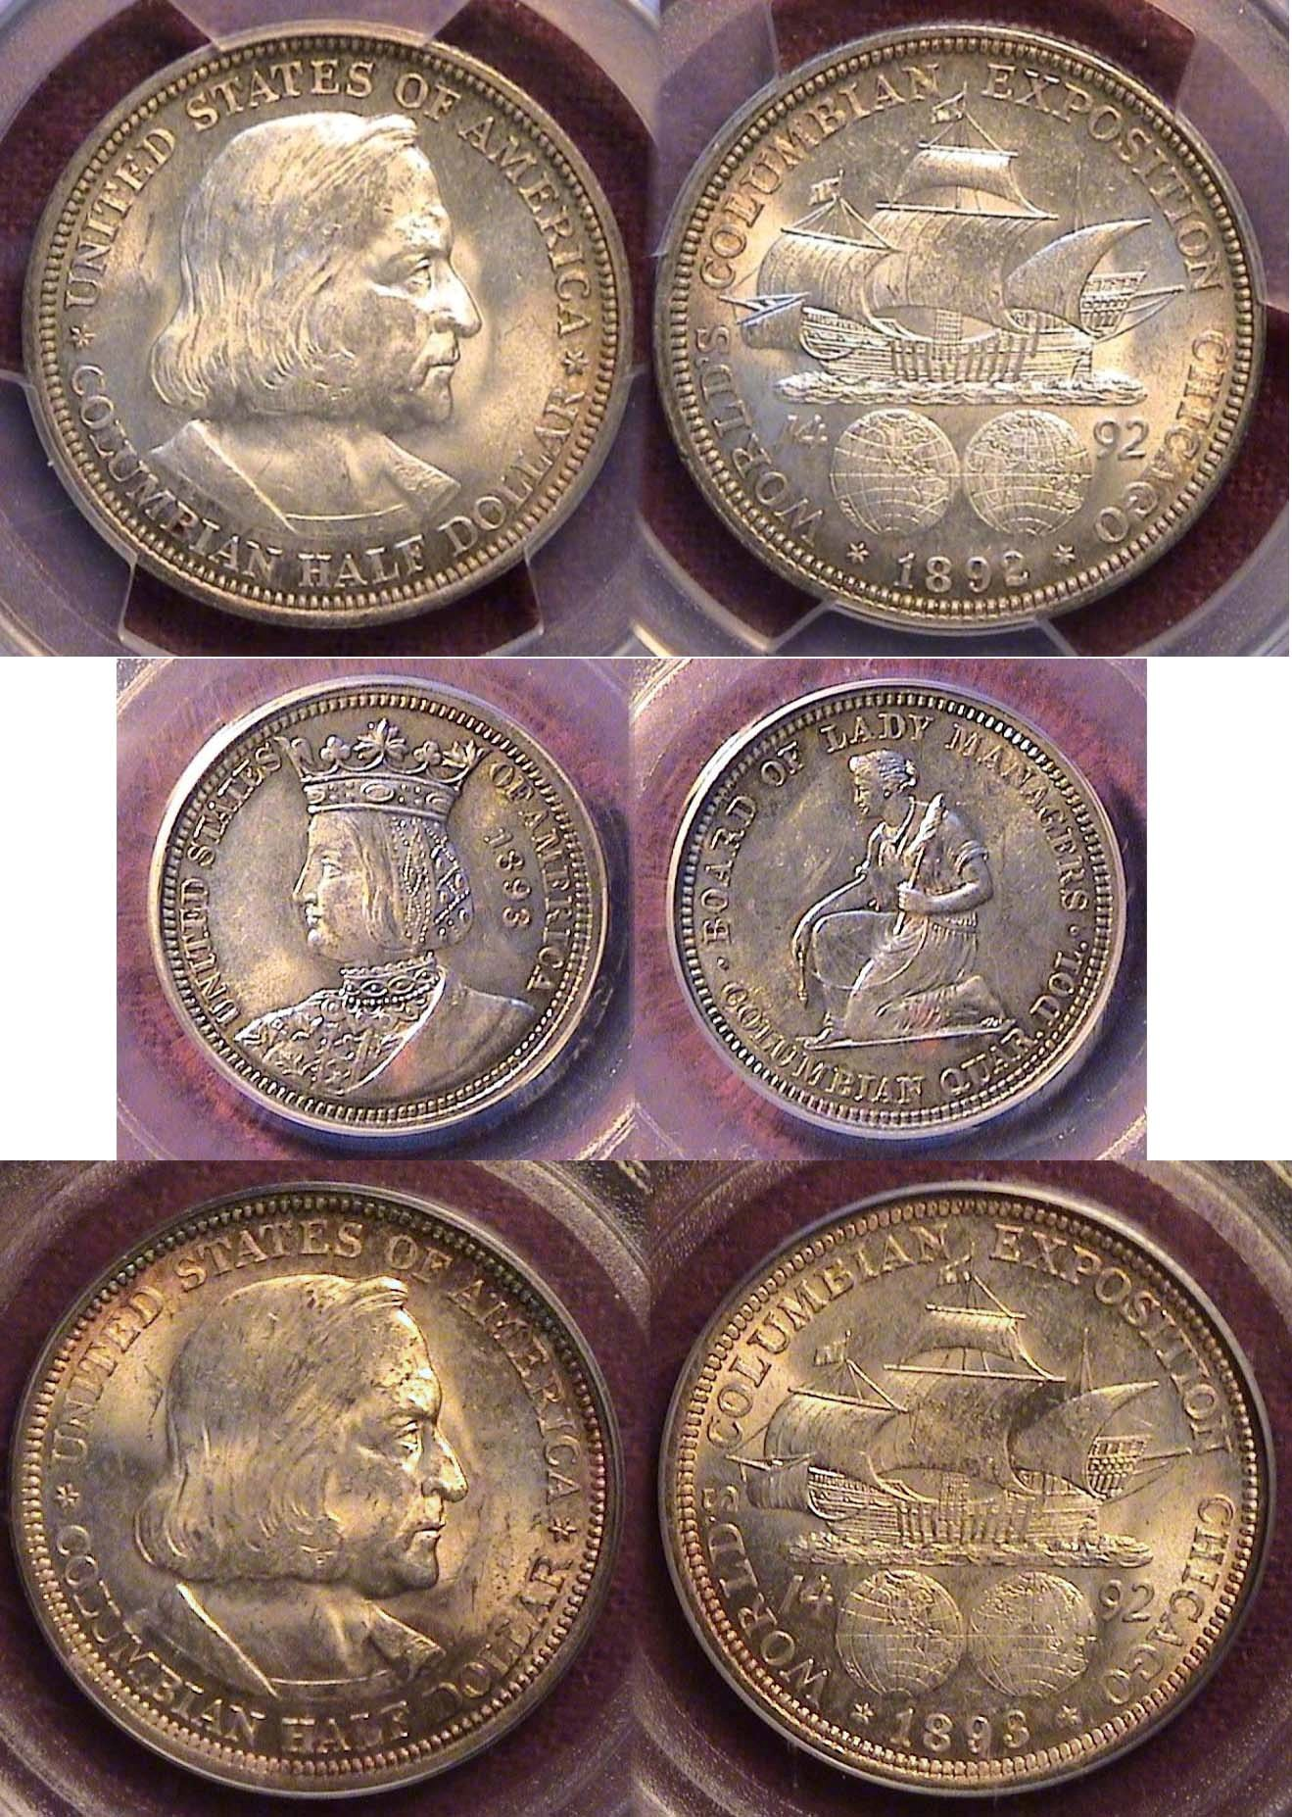

1892 Colombian half-dollar certified MS-64 above
1893 Isabella Quarter certified MS-62 over
1893 Colombian 50c certified MS-63 by PCGS
[Enlarge page to fill monitor screen to view details.]

Arno Safran shared three PCGS graded 1892 and 1893 Columbian Exposition Commemorative silver half dollars. They were beautiful examples of these still popular 90% silver coins produced to commemorate the 400th anniversary of Columbus’s voyage as well as the World Columbian Exposition, also known as the Chicago World’s Fair. Arno further related that these coins, de-signed by Charles E. Barber, were the first commemoratives made by the US Mint and they sold in 1893 at the Chicago World’s Fair for $1.00 each.

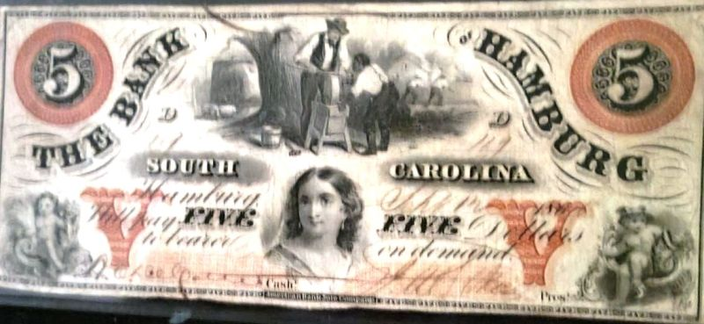

A $5.00 obsolete currency note issued by the Bank of Hamburg, SC

John Kolmar brought in an obsolete Bank of Hamburg $5.00 note in wonderful condition and he
shared some history of the note and the town of Hamburg, SC. John described how Henry Schulz was the driving force in the founding of Hamburg in 1821, largely because he felt he was treated unfairly by Augusta. Schulz built the first successful bridge across the Savannah River at Augusta, and for a time Hamburg was the western terminus of the SC Rail Road until a rail bridge was built in the 1850s. Due to various economic factors, Hamburg had become virtually a ghost town by the time of the Civil War.

The July program,

The Dahlonega Mint and The Gold Museum, was presented by Steve Kuhl. Steve related that in November, 2020, he and his wife, Crissy, made the three-hour trip to Dahlonega, GA, to tour the Dahlonega Museum and learn about the Dahlonega Gold Rush, Mint and Museum. Steve said he learned that twenty years before the 1849 gold rush in California, thousands of prospectors flocked into north Georgia.

The story goes that gold was discovered by accident in an area now known as Dahlonega GA. By late 1829, north Georgia--known at the time as part of the Cherokee Nation--was flooded by thousands of prospectors. Within one year’s time some 15,000 miners had rushed to find some gold for themselves.
Gold rush towns sprang up quickly in north Georgia, and trade in the region suffered from a limited circulation of currency. Merchants wanting immediate payment for goods in cash or gold were determining the value of the gold.

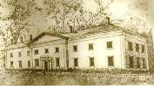

The Dahlonega Mint
It was apparent that the miners needed a local mint where they could have their gold assayed and exchanged for gold coins. Congress soon authorized the establishment of the federal Branch Mint at Dahlonega, which opened in 1838. It coined more than $100,000 worth of gold in its first year, and by the time the Dahlonega Branch Mint closed in 1861with the start of the Civil War, it had produced almost 1.5 million gold coins with a face value of more than $6 million.

`Steve noted that Dahlonega-minted coins stood out for their distinct color – which was due to the
purity of the gold from the area. Steve explained that the gold rush was one of the major reasons behind the removal of the Cherokee Indians from north Georgia. In 1830 the U.S. Senate had passed the Indian Removal Act
granting the President authority to negotiate treaties that swapped Indian lands east of the Mississippi River for reservations in the West and money.
____________________________________________________________________________________________________
(Club minutes continue on page 6, column 1)
STEPHEN JAMES CSRA COIN CLUB
Regular Meeting Thursday, July 1, 2021
(Continued from the previous page)

Because of the huge encroachment of the whites due to the discovery of gold on the Cherokee land in north Georgia, factions of the Cherokee Indians, believing the Cherokee would eventually lose their lands and removal was the only way to preserve the Cherokee Nation status entered into the Treaty of New Echota, which was ratified in 1836.
The Treaty of New Echota gave the Cherokees $5 million and land in present-day Oklahoma in exchange for their seven million acres of ancestral land. By May 1838, only 2,000 Cherokees had moved voluntarily, and the
federal government sent 7,000 soldiers to evict the remaining Cherokees.

The 1,200-mile trek, begun in October 1838, lasted six months. Along the way, an estimated 10 to 25 percent of the tribe died of disease, starvation and exhaustion. Due to the misfortunate’s suffered on the trip west, the route of the journey became famously known as “The Trail of Tears”.

Steve further related that by the early 1840’s the reason for both the establishment of the Dahlonega Mint and the removal of the Cherokee Indians was disappearing because the gold was playing out. It was difficult for the miners to make a living washing the placer deposits and veins of quartz containing gold were harder to mine. In 1849, word of the California gold strikes reached the miners in Georgia who left in huge numbers.

The Dahlonega Museum is housed inside the 1836 Lumpkin County Courthouse, which is on the
National Register of Historic Places. Steve said they especially enjoyed seeing a complete set of gold
coins from the Dahlonega Mint.
​
Steve’s informative power-point program was the fourth in his Numismatics in “Our Neighborhood series”.
Members enjoyed becoming acquainted with another place of numismatic significance in our neighborhood that they could easily travel to. The others were the Bechtler Mint in Rutherford, Georgia, the Merchants Bank of South Carolina in Cheraw, South Carolina, and the South
Carolina Blue Ridge Railroad starting in the Anderson, South Carolina, area. President Engel thanked Steve and said the members were eagerly looking forward to more programs in this series.

Jim Sproull won $17.00 in the 50-50 raffle drawing. An auction was held with three members
offering items and a good amount of bidding occurred.
President Engel reminded the members that the next meeting would be on August 5, 2021, and adjourned the meeting at 8:50 p.m.

Respectfully submitted,
Jim Mullaney, Secretary
Little Coin of the Month filler No. 2

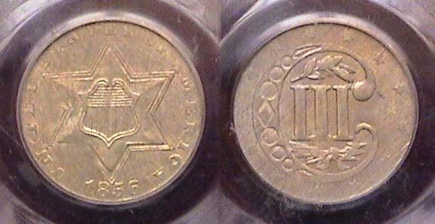

An 1856 Type 2 silver 3c trime grade AU-58 by PCGS
[Enlarge page to fill monitor screen or 500% to view details.]

One of the last coins the author acquired at a major show before the Coronavirus hit was this 1856 3c silver trime he found at a dealer’s table at the ANA show held at the Conn Galleria in Atlanta at the end of February, 2020. During the coin’s tenure (1851 thru 1873), there were three sub-types but the middle one which was struck from 1854 thru 1858-showing two lines around the star on the obverse with an olive spring over the III and three arrows below on the reverse--is the scarcer type. Regrettably, this type tended to be weakly struck as the one shown above. The coin was only 14 mm in diameter and may have been mostly used for buying a 3c first class postage stamp.
____________________________________________________________________________________________________________________
Kindly Patronize our advertisers

