Pres. Willie Simon
V .P. James Barry
Sec. Helen Barry
Treas. Pat James
Sgt. in Arms: J.J. Engel
Committees:
Auction: J.J. Engel
Programs: James Barry
Newsletter: Arno Safran
The Stephen James
CSRA Coin Club of Aiken
P.O. Box 1739
Aiken, SC 29802
Web site: www.sjcsracc.org
The SJ CSRA CC Now Meets on the 2nd Thursday of the Month at the Cedar Creek Community Center in Aiken, SC

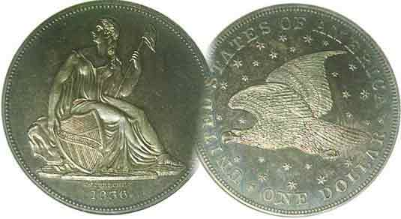

Volume 5, Number 9 the Stephen James CSRA Coin Club Monthly Newsletter September, 2006
Annual Club Show Coming Up Fast
Our Next Meeting is on the 2nd Thursday, September 14, 2006 at 7:00 PM
2006 Meeting Schedule - 2nd Thursdays at 7 PM
June 8, July 13, Aug. 10, Sep 14,
Show: Sept. 16 Oct 12, Nov 9, Dec 14_

Show Help Needed at Welcoming Desk; Raffle Sales

Club Show Chairman J.J. Engel reported on the status of our upcoming show at the August 10 meeting. As of that date 13 tables had been sold but JJ expected at least 20 to 25 dealers would be on board by Sept. 16, the date of our show. Our next meeting will occur two days prior to our annual fund raising event and President Willie Simon has asked for volunteers to help with the set-up starting around & AM on the morning of the show, to serve at the Registration Desk during the show and help take-down after. If seven different members volunteer to take turns manning the Registration desk, no one individual will have to serve more than an hour. Help is also needed selling raffle tickets. There are three “big” prizes, 1st: an Olympic Gold & Silver commemorative set, 2nd: a silver proof set and 3rd: a certified BU Morgan dollar. Sell nine in your raffle book and the tenth is yours free. If each member sells ten tickets, we will more than pay for the prizes. Donors need not be present for the 3:30 PM drawing but their name and ten digit telephone number must appear on the ticket stubs to be turned in no later than 2 PM the day of the show.

Club Business: President Simon announced that there are still some 2007 Red Books available to club members at $9.00 apiece. That’s almost $6.00 below the price you would have to pay at any area book store that carries them. A short discussion ensued on a proposal to have area dealers set up at the meeting to conduct sales before and after the business meeting and auction; something akin to a mini-bourse. We will try this idea out at the Sept. 14 meeting, so member dealers bring in a tray or two of coins to sell.

Show & Tell: There were two short “Tells” without “Shows” both on the subject of provenance introduced first by VP Jim Barry who suggested that knowing who may have owned the coin before you can sometimes provide the collector with a link to its history. Arno Safran followed up by relating how he acquired two coins he failed to win at the Jules Reiver sale.
_____________________________________________________________________________________________________________________
(Club News continues on page 3, column 2)

The Latin American Alternative: The Dominions of Spain the Portrait Coinage of Charles IIII
By Arno Safran

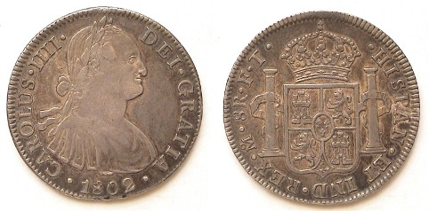

This 1802 8 Reales of Charles IIII grading VF is listed at $60.
An 1802 US Bust dollar in the same grade would cost $3,000.
Both were accepted as specie at the time of issue and circulated in the USA.

After the magnificent Pillar coinage of Philip V, Ferdinand VI and Charles III, the portrait coinage of Charles III (1772-1788) was rather disappointing aesthetically. When Charles III died in 1788, his portrait continued to appear on Latin American coins dated 1789 and 1790. During these transitional years; the inscription was changed from Carolus III to Carolus IV and finally Carolus IIII. The visage of Charles IIII first appeared in 1791. The engraver(s) presented the new King in a far more attractive manner than his father. The crowned Bourbon Coat of arms appeared on the reverse as before with mint mark and engravers’ initials updated accordingly.

While the previous king had attempted some reforms, his son Charles IV--who was not overly bright--allowed his wife (and first cousin) Queen Maria Louisa of Palma and her lover Manuel de Godoy to run the affairs of state; a situation that would eventually prove a disaster for Spain. The reign of Charles IV encompassed the French Revolution near its beginning and ended with his abdication to his son Ferdinand VII in 1808 during the height of the Napoleonic wars. He lived in exile in France and later in Rome where he died in January of 1819.

Under the aegis of the Dominions of Spain, the
__________________________________________________________________________________________________________
(Continued on page 2, column 1)
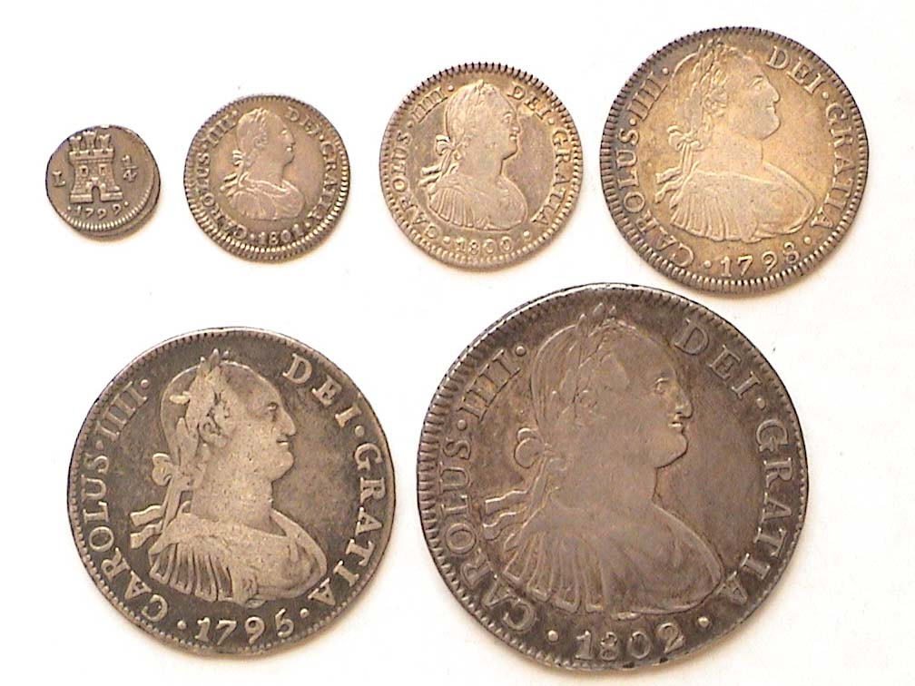

The Six denominations of Charles IV coinage
From top left: Obverses of 1799 ¼R, 1801 ½R, 1800 1R & 1798 2R
At bottom from left, 1795 4R and at right, 1802 8R
Magnify up to 150% to observe an L for Lima, Peru Mint on the ¼ Real

The Latin American Coinage of Charles IV
(Continued from page 1, column 2)

Hispanic American coinage of Charles IV was struck in prodigious numbers that included Mints in Mexico City, [Mo] New Guatemala, [NG], (Guatemala City today), Popayan, Colombia, [P] rare; San Luis Potosi, Bolivia, [PTS monogram] Lima, Peru [L] and Santiago, Chile [So]. As the leading world silver trade coin of the colonial era, millions of 8 Reales were produced in most mints dwarfing those of our Bust dollar (1795-1803) with which these coincided. As a result, a Charles IV portrait dollar grading Choice VF today sells for around $60 compared with a US Bust dollar valued at $2,500 to $3,000 in the same grade.

The Quartillo: The silver coinage of Charles IIII continued the tradition established by Charles III; all featuring the same portrait of the King on the obverse with the Pillars of Hercules and Bourbon Coat of arms on the reverse, but in addition to the ½ Real, Real, 2 Reales, 4 Reales and 8 Real, a new silver denomination was added, the tiny quartillo or ¼ Real. Due to its small size the obverse featured a castle with a mintmark at left and the fraction ¼ at right accompanied by the date below. The reverse displayed a solitary lion. All silver coins were struck in .896 silver and were legal tender in the US until 1857.

Valuations: At the time of issue the three upper denominations; (the 8R, 4R and 2R) were equivalent in value to our silver dollar, half dollar and quarter respectively. The two lower ‘fractional’ denominations; the Real which was worth 12½¢ and the half Real, 6¼¢, were usually accepted slightly below their nearest US counterparts if no US half cents were available; (i.e., a dime or half dime.) In the unlikely event that the tiny quartillo--worth technically 3&1/8¢--surfaced in the US, it may have been accepted in change for three large cents. Today, an example of all six Charles IV Latin American denominations would sell for a mere fraction of their US counterparts even though the minor coinage is not as common as once thought._

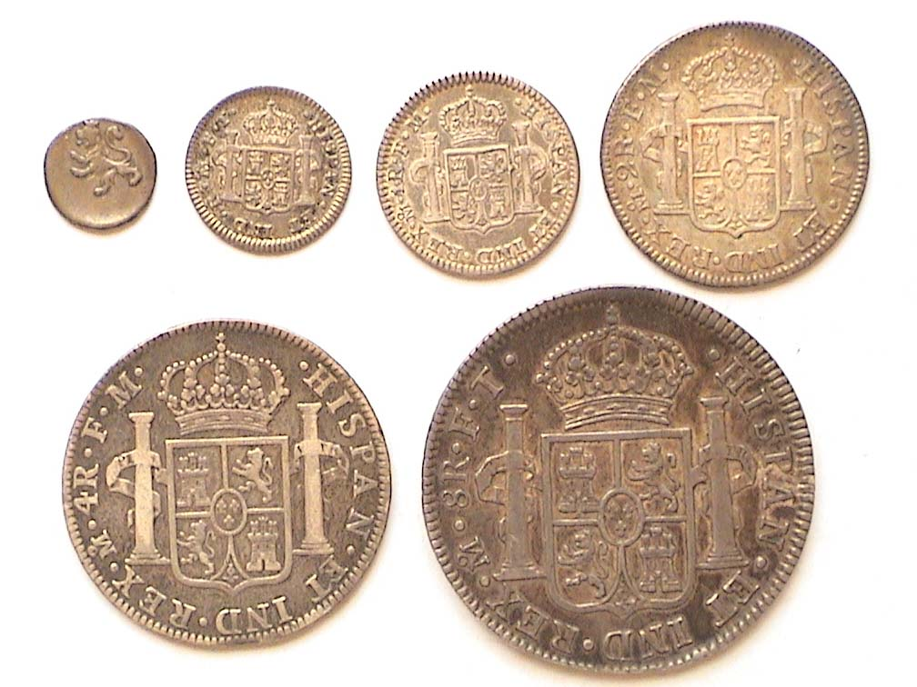
The reverses of Charles IV Latin American coinage
With the exception of the ¼R at top left which bears the figure of a lion, the other five displays the crowned Bourbon Coat of Arms surrounded by the Pillars of Hercules.

Of the six Charles IV silver denominations, the 4 Reales is the least common. These seldom surface in VF or better and when they do the can be expensive. A specimen like the one shown above grading Fine might sell today for around $75 according to the latest Standard Catalogue of World Coins edited by Chester Krause, Clifford Mishler and Colin Bruce II. By comparison, a 1795 Flowing Hair US Half dollar in the same grade is currently listed in the Coin World’s latest Coin Values (nee Tends) at $3,000.

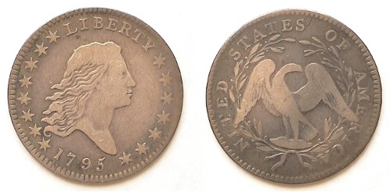

A 1795 Flowing Hair Half Dollar, O-102 R4 grading Fine

Since much of the Latin American coinage of Charles IV of Spain was struck concurrently with early US coinage more comparisons are worth studying. An 1800 Charles IV real grading XF is listed at only $60 in the Standard Catalog of World Coins under Mexico. By comparison, an 1800 Draped Bust dime certified VF-30 today retails for over $2,000.

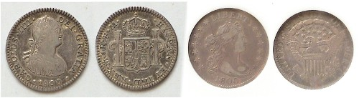

Left, an 1800 Mexico Chas. IV Real; Right, an 1800 Draped Bust dime
Magnify up to 200% to see details more clearly.

The Coinage of Charles IV (Continued from page 2, column 1)

The sobriquet, “two bits” derives from two segments of silver cut from an 8 Reales Piece of Eight and later from the Spanish 2 Reales struck for the Hispanic American colonies under the Dominions of Spain. The 2 Reales coins circulated extensively in early 19th century US commerce; perhaps the Charles IV, the most. Today, they surface less frequently at the major shows; especially above VG. What has happened to them? Finding a Choice VF is still possible but becoming more of a challenge. If one were to compare today’s prices for a Charles IV 2 Reales with that of the least expensive US quarter of the period; say an 1806, the disparity in cost would be no less astonishing than the other denominations.

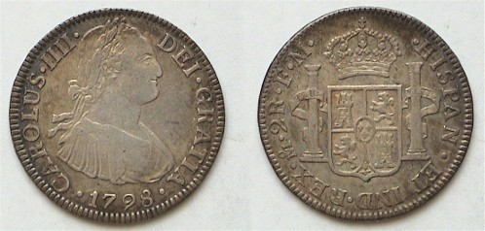

A 1798 Chas. IV 2 Reales in Choice VF – Value $50 today
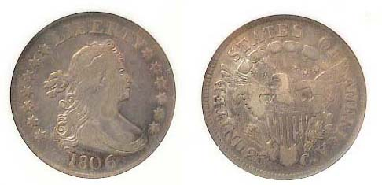
A 1806 Draped Bust Quarter in Fine-12 – Value $600 today

The 1798 Mexican 2 Reales is listed at $30 in VF and $85 in XF while the 1806 Draped Bust quarter is listed at $600 in Fine-12 and $1,000 in VF-20. The writer obtained his two specimens back in the early 1990’s when prices were less; paying $40 for the 1798 2 Reales as a Choice VF and $240 for the 1806 25¢ certified by Anacs as a Fine-12.

When one compares the small size half real with our early Draped Bust half dimes, the disparity in price is even greater. The 1801 FT Charles IV Half Real is listed at $22 in VF and $45 in XF. (The engravers’ initials FM are more expensive.) For the low mintage Draped Bust half dime series (1800-1805) the most common is the 1800 issue. Even in Fine-12, that date is listed at a whopping $1,800 according to Coin World’s latest Coin Values monthly supplement. There is no equivalent in US silver coinage for the ¼ Real.

The Latin American coinage of Charles IV makes for a handsome set of inexpensive silver coins that were possibly more recognizable to our early US ancestors than the small number of US coins being struck at the Philadelphia Mint. Back then, most basic goods sold for less than $1.00 or 8 Reales. [A meal at an Inn cost 15¢.] Our large cents and half cents along with the Real and 2 Reales were the work horses of our pocket change during the Charles IV era and the administrations of our first three Presidents; Washington, Adams and Jefferson.
___________________________________________________________________________________________________________________
_
More Club News (Continued from Page 1, column 1)

Bill Myers Presents Program

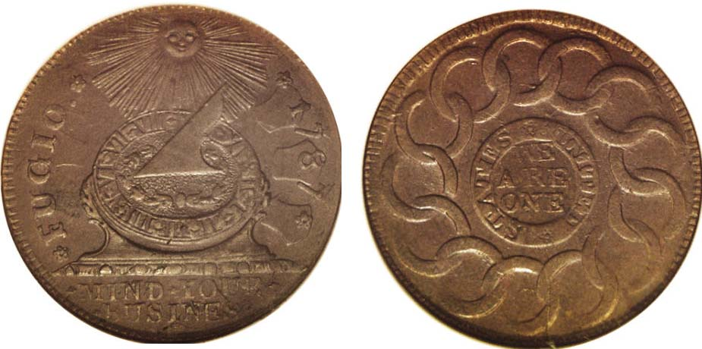

A 1787 Fugio Cent [Newman variety 11-X R4] NGC MS-64
(Courtesy of Heritage Auctions Archives)

In honor of the 300th anniversary of Benjamin Franklin’s birth year, member Bill Myers presented a PowerPoint program on the Fugio Cent, a colonial copper coin about the size of our large cent that had been the brainchild of Franklin’s. Bill explained how the original contractors for the coin got themselves into a lot of legal trouble due to some chicanery involved with the coin’s weight, amount of copper, minting practices and distribution. He described the coin’s obverse as featuring the design of a sun dial that had originally appeared on the 1776 Fractional Continental Currency notes valued at one-sixth and one-third of a dollar as well as he 1776 Continental Pewter dollar coin but with a number of differences. On the Fugio Cent, the sun appears directly above the sun dial, its rays spreading outward and downward towards the Roman numerals forming the face of a clock that is on its side. The date 1787 is on the right with the word FUGIO--which idiomatically means “Time flies”--on the left. Below the sun-dial is the motto, MIND YOUR BUSINESS. Bill explained that this inscription was never intended as an insult but as a slogan implying the integrity and productivity that comes from monitoring one’s industry.
The speaker described the reverse of the Fugio Cent as having concentric rings with the legend UNITED STATES separated by two stars at its core encircling the motto WE ARE ONE. Surrounding these were the thirteen intertwined rings but without the names of the states that originally appeared on the Continental dollar of 1776. Bill showed examples of his own original certified NGC XF-40 specimen along with a Gem Red BU Gallery Mint Museum example at a fraction of the original but with the word COPY incused on the reverse placed below the central rings. He also displayed a cast copy of the Continental dollar without the word COPY; the replica having been made prior to the 1973 law. Bill also spoke about surviving hoards of Fugio cents that have since been dispersed into the coin collecting fraternity. The club thanks, Bill for a most informative presentation.
In other club news, Glenn Sanders announced an upcoming show in late August by the Low Country Coin Club. Jerry Axner donated coins for the Young Numismatists’ grab bag. Thanks, Jerry! Winner of the door prize was Paul Simon and Helen Barry won the 50/50. Congratulations go out to both!
x
At the September 14 meeting, Arno Safran will be presenting a PowerPoint program on US Coins By the Sixes (I). As this will be our last get together before our show it will be an important meeting. Hope to see you all then.
________________________________________________________________________________________________________________________

GERMAN EAST AFRICA – World War I
By Bill Myers

A coin is more then a chunk of metal that represents a value to be used in commerce. It is a piece of history that has a story to tell. I acquired two 1916 20 heller pieces from German East Africa (GEA). They are relatively crude coins, with unimpressive designs and somewhat irregular shape. They wouldn’t attract much attention, not even in a junk box. Yet these coins represent a World War, an undefeated German force and a warship.

The countries of Europe had begun carving up Africa by colonization and Germany obtained control of East Africa by treaties in 1885. It included portions of present day Rwanda, Burundi and Tanzania. When war erupted in Europe in 1914, German East Africa was surrounded by its enemies.

Col. Paul von Lettow-Vorbeck was in charge of the military in GEA at the time. Since the Allies surrounded him, he was under siege. The Imperial German Navy cruiser SMS Konigsberg was stationed in GEA. It had a short life as a raider, but due to fuel shortage and mechanical failures was forced to hide in the Rufiji River delta. The enemy located the ship and severely damaged it and the Germans scuttled the ship. Col. von Lettow-Vorbeck with a total force of 14,000 men opposed an enemy force of 373,000. With no more than 4,000 troops at any one time, he led a guerilla war against the Allies. The Allies chased von Lettow-Vorbeck across East Africa and suffered thousands of casualties as a result, many from disease. Col. von Lettow-Vorbeck was never defeated and only surrendered after the surrender of Germany.

While fighting the enemy, Col. von Lettow-Vorbeck set up a mint in Tabora. There was a severe shortage of most materials, so one of the brass guns from the SMS Konigsberg was melted down to provide metal for coins. Scrap copper and brass from such items as spent cartridges, wiring, and household items were used for the coins as well.

The mint produced three denominations of coins and all are dated 1916 and have the “T” (Tabora) mint mark. The 5 heller is made of brass. The obverse has a crown over “1916 D.O.A” (Deutsch Ost Afrika). The reverse has a wreath with “5 HELLER T” in the center. The varieties are an oval base and a flat base on the crown. Mintage is listed as 30,000 in Krause. Other sources reported 302,000. The 20 heller coins have a crown above “1916 DOA T” on the obverse and a wreath around “20 HELLER” on the reverse. They were produced in copper and brass. There are 2 obverse and 3 reverse varieties. According to Krause, type A obverse has a large crown and type B obverse has a small crown. Type A reverse has a curled tip in the second L of heller, type B reverse has pointed tips on both L’s and type C reverse curled tips on both L’s. All combinations are available (AA, AB, AC, BA, BB, BC) and come in copper and brass. Individual mintages are unknown, but total mintages in Krause are: copper-300,000 and brass-1,600,000 (325,940 and 1,307,760 in another source).

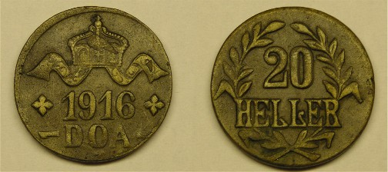

1916 GEA 20 Heller pieces – Type A

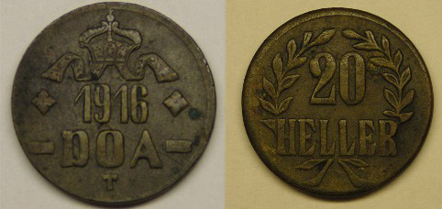

1916 GEA 20 Heller pieces – Type B
Notice the differences in the devices, numerals and lettering between A & B.

The story does not end there. A more sophisticated minting device located in a train carriage was used to mint gold 15 rupien pieces. The coins were of a high quality, considering the conditions under which they were minted. The obverse has a trumpeting elephant in front of Mount Kilimanjaro above the date “1916 T”. The reverse has the German Imperial eagle with “DEUTSCH OST AFRICA 15 RUPIEN” around the rim. There are 2 reverse varieties. They vary in the position where the right arabesque (ornate design) extending from the wing of the eagle ends. In Type A it is under the “A” in Afrika and in Type B it is under the “T” in Ost. The mintage listed in Krause for Type A is 6,395 and Type B is 9,803. Other sources list Type B mintage as 9,035.

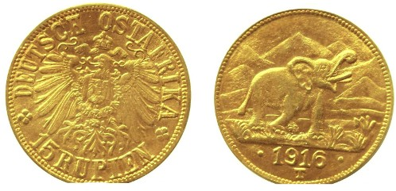

A 1916 15 Rupien Gold GEA coin

Each coin has a story and the GEA coins of 1916 have a rather involved and interesting one to tell.
____________________________________________________________________________________________________________________________
Member Bill Myers is an orthopedic surgeon serving both the CSRA and the military at Fort Gordon with the rank of Colonel. He recently learned that he has been reactivated for duty in Iraq starting late September. The club wishes Bill a successful tour of duty and a safe return.
________________________________________________________

Don’t forget, our Show is coming up fast; Saturday, Sept. 16. 9:30 AM to 4:30 PM
H. Odell Weeks Activity Center on Whiskey Rd. (Rte. 19) across from Home Depot
Raffle Drawing at 3:30 PM
Please sell those raffle tickets and thanks!

__________________________________________________________________________________________________________________

Fish scales or the Story of the Trime
Our first 3¢ Coin By Rich Baker
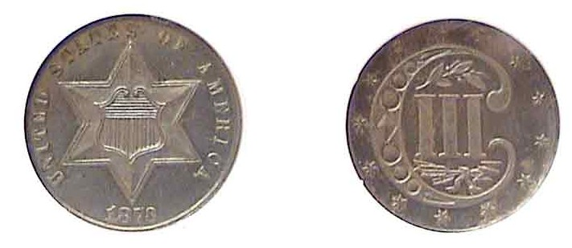

An 1873 3¢ silver Proof Trime; the final year of issue (Actual size).
Increase magnification to 200% to better view the coin’s details.

There were three events in American history that collided in the l840's to bring about the three cent coin. These were the gold rush, the burgeoning railroad system and the circulation of foreign small change in the United States. The gold rush of 1848 provided new supplies of gold, which due to supply and demand, reduced the gold price in relation to silver. This made silver more attractive to speculators for hoarding and subsequent exporting. Silver coinage, which included the half dime thru dollar, was being hoarded since their melt value was greater than the coin's value.

In the 1840's, a letter could be delivered by the US government for 5 cents for the first 300 miles. By 1851, with the advent of the railroad system and private mail carriers (competition), the US government was losing the mail business and had to due something. The Postal Act of March 3, 1851 reduced the cost of a letter from 5 cents to 3 cents for delivery up to 3000 miles. However, this also posed another problem; how to make change. Since the only change available was the large copper cents and half cents, most small denomination coinage being hoarded for their silver content, this posed a problem for merchants to make change. Senator Daniel Stevens Dickinson of New York proposed the coinage of a 3 cent coin to alleviate the problem. At first it was feared that a silver coin would result in more hoarding like other silver coinage. That combined with the fact that many people would not take to a coin whose proposed alloy was to be 75% silver bonded with 25% copper. Despite these concerns, the new denomination and metal content was included in the Postal Act of 1851.

The series consists of three types (I, II, III) all designed by James B. Longacre. Type I, (no outline around star) was minted from 1851 to 1853. Approximately 36 million were coined. This is considered the most common variety. The obverse consists of a Union shield within a 6-pointed star with United States of America around and the date below. The reverse has a large C with Roman numeral III in the center with 13, 6-pointed stars around. The majority of the 3 cent coins were minted in Philadelphia. 1851 was the only year the New Orleans mint produced a 3 cent coin. The mint mark is located on the reverse at the opening of the C on the right.

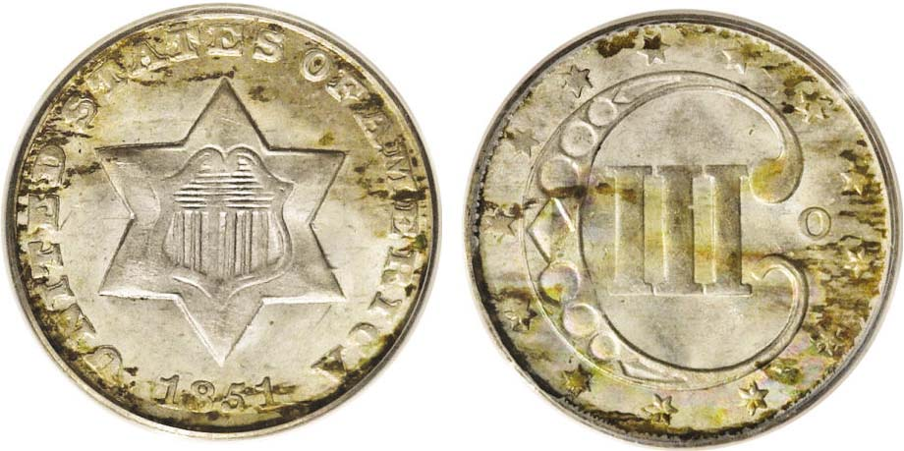

An 1851-O 3¢ silver piece graded PCGS-65
(Courtesy of Heritage Auction Archives)
The mintmark O (for New Orleans) is located on the reverse at right.
This is an example of the Type I Three cent silver piece
With no outline around the star.

The 1851-53 three cent pieces were the first coins to be worth less than their metal value (approximately 86% of face or 2 1/2 cents). The coin was 15 mm in diameter and consisted of 750 parts silver and 250 parts copper (approximately 0.6 grams of silver). Although, not the smallest US coin struck, it was the lowest silver denomination minted. [The Type 1 $1.00 gold piece (1849-54) was only 14 mm in diameter]. Another key aspect of the 3¢ silver piece is that it was the first US coin not to depict a portrait of lady Liberty or have LIBERTY inscribed on it.

The Origin of Type II Silver 3¢ Pieces

The Subsidiary Coinage Act of 1853 lowered the silver content in virtually all US silver coins by 7 percent in order to combat the hoarding and subsequent exporting of silver coinage. While reducing the amount of silver in all standard silver denominations except the silver dollar, the Mint actually raised the silver content in the 3 cent piece to 0.675 grams by increasing the silver content to .900 fine to be in line with the other silver coins of that time. The actual weight of the coin was decreased to 3/4 of a gram. Longacre added two outlines around the star on the obverse; placing an olive sprig over the III and a bundle of arrows underneath on the reverse to distinguish the higher silver content from the Type I pieces.

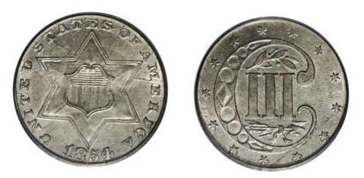

An 1854 3¢ silver piece Type II (Double outline around star) PCGS-65
(Courtesy of Heritage Auction Archives)
Magnify up to 200% to observe the subtle additions of the two olive sprigs inserted inside the ornate C above and below the III on the reverse.

Type III: In order to improve the striking effectiveness of the coin, Longacre reduced the two outlines around the star to one and the date and lettering made slightly smaller. This sub-type remained through 1873 and is known as Type III. During the Civil War the mintage started decreasing rapidly for the 3 cent coin and by 1863 only 21,000 were minted. Circulated coins after 1863 are rare since most were turned in for melting at the mint or exported with proof only examples minted in 1873.
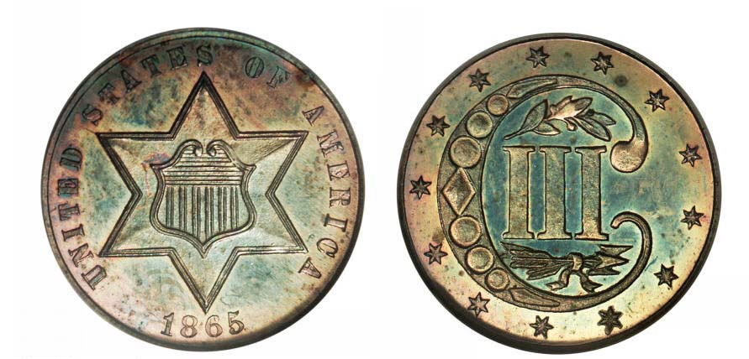

A rare 1865 3¢ Type III silver piece
Business strike with a mintage of 8,000
(Courtesy of Heritage Auction Archives)

The War had brought about a severe coin shortage. At first the authorization of Fractional currency known as “shin- plasters” seemed to help but 3¢ paper money was unpopular. With nickel interests lobbying Congress, a three cent nickel piece was created by the Act of March 3, 1865. The early successes of the new nickel coin led to the slow demise of the 3 cent silver piece. The Coinage Act of 1873 did away with a number of denominations including the 3 cent silver piece.
____________________________________________________________________________________________________________________
(Continued on page 6, column 1)
Types I, II and III 3¢ silvers enlarged and compared.

1851-O 3¢ Trime Type I enlarged
1854 3¢ Trime Type II (enlarged)

1865 3¢ Trime Type III (enlarged)

Summary: Many collectors obtain a single specimen for their collections. A collection of each sub-type; (i.e. Type I, II and III) as well as the one year 1851 New Orleans mint marked coin is also collectible. All Type Ones are relatively affordable. For Type II, the 1858 issue appears to be the lowest priced and for Type III, the affordable dates are 1859-1862.

The silver 3 cent piece was born out of necessity. It was known in some areas as a "fish scale" due to its small size and dullish appearance with wear. Others refer to it as a "trime", a combination of "tri" as 3 and "dime" because its closeness in size to the dime.
_______________________________________________________________________________________________________________________________

I dedicate this article to a dear friend and fellow collector, the late Don Bitner whose help over the years has helped me in my numismatic endeavors as well as many young numismatists. - Rich Baker
_
More Upcoming Show News

If you would like to set up as a dealer
at our upcoming Sept. 16 show, please contact our Show Chairman J.J. Engel at his E-mail address or phone number shown below.

jjkingcobra777@bellsouth.net or phone: 803-648-0982
__________________________________________________________

Kindly Patronize Out Advertisers

