The Stephen James
CSRA Coin Club of Aiken
P.O. Box 11
New Ellenton, SC 29809
Web site: www.sjcsracc.org
The SJ CSRA CC of Aiken, SC meets on the 1st Thursday of the month at the Aiken Public Library

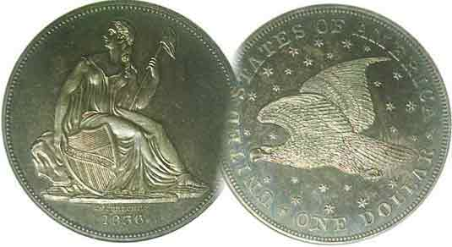
Pres. J.J. Engel
V .P. Pat James
Sec. Jim Mullaney
Treas. Chuck Goergen
Sgt. in Arms: Jim Sproull

Programs: Pat James
ANA Rep.: Glenn Sanders
Show Chair: Board members
Photos: Steve Kuhl
Publicity: Pat James
Newsletter: Arno Safran
E-Mail: arnosafran@comcast.net
Auctioneer: Jim Sproull
Web site: Susie Nulty (see above.)

Our next meeting is Thurs. October 3 at the Aiken Public Library, starting time 6:45 PM

2019 Club Meeting Schedule
Volume 18, No. 10 the Stephen James CSRA Coin Club, Founded in 2001 October, 2019
Monthly Newsletter
Last Month’s Club Show, a huge success!
Jan. 3 Apr. 4 July 11 Oct. 3
Feb. 5 May 2 Aug. 1 Nov. 7
Mar. 7 June 6 Sept. 5 Dec. 5

Club show on Sept 7, was one of the best!

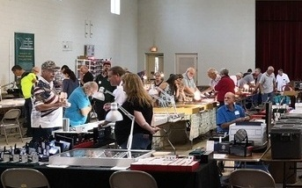

Everything was aglow at the SJ CSRA CC September show
Photo taken of the rear left section of the hall by Robert Sanborn

When our regular show host of 14 years opted to bounce our calendar spot for a bigger group late in 2018, it was too late to find another venue. It was important that we make the necessary preparations for our club to hold our annual fund raising event, so with the help of past Presidents Steve Kuhl and his wife Chrissy, we were able to secure a new site that satisfied our needs. A number of members helped with the set up and take down which was nicely handled by Sgt. At Arms, Jim Sproull, former presidents Steve Kuhl and Willie Simon, current president, J.J. Engel, member John Kolmar and several others. The Gym of the South Presbyterian Church was the perfect size for the club’s show needs. VP Pat James volunteered to serve as bourse chairperson and with assistance of other members was able to sell 42 tables. The photo above shows slightly more than the rear quarter of the bourse. The other sections of the commodious room were similarly busy. Ms. Pat did an excellent job of attracting a fine group of dealers who had a variety of numismatic offerings that included US coins, commemoratives and paper money as well as dealers toting coins from India and the orient, foreign banknotes, ancient coins, also tokens from South Carolina as well Hard Times and Civil War era pieces.
Collecting US Large Cents by 4s & 9s
By Arno Safran

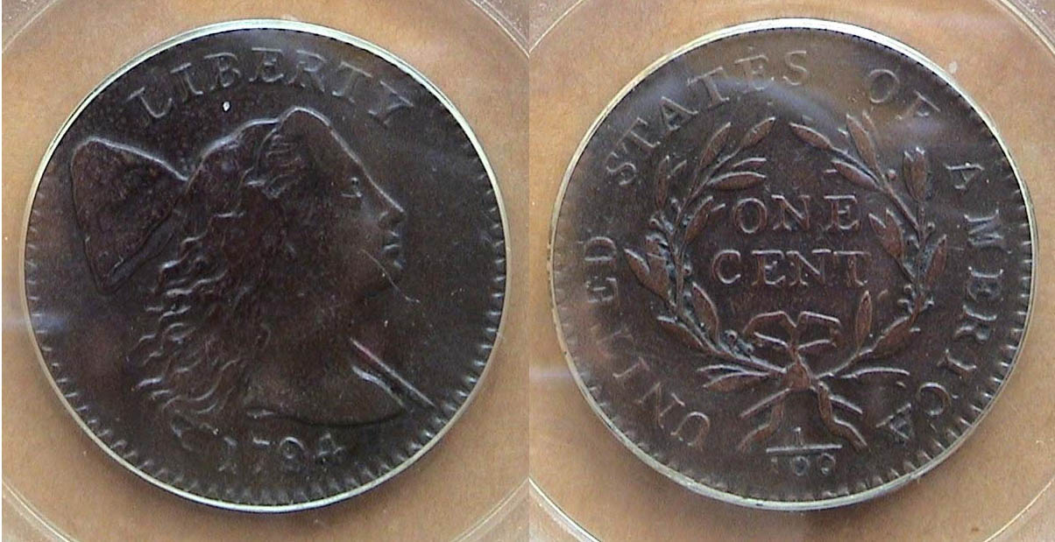

A 1794 Liberty Cap large cent, S-31, R1 graded VF-30 by PCGS
[Use 3X glass to view hard copy or enlarge page to fill monitor screen]

There is a large number of serious collectors who specialize not only in large cents by date (1793-1857) but are also devoted to acquiring all known die varieties for some dates and finally there is an idiosyncratic group known as the Boyz of 94 who collect only 1794 Liberty Cap large cents because it had the most die varieties of any US coin. Over the years, the writer managed to acquire at least one specimen of all the dates of the large cent series except for the three 1793 types and the 1799 with the Gallery Mint coming to the rescue there.
Oddly enough, the example of the 1794 Liberty Cap large cent shown above was acquired at one of our early club meetings away back in April, 2004 when one of the members offered it for sale after a Show & Tell session. It was certified VF-20 by PCGS. The author thought the coin was under graded, so after looking at similar graded examples on the internet he resubmitted it to PCGS and it came back in a VF-30 holder adding $1,000 to the coin’s value. The die variety of the piece was fairly common which kept the original asking price down.
The next date in the four and nine grouping of early large cents was a non-starter, the 1799. With just 42,540, reportedly coined, the date is rare in all grades and even a PCGS graded Poor 1 was incredibly expensive costing the winning bidder $1,800 at a Heritage auction .

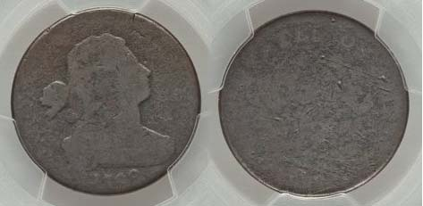

A 1799 Draped Bust large cent graded Poor 1 by PCGS
[Use 3X glass to view hard copy or enlarge page to fill monitor screen]
(Continued on page 2, column 1)
Collecting US Large Cents by 4s & 9s
(Continued on page 1, column 2)

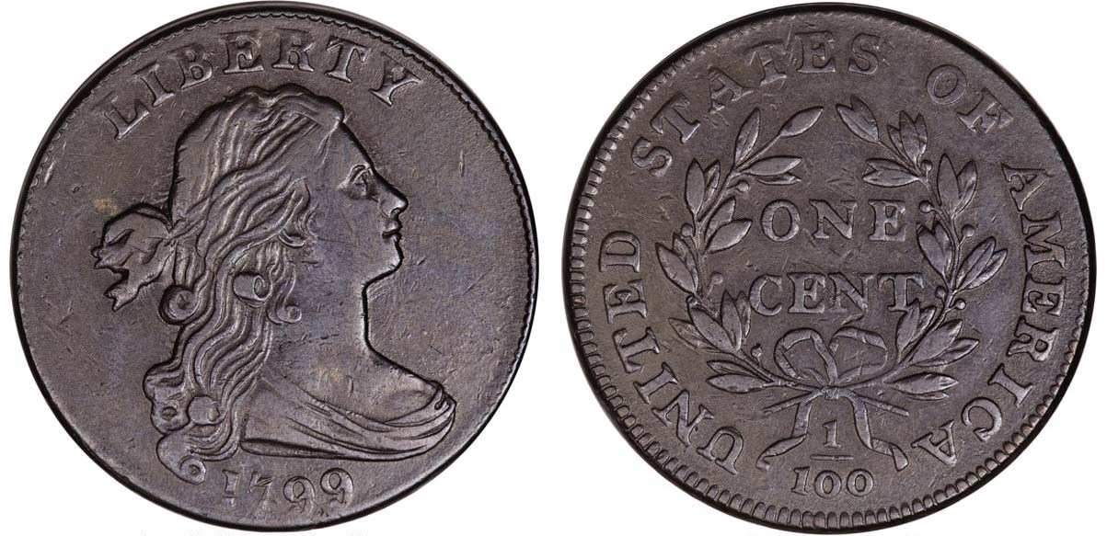
A 1799 Draped Bust large cent graded XF-45
This coin realized $161,000 at a Heritage auction in February, 2008
(Courtesy PCGS COINFACT & Heritage Auctions Archives)
[Use 3X glass to view hard copy or enlarge page to fill monitor screen]

By comparison, the highest graded 1799 Draped Bust large cent known is this PCGS-XF-45 certified example pictured atop this column. The example isn’t close to being uncirculated yet it sold for $161,000 compared with the $1,800 basil state piece shown on the bottom of the preceding page. If there are any uncirculated specimens out there, one can only imagine what they would bring at a major auction today. The reason for this may be due to the fact that during the first fifty-plus years of our nation’s coinage, the large cent denomination was the workhorse of the economy and inasmuch as there were hardly any collectors back then, the cent denomination circulated heavily causing their greater scarcity and value today.

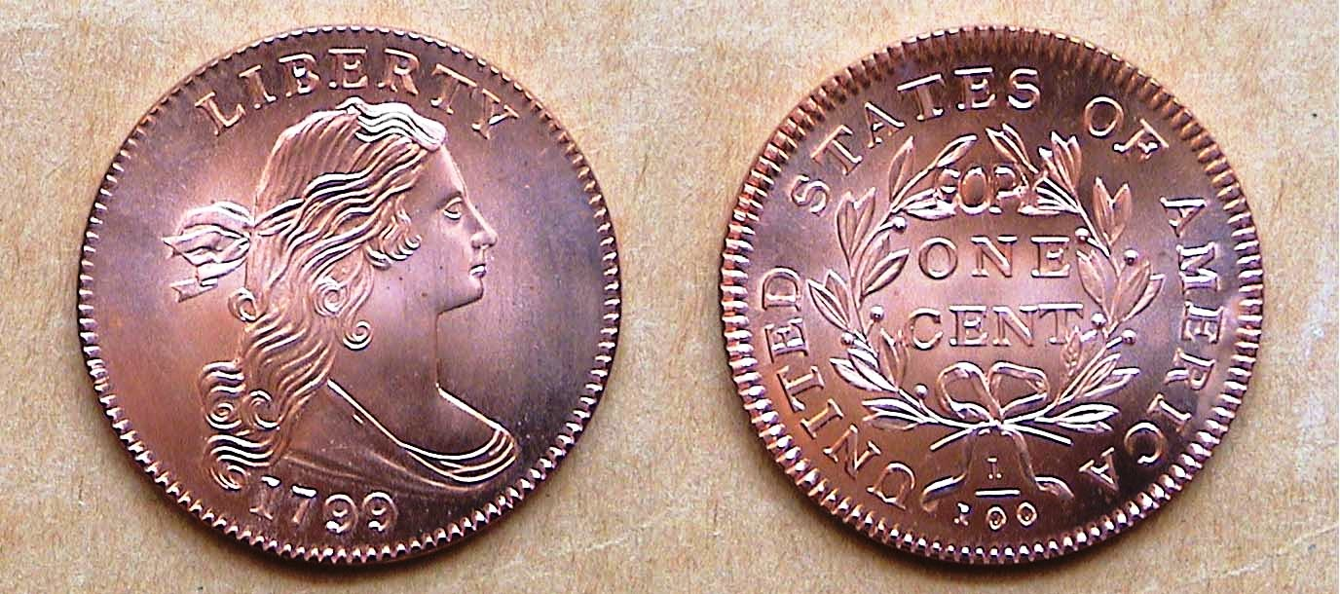

A 1799 Gallery Mint replica of the Draped Bust cent
[Use 3X glass to view hard copy or enlarge page to fill monitor screen]

With the prices for an original 1799 Draped Bust cent out of sight for most collectors, the Gallery Mint Museum (1993-2008) located in Eureka Springs, AR created a replica of the 1799 dated Draped Bust large cent in 2002. It sold for just $12.00 albeit with the word COPY on the reverse or obverse depending on the purchaser’s choice. The example above--engraved by founder Ron Landis--would probably certify MS-68 today due to a few tiny spots on Miss Liberty’s cheek which can only be seen under a magnification of 500%. During the GMM’s existence, Landis created many wonderful replicas of US coinage including complete year sets of 1792, 1793, 1794 and 1796.

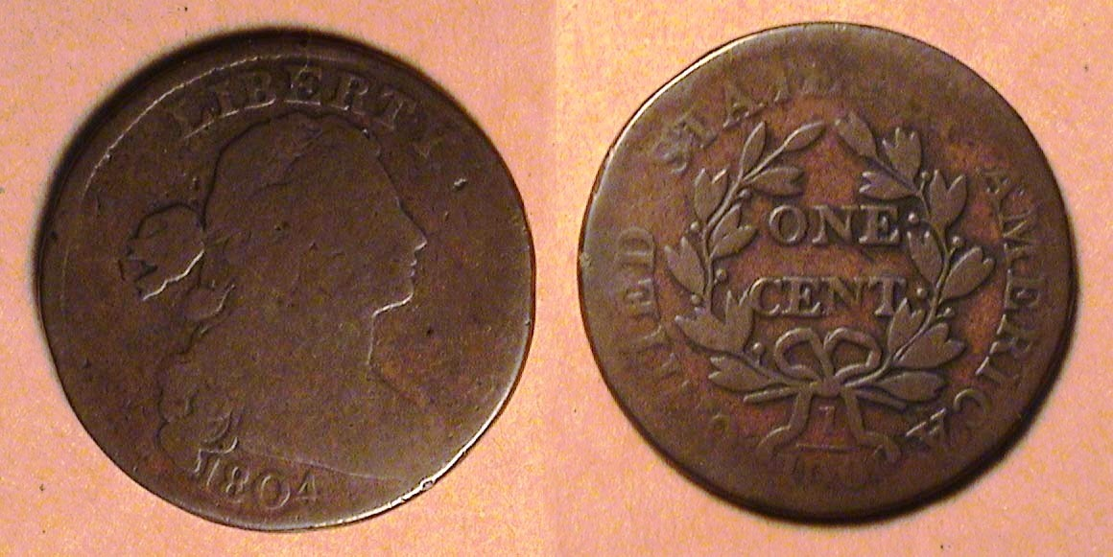

A 1804 Draped Bust large cent S-266a graded Good-6
[Use 3X glass to view hard copy or enlarge page to fill monitor screen]

With a reported mintage of just 96,500 the 1804 Draped Bust cent is the third rarest date of the large cent series and a lot of survivors look like the low grade piece shown directly above. Despite the wear, the coin has natural brown color with decent surfaces. . Enlarging the image will reveal more detail. There is a crude replica of the 1804 cent combining an altered 1803 with an 1820 reverse.

What formed the basis for this current article was the writer’s on line search for an 1812 large date variety of the Classic Head cent series. With the exception of two certified higher grade circulated graded specimens he saw, most of the on line cents from this series were horrible looking coins that were either uncertified or in GENUINE holders.

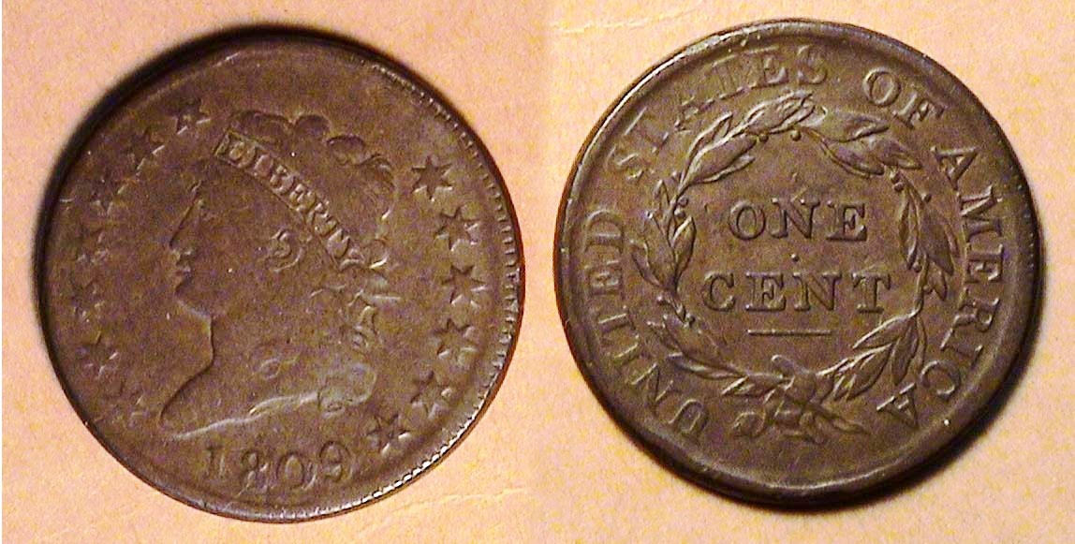

An 1809 Classic Head large-cent S-280, R2 graded Fine-12
[Use 3X glass to view hard copy or enlarge page to fill monitor screen]

Of all the large cent types, my favorite has always been the short run seven year Classic Head series designed by John Reich who served as Asst. Chief Engraver of the United States Mint from 1807 thru 1817. The type was first issued in 1808 and struck in consecutive years thru 1814. Compared with the earlier types when some single dates had well over twenty die varieties, there were only nineteen known die varieties within the entire classic cent run. What makes this particular type so challenging is finding nice looking coins in the lower to middle circulated grades.
The problem began when Mint Director Robert Patterson began to have difficulties obtaining quality copper planchets from the firm of Mathew Boulton of Soho-Birmingham, England. This was during the years leading up to the War of 1812 with Great Britain when the British navy were removing American sailors from their ships claiming they were British deserters. As a result, of the tension between the two nations, there were long delays in the shipping of goods which included the cent size planchets that were often of sub-par quality compared to those used for coining the Draped Bust cents. Instead of appearing coppery, many of the planchets looked charcoal gray, were found to be sometimes porous or tainted in verdigris having been kept in damp storage holds in the ships during the weeks of passage. The two toughest dates of the series are the 1809 and 1811 issues due to far lower mintages than the even numbered dates with the exception of 1814. With a reported mintage of just 222,867, the 1809 shown above is considered the key date of the series because the 1811 with a slightly lower reported mintage has more survivors. The 1809 was acquired at a major New York City show held at the World Trade Center in March, 1991 at a cost of only $350. Today, similarly graded specimens are listed at $1,000 and selling at auction at around the $850 level.

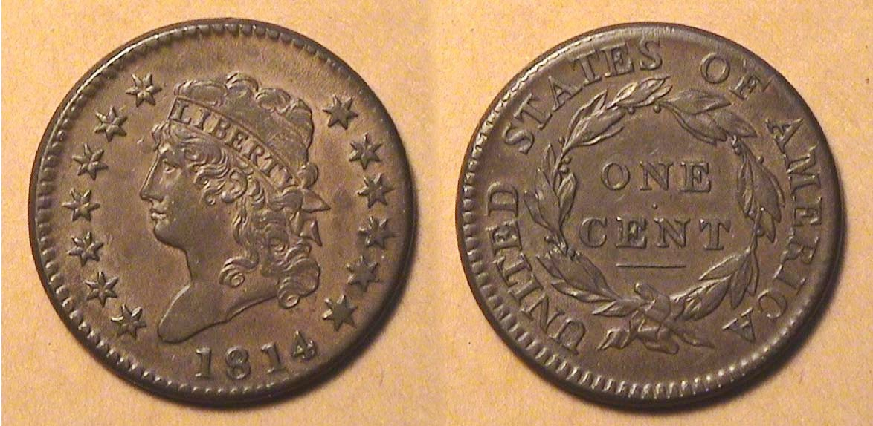

A 1814 Classic Head large cent, S-294, Crosslet 4 graded AU-55
[Use 3X glass to view hard copy or enlarge page to fill monitor screen]

The 1814 Classic Head cent had a reported mintage of only 357.830 with just two die varieties, the crosslet 4 and the plain 4. The author came across this exceptional example of the crosslet 4 at a one day commercial show in Oct. 1992 and sold a number of modern $5.00 gold commemorative coins to dealers in order to obtain it.
(Continued on page 3, column 1)
Collecting US Large Cents by 4s & 9s
(Continued on page 2, column 1)
“The Matron Heads”

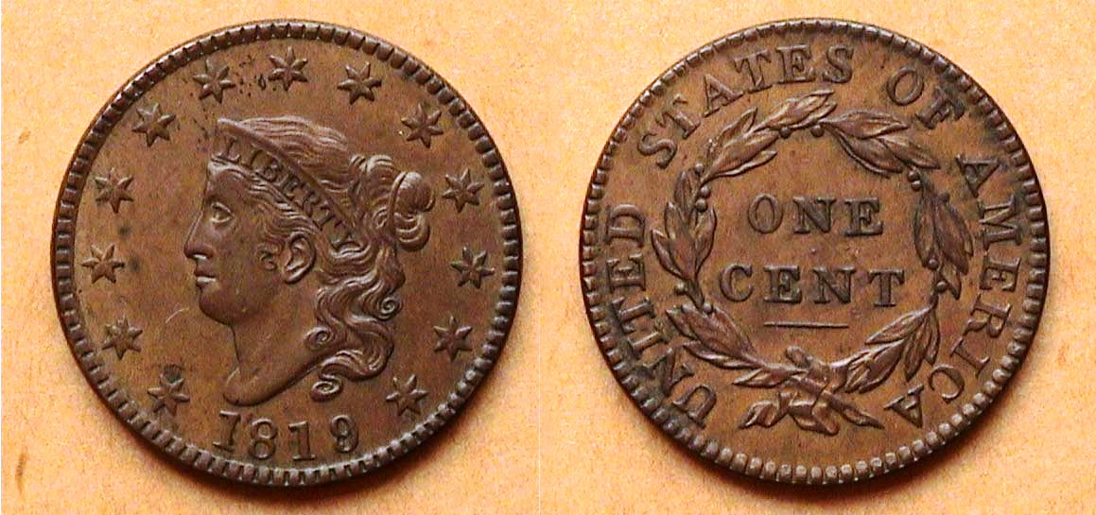

An 1819/8 Coronet large cent, N-1, R1 Lg. dt. graded AU-58 BN
[Use 3X glass to view hard copy or enlarge page to fill monitor screen]

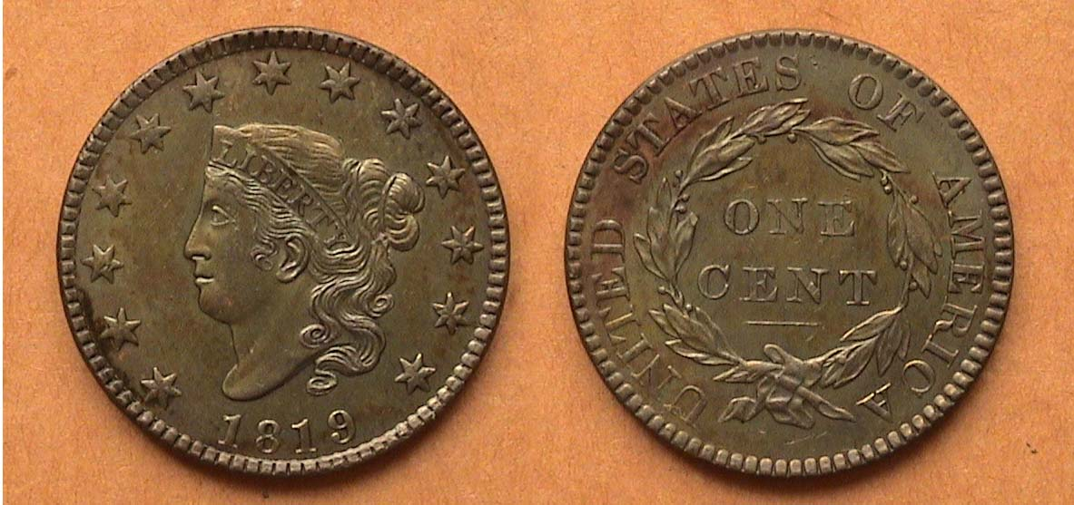

An 1819 normal date large cent, N-9, R1 Small dt. graded MS-60 BN
[A Randall hoard specimen]
[Use 3X glass to view hard copy or enlarge page to fill monitor screen]

Unlike the previous large size coin types that were considerably short-lived, the Coronet type specimens, struck from 1816 thru 1839 are fairly common with the exception of the 1821 and 1823 and rare varieties. So, finding moderately priced coins from this series represents much less of a challenge for the contemporary collector.

For a long time, it was believed that our first chief engraver Robert Scot designed the Coronet type large cent. More recent research by numismatic scholar R.W. Julian suggests it was the work of John Reich who in 1816 was still at the Philadelphia Mint serving as Asst. Chief Engraver and the lesser artistic quality of the new design type derogatorily referred to as the “Matron Head” was due to Reich’s sudden failing eyesight. Originally, it was believed that Scot, who was already in his later years when he supposedly created the design was slightly “off his game” due to his failing eye sight. The writer believes that if the Coronet type was considered inferior by the mint officials of that era, the design would have been short-lived but it’s style exists similarly as the Braided Hair or Mature Head on the obverses of the late date half-cents and large cents as well as the $2.50, $5.00 and $10.00 gold pieces during the remainder of the 19th century into the early 20th.century. Simply put, the rendering of Miss Liberty wearing a tiara represents the Nouveau style of that era.

The pair of 1819 Coronet cents shown above represent two important varieties. The uppermost one portrays the large date which upon magnification is also an over-date, 9/8. The coin below it shows the small date version but it is also historically interesting as well because years after the Coronet cent was struck, a hoard of some of the earlier date pieces (1816-20) was discovered in a large wooden keg under a Georgia RR station and eventually found its way to a coin collector named John Randall who lived in Norwich, New York. Many of the coins were still in uncirculated condition, presumably from the middle of the keg while those situated along the top or bottom, may have been corroded due to moisture seeping in. The Randall Hoard was eventually sold off piecemeal for a few cents each. Today, their popularity and high grade condition brings much higher prices than what this writer paid even three decades ago.
1824 is a memorable date not only for the large cent but for some others because a number of leftover 1822 coinage denominations were later repunched with a four over the last number in the date that year and these coins are scarce to rare today, The 1824/2 dime and quarter immediately comes to mind as scarce dates.

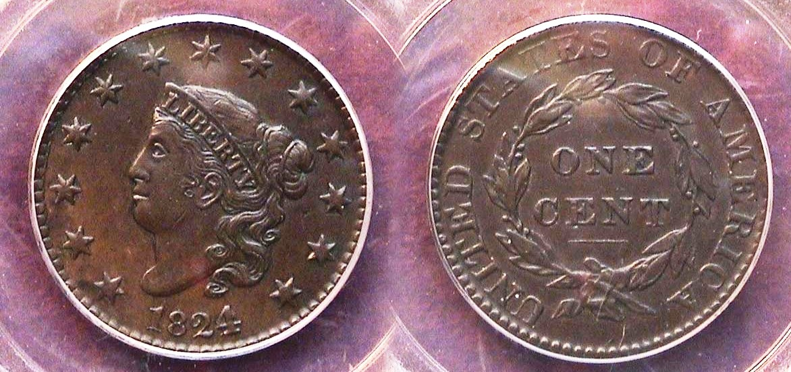

An 1824/2 Coronet large cent, N-1 graded AU-50 by PCGS
[Use 3X glass to view hard copy or enlarge page to fill monitor screen]

By now, the reader may have noticed the N followed by a number before the grade under the large cents illustrated on this page. The N stands for the late Harold Newcomb, a coin dealer whose hand-written text first published in 1941 became the hallmark for the identification used by dealers and collectors in attributing all the then known die varieties of the middle-date Coronet large cents series. The number following the N represents the level of rarity with R-1 being the most common having over 2,000, R-2, up to 2,000, R3, up to 600, R4, 400, R5, 31-75, R6, 13-30, R-7, 4-12 and R-8, 1-3 known.

In 1824, there were five large cent varieties, two with overdates and three with normal dates. While the total reported mintage for the date was 1,262,000, the over-date specimens tend to be scarcer and more expensive than the normal date issues, especially so in the higher circulated grades such as XF and AU. The example above shows strong coppery color with nice surfaces. It was acquired as shown back in January, 2007 at the annual art the FUN show held in Orlando, FL from a dealer who specialized in early American copper coinage.
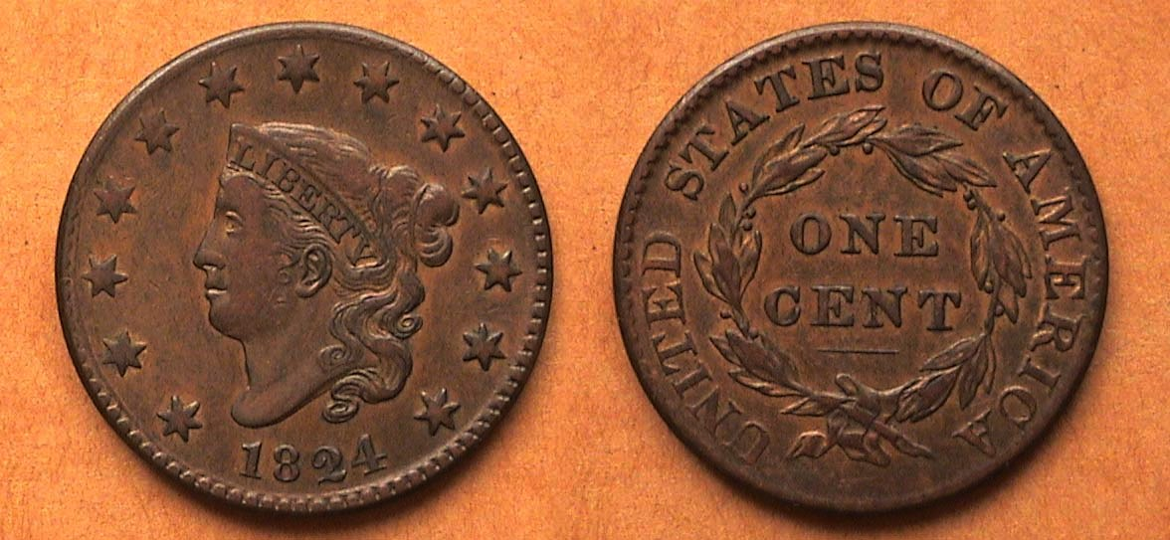
An 1824 Coronet large cent N-3, R2 graded VF-35
[Use 3X glass to view hard copy or enlarge page to fill monitor screen]
This 1824 normal date coin shown displays slightly more wear then the over-date but has nice brown color and decent surfaces. and was far less expensive. It was acquired “raw” back in Nov. 1992 from another Early American coppers dealer at a weekend show held in Maryland, just north of Washington DC. The author remembers that his wife Vilma met him at the mainline NYC to Washington, DC RR station since she had earlier driven down to the Smithsonian Institute in Washington to do extensive research on her doctoral dissertation. Aside from the show, we spent a wonderful weekend touring the Smithsonian which also houses one of the most spectacular collections of rare US coins.
Between 1816 and 1834 the Coronet large cent remained pretty much the same. Around 1835, Christian Gobrecht (who would become Chief Engraver of the Mint in 1840), started to tinker with the cent design, thinning Miss Liberty’s neck, adding beads to Miss liberty’s hair in 1837, creating five different subtypes in 1839, the two most important being the Beaded hair and incoming Petite Head sub-type of 1840.
(Continued on page 4, column 1)
Collecting US Large Cents by 4s & 9s
(Continued on page 2, column 1)

“From” Matron Head” to Petite Head”
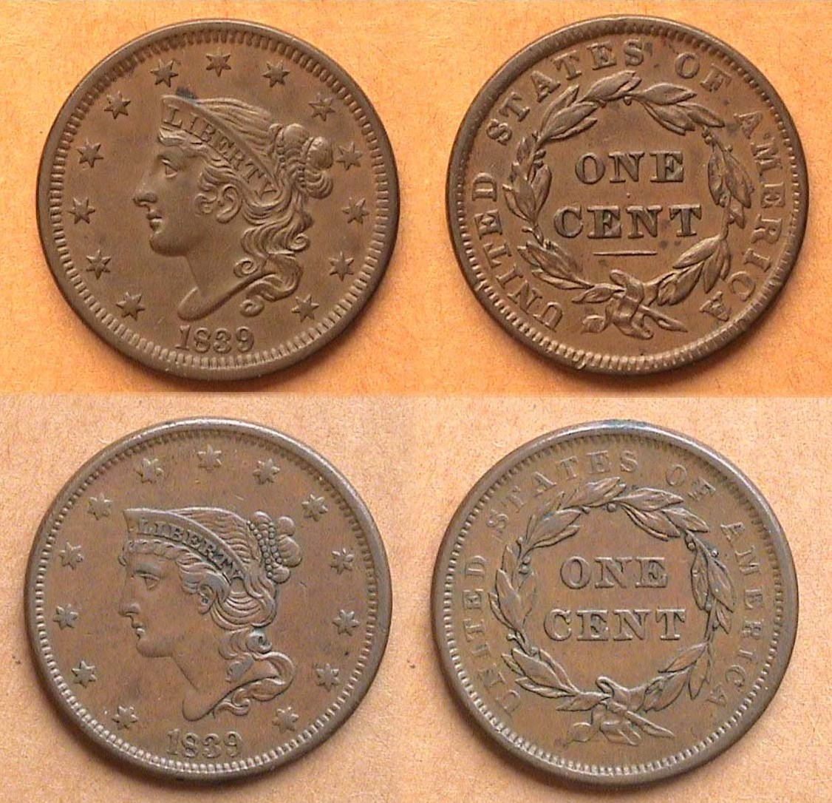

The 1839 Beaded Hair Cord N-2 variety large cent
over the Petite Head N-8 variety Large Cent

As previously illustrated in “the US Coins of 1839” article that appeared in the May, 2019 issue of the club newsletter, the 1839 cent underwent five modifications by engraver Christian Gobrecht but the two most important ones of the 1839 cent varieties were the changeover from the Beaded hair cord sub-type on Liberty with head upright to the slightly smaller Liberty tipped head design known as the Petite Head. Both of these design types are relatively common for the date and nice circulated specimens are available at affordable prices.

The final transitional Braided Hair sub-type date

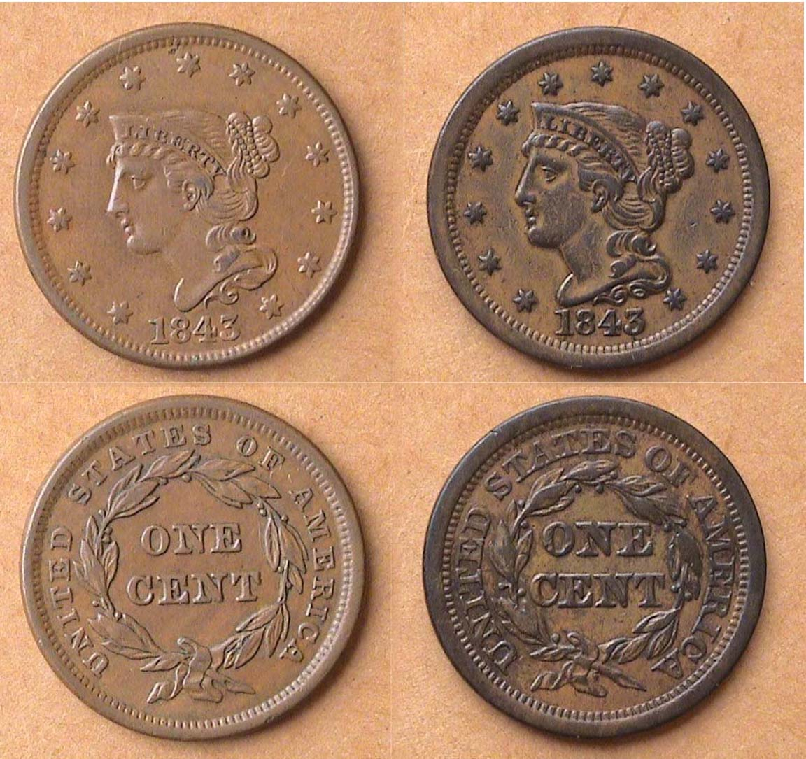

1843 Large Cents: “Petite” Head left & 1843 “Mature” head at right
N-9, a R1, more common and N-16 a R3, scarcer
[Magnify page to fill monitor screen to view details.]

Among the entire Coronet Liberty large cent umbrella there was one final sub-type transitional date pairing, the cents of 1843. The two main changes was the moderately tipped Petite head struck in early 1843 and then later in the year, the new Mature Head design, the last Hurrah for chief Mint Engraver Christian Gobrecht who sadly passed away later in 1844.
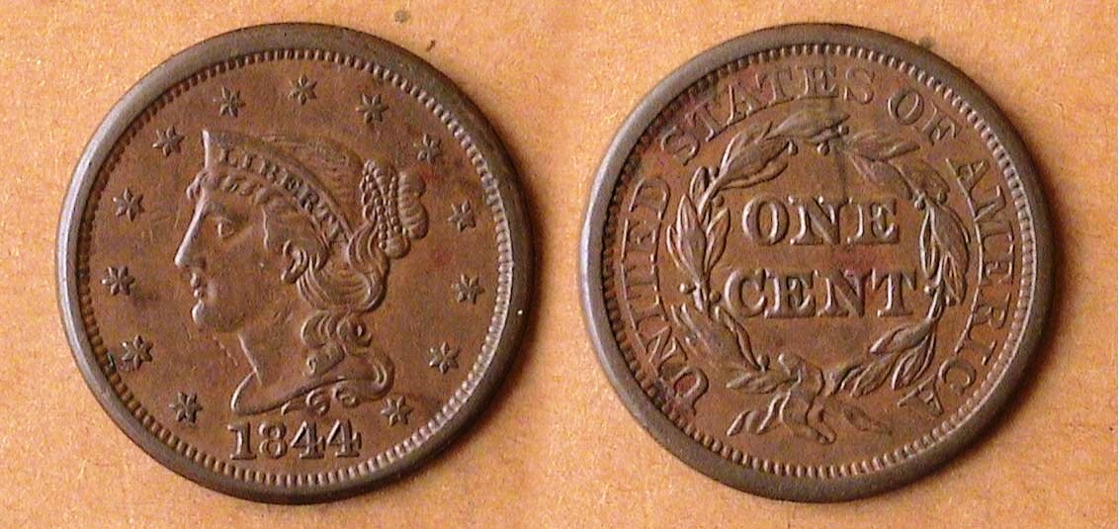

An 1844 “Mature Head” large cent, N3, R3 graded XF-40
[Magnify page to fill monitor screen to view details.]

There is nothing extraordinary regarding the 1844 Mature Head type large cent shown directly above except that is a decent and attractive coin for the grade. It is neither scarce nor rare. The N-3 designation places it somewhere in the middle of the rarity scale suggesting no more than 600 survivors are known to exist. An R-3 designation was once considered to be scarce, but today, most sellers place it in the lower-end among the common dates and seldom ask a premium. The coin was acquired away back in March, 1992 when New York was renowned for holding major coin shows and this one was held on the basement level of one of the two World Trade Center skyscrapers in lower Manhattan. The dealer who sold it was the late Don Valenziano who was a specialist in early American copper coins and one of the most reliable and decent persons in numismatics.. His passing due to a fall was a shock to everyone who knew and respected him.

After the Mature head design was firmly established in 1844, the coin type continued to be minted for thirteen more years through 1857 when it was replaced by the Flying Eagle small cent later in that year. During the that short time span, six men sat in the Oval Office, John Tyler, James Knox Polk, Zachary Taylor, (a retired general Old nicknamed “Old Rough and Ready”), Millard Fillmore, Franklin Pierce and finally James Buchanan

Of all the large cent types, the author’s two favorites are the Draped Bust of Robert Scot and the Classic Head design of John Reich, possibly the most beautiful of them all. Perhaps this article may draw some of the reader’s numismatic interests towards collecting some of these beautiful if challenging early American coppers.

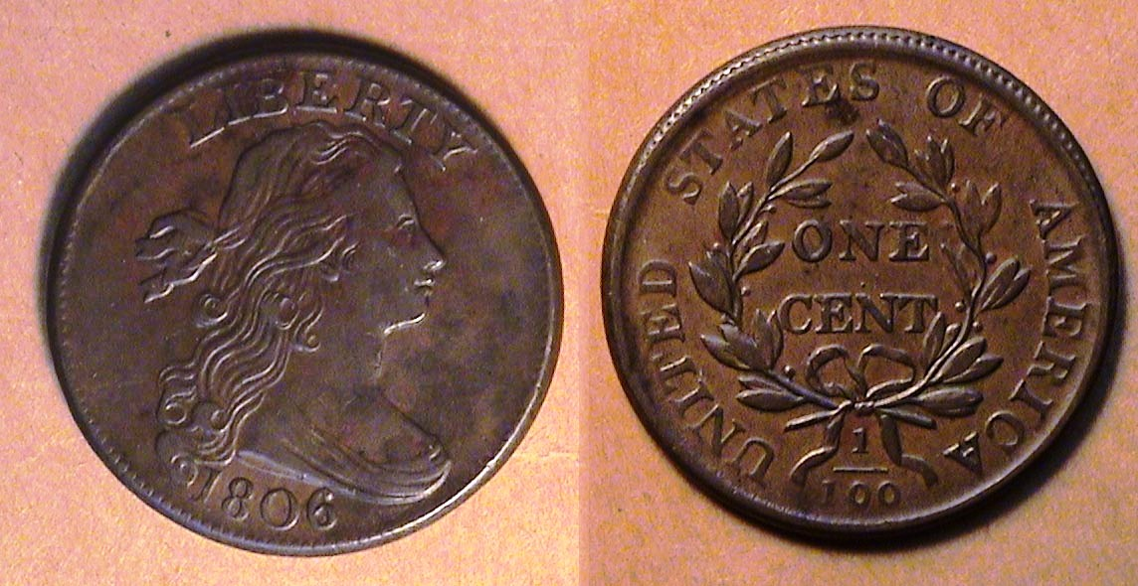

An 1806 Draped Bust large cent S-270 graded XF-40
[Magnify page to fill monitor screen to view details.]

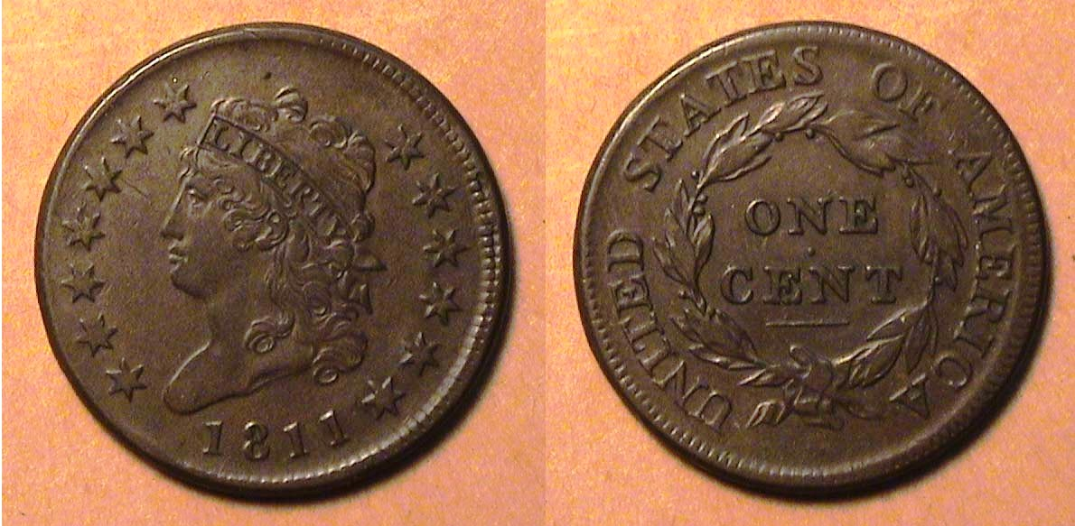

An 1811 Classic Head large cent S-287, R2, graded VF-35
[Magnify page to fill monitor screen to view details.]
STEPHEN JAMES CSRA COIN CLUB
Regular Meeting September 5, 2019,
Aiken County Library

President J.J. Engel called the regular meeting of the club to order at 6:45 p.m. Jim Sproull reported that there were 25 members present, and 2 guests. Steve Kuhl won the members’ door prize, a 2019 Silver Eagle Jim also announced information concerning several upcoming coin shows in the vicinity.

A motion was made by Steve Kuhl, seconded by Sharon Smoot, and passed to dispense with the
reading of the June 2019 meeting minutes. A copy will be on file with the other club records, and a
copy will appear in the club newsletter.

Treasurer Chuck Goergen reported the Club’s bank balance of $3,975.10.

Arno Safran reminded the members of the meeting of the Augusta Coin Club will be holding its annual Pizza Party at its Sept. 19 meeting starting at 7 p.m. at the Sunrise Grill, West Town Market Square on Washington Road in Martinez, Georgia.

Upcoming SJ CSRA CC Show:
VP Pat James, Show Coordinator for the 2019 Coin Show, reported that twenty-two dealers had reserved 41
tables for the September Coin Show. This provides the club with $3075 in table fees. 41 tables will
essentially fill the entire gym. Jim Sproull requested that all members who are able to come to the gym
after 2:30 on Friday to assist with the setup of the tables.

Upcoming South Carolina Numis. Assn. Convention
Steve Kuhl reminded us that the SCNA convention is coming up Oct 25-27 in Greenville. Bob Moon,
Tony Chibbaro, and Wayne Damron are presenting programs on various topics. Steve also announced that SCNA officer elections are coming up between now and the convention.

2020 SCNA Election for President
Most positions are uncontested, but there are two candidates for President. Incumbent Randy Clark is
running along with Bruce Getman, who was a guest at our club meeting in September and has been a
coin dealer at our annual show for many years. If you are a member of the SCNA, check your mail for
a ballot and return it before the deadline.

Club Christmas Party
President JJ Engel announced that the club’s Christmas dinner will be at the Columbus Hall on the first Thursday in December. There will be a choice between Steak and. Chicken & crab cake, along with a vegetable, potato, and iced tea. at a cost of $25.00.

The Program:
Steve Kuhl presented a program on “Confederate Raid at St. Albans VT” during the Civil War.
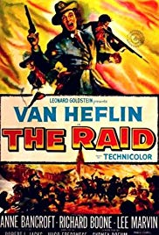
This PowerPoint presentation showed the history behind an event that VP Pat James had mentioned in her comments at the August meeting. Steve presented a wonderful summary of the events leading up to the raid, as well as the frightening event itself and the legal aspects following the raid when the confederate raiders were arrested in Canada and tried for crimes in the U.S. This was followed up by club Sec. James Mullaney’s showing of a twenty-minute segment of the famous 1954 Hollywood movie called “The Ra id” starring Van Heflin and Anne Bancroft which when displayed on the large size screen in the library meeting room was riveting in its dynamic power.

Due to the length of the meeting agenda as a result of the upcoming club coin show and the presentation, president J/.J. Engel suggested that we dispense with the Show & tells for this meeting until next month.

The program for our October 3 meeting will be on Brook green Gardens - SC Trove of Sculpture with Numismatic Ties presented by Recording Secretary James Mullaney.

Following the monthly auction, President Engel adjourned the meeting at 8:25 pm.

Respectfully submitted,
Jim Mullaney, Secretary
____________________________________________________________________________
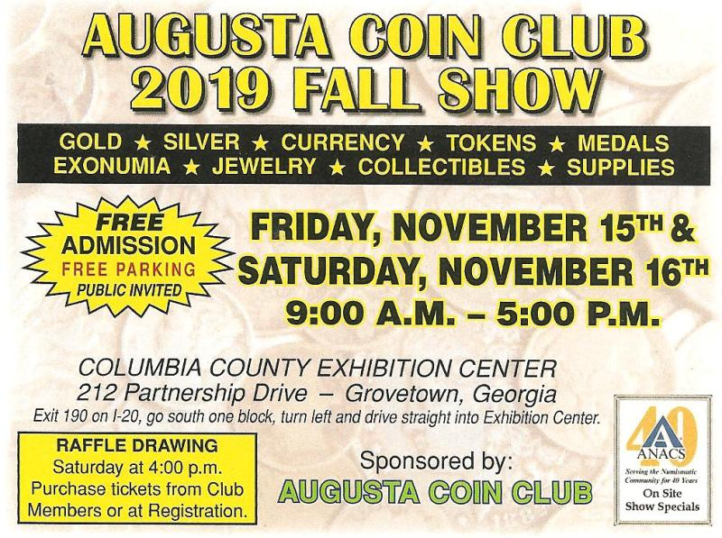

A Wonderful Summer of
Show & Tells!
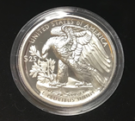
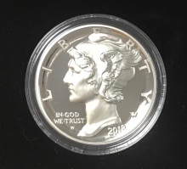
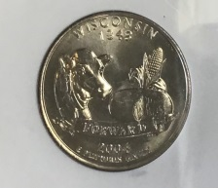
The SJCSRACC has enjoyed a summer full of numismatic education! The Club has a vibrant “Show and Tell” culture and this summer brought many fine numismatic items, such as:
A 50th WW II Anniversary commemorative set issued in 1993
A 2004 Wisconsin quarter with the extra leaf error
An 1893 Barber quarter graded MS-63 but with MS-65 eye-appeal
An uncommon one ounce .9995 palladium 2018-W $25 proof coin. It has a high relief Mercury dime design obverse and a reverse with a different eagle from the Mercury dime, perhaps akin to the one Adolph Weinman used for the reverse of the Walking Liberty half-dollar.
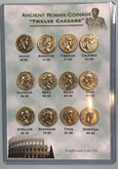
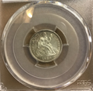
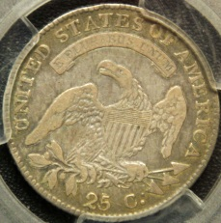
A reproduction gold set of the twelve Caesars from Julius in 44 BC to Domitian in 96 AD.
A 1917 Variety 1 U.S. Standing Liberty quarter
An 1882 ANACS MS 61 Morgan
An 1883-O ANACS MS 62 Morgan with lots of eye appeal
An XF 1832 capped bust quarter
A 1995 Lincoln penny double-die, along with information from the Cherry-Pickers guide on spotting this variety.
A beautiful PCGS MS-62 1889 Seated Liberty dime
A 1980-P nickel that had been minted on a penny planchet.
A 1985 one-dollar error bill - where a strip ~1/4 inch-wide across the bottom of the note reverse showed a mirror image of the front of a one-dollar note
Two graded examples of 1819 Quarters one graded VF20 by ANACS and the other, a “small 9” variety, graded VF20
Counterfeit “silver” rounds, one of which was actually marked as “one troy ounce .999 fine silver”.
Augusta Coin Club News
The Augusta Club is celebrating its 60th Anniversary this year. A special token was minted to commemorate this great achievement! They are available for purchase by contacting Club President Steven Nix at 706-551-5115 or FleetwoodCoins@hotmail.com
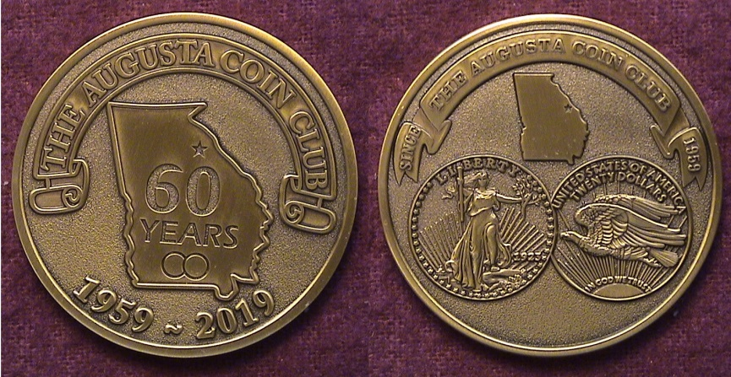

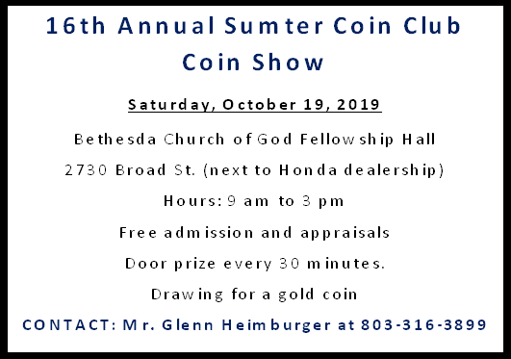

“Time is the coin of your life. It is the only coin you have, and only you can determine how it will be spent. Be careful lest you let other people spend it for you.”
Carl Sandburg
All the perplexities, confusion and distress in America arise, not from defects in their Constitution or Confederation, not from want of honor or virtue, so much as from the downright ignorance of the nature of coin, credit and circulation.
John Adams

Annual Show Successfully Returns!
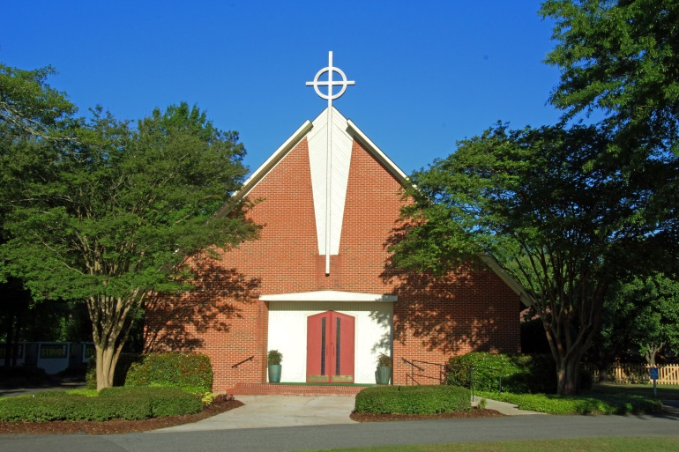
After a year hiatus and enduring a change of venue, the Stephen James CSRA Coin Club held its 17th annual coin show in early September, this time in the gym of the South Aiken Presbyterian Church!
Host facility for the 2019 SJCSRACC Show, the South Aiken Presbyterian Church
The church graciously allowed the use of their gymnasium for the show, and the gym was filled to capacity with coins, currency, tokens, and exonumia for the viewing, buying, and selling! Many dealers commented on how well they liked the new facility and layout, saying it had a more “intimate feel”.
As a way to say “thank you” to South Aiken Presbyterian Church for the use of their facility (gym, kitchen, restrooms, etc.…) as well as to offset the cost of the utilities used by the show, the Club and club members donated $200 to the church.
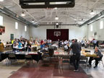
View of bourse floor at the South Aiken Presbyterian Church gymnasium
Twenty-three dealers from across South Carolina and Georgia participated and they reserved 43 tables.
Unfortunately, one of our own dealers, Mr. Howard Hillman, had to drop out at the last minute. He was missed by all who are used to seeing his smiling face at our show!
Approximately 200 patrons visited our show, and while this attendance is down from previous years, many dealers noted that it takes a year or two to recover from a change of venue, or missing a year, and the SJCSRACC experienced a double-whammy. Recognizing this, conversations with the dealers indicated they were generally pleased with the show, and they plan to return next year!
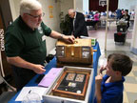
One common point of feedback received was on the helpfulness and enthusiasm of the Club volunteers who aided the dealers in packing their show material into and out of the venue. Our Club’s reputation for this customer service is well-known, and this year 26 volunteers, including some non-Club members, stepped up in a big way, and their efforts earned substantial praise from the vendors! A great big THANK YOU! Is given to all the volunteers who helped make this show a success! (See separate article in this issue on the volunteer’s efforts!)
Chuck Goergen being assisted by Bentley Bailey, the young man who drew the winning prize tickets
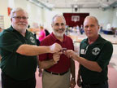
This year, as always, the Club offered guests the option of purchasing raffle tickets for one of three prizes: a 1/10th ounce American Gold Eagle, A certified Morgan dollar, and a 2019 Proof set. Winning tickets were drawn by a young visitor, Bentley Bailey. Thanks to Bentley, Club member Andrew Goslen won the 1/10th ounce Gold Eagle.
Chuck Goergen, Club Treasurer (l) and Willie Simon, Past President (r) with 1st Prize winner Andrew Goslen (c)
Ms. Connie Nix of Fleetwood Coins and a member of the Augusta Coin Club won the certified Morgan, and guest Mr. Jim Livingston won the 2019 proof set!
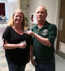
Willie Simon, Past President (r) with 2nd Prize winner Connie Nix (l)

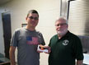
A fourth “participation prize” was begun in 2017 where anyone who brought one of the Club’s show business cards to the show was entered into a free drawing for an American Silver Eagle. This year Mr. Jim Sproull, Sergeant-At-Arms for the SJCSRACC won this coin! Congratulations to all the lucky winners!
Chuck Goergen, Club Treasurer (r) with 3rd Prize winner Jim Livingston (l)
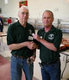
Willie Simon, Past President (r) with “Participation Prize” winner Jim Sproull (l)

All in all, this show met the challenges presented by missing a show and having to change show venues. This success is due to the participating dealers who believe in and support out Club – THANK YOU!! - The Volunteers, and of course the Guests. All of us look forward to next year being even bigger and better!
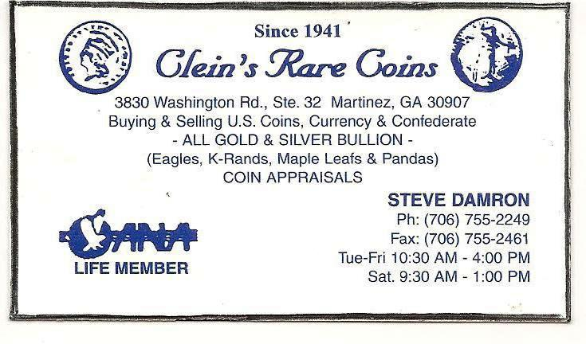

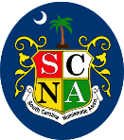
SCNA’s
Super Saturday!!
October 26, 2019
Greenville Convention Center
On Saturday, October 26th, the SCNA will present educational seminars by three preeminent and award-winning members of SCNA:
10AM to 11AM
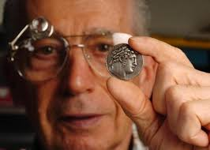
“Coins of the Bible”
Presented by
Mr. Wayne Damron

11:30AM to 12: 30PM
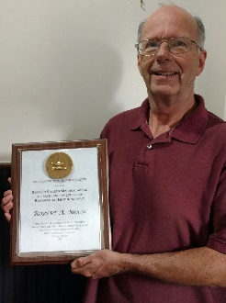
“A Beginner’s Guide to Collecting National Bank Notes”
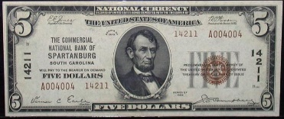
Presented by
Mr. Robert Moon
1PM to 2PM
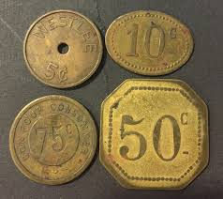

“Collecting Trade Tokens for Fun and Profit”
Presented by
Dr. Tony Chibbaro
Be sure to attend these excellent programs, you don’t want to miss them!



While there was a significant amount of work done in the months and weeks leading up to the show by the show committee (the SJCSRACC Officers and Board), the Stephen James CSRA Coin Club humbly thanks the following twenty-six volunteers who made our 17th annual show a success! On the day before and the day of the show these volunteers:
- set up the entire show on Thursday afternoon by moving bleachers and setting up 91 tables and 150 chairs
- Toted coins and show material into and out of the show for 23 Dealers
- Took down and stored the tables and chairs
- Cleaned the gym, the restrooms, the kitchen, and the common areas
- Put up and took down directional signage and banners that promoted the show and directed patrons into the facility
- Coordinated, fetched and delivered lunches to the Dealers and Volunteers
- Set up and maintained refreshments throughout the day
- Created displays of numismatic material – magazines, literature, the Club’s scrapbook etc.… for the patrons to enjoy. And the patrons were allowed to take the magazines and literature home with them!
- Set up and ran the registration table, where guests had the opportunity to purchase raffle tickets for the three prizes available.
- Watched tables for dealers when they needed breaks during the day Welcomed and assisted the guests by providing directions.

THANK YOU TO OUR
WONDERFUL VOLUNTEERS
SCNA CONVENTION
VOLUNTEERS NEEDED!
SCNA extends its sincere appreciation to the volunteers who worked the 2018 Convention!
Help is needed again, in 2019,
with these activities:
• Set up the show on Thursday 10/24
• Take down the show on Sunday 10/27
(this is a critical need!)
• Work at the registration table
• Assist with the YN Program
• Run errands during the show

REWARDS!
• Give at least 2 hours during the weekend and get a free 1-year SCNA membership
• Give 6 hours or more during the weekend and you will receive:
♦ Free 1-year SCNA membership
♦ An American Silver Eagle
♦ Free entry in a drawing for a 1/10th oz. gold coin!
Be sure to sign attendance roster to log your volunteer hours. See SCNA Secretary Pascal Brock at the Convention and he will assist you!

Anyone interested in helping should contact Bourse Chairman Bill Latour at: lowcountrycoins1@bellsouth.net or
843-532-5089

