The Stephen James
CSRA Coin Club of Aiken
P.O. Box 11
New Ellenton, SC 29809
Web site: www.sjcsracc.org
The SJ CSRA CC of Aiken, SC meets on the 1st Thursday of the month at the Aiken Public Library

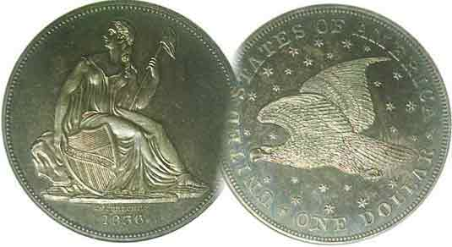
Pres. Willie Simon
V .P. Pat James
Sec. Jim Mullaney
Treas. Chuck Goergen
Sgt. in Arms: Jim Sproull

Programs: Pat James
ANA Representative: Jim Barry
Show Chairman: Steve Kuhl
Photos: Helen Barry
Publicity: Pat James
Newsletter: Arno Safran
E-Mail: arnosafran@comcast.net
Auctioneer: Jim Sproull
Web site: Susie Nulty (see above.)

2014 Club Meeting Schedule
Volume 13, No. 5 the Stephen James CSRA Coin Club, Founded in 2001 May, 2014
Monthly Newsletter
Our next meeting will be held on Thursday, May 1, 2014 at the Aiken Public Library

Club Show to Remain on Sept. 6, ACC Show May 9 &10
Jan. 2 Apr. 3 July 3 Oct. 2
Feb. 6 May 1 Aug. 7 Nov. 7
Mar. 6 June 5 Sept. 4 Dec. 4

Club Show Date Set

When the Low Country Club belatedly chose the same date for their September show as ours in order to share the facility hosting an area gun show that very weekend, some dealers who normally do both events decided not to do ours. As it turned out a couple of our regulars arranged to have representatives serving at both events while others we canvassed replied they would do ours. The Club Executive Committee decided to keep the show date in line with the Aiken-Makin Weekend and will endeavor to add other dealers to the bourse.
_______________________________________________________________________________________________________________

Georgia Numismatic Association’s 50th Anniversary Convention a Huge Success

The GNA held its 50th Coin and Paper money show at the Georgia Northwest Trade and Convention Center in Dalton, GA on April 11-13 and by the size of the bourse and attendance by the public, it has to be regarded as a huge success. This is a good sign that the overall economy is improving. Dealers were generally pleased with their sales and many collectors were delighted to find some of the elusive numismatic items they were seeking. The balmy spring weather helped greatly. There were numismatic programs and a number of outstanding exhibits. Dalton is a lovely small city located in the northwestern corner of Georgia about 27 miles south of Chattanooga, TN along I-75. The next important regional show scheduled there will be hosted by the Blue Ridge Numismatic Association (BRNA) in August.
________________________________________________________________________________________________________________

Augusta Coin Club to hold Show May 9 & 10 at new Expo Center in Grovetown, 9 to 5 both days

From Aiken: take I-20 west to Interchange 190. Turn left at end of ramp. At Gateway Blvd traffic light. turn left again. Pass Wal-Mart on left and go beyond Center For Primary Care at right to Columbia County Exhibition Center. Park near the right entrance of 212 Partnership Drive.
_______________________________________________________________________________________________________________________

Collecting the US Coins of 1814: 200 Years Ago
By Arno Safran
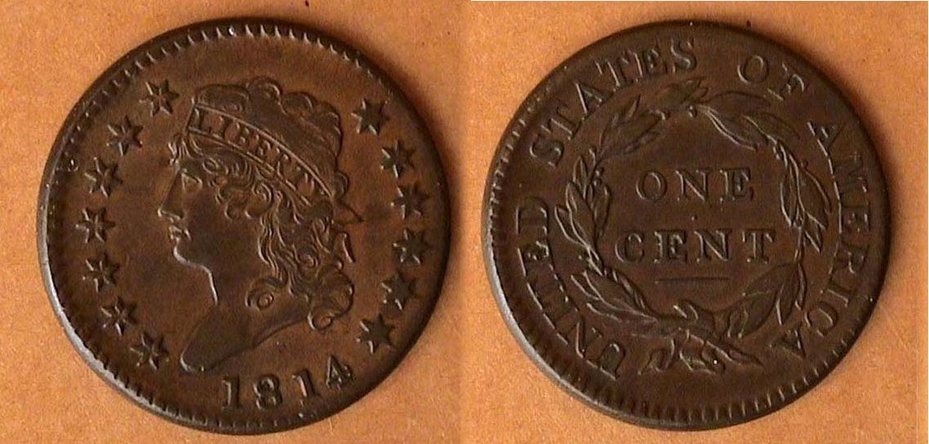

An 1814 Classic head Large Cent, S-294 R1 (crosslet 4)
[Use 3X glass or magnify page to 200% t view details.]

In the early years of our nation’s coinage, there were no guarantees that all ten authorized denominations would be produced every year. In fact, between 1793 and 1848 the only year all ten denominations were struck was back in 1796. For one thing, obtaining sufficient silver and gold to mint coins were costly. For another, hostilities between Great Britain and the United States increased during the teen years of the 19th century culminating in the three-year conflict known as the War of 1812. During this period, it became increasingly difficult if not impossible for the Mint to obtain the necessary copper blanks to strike cents and half cents. By 1814, the Mint had barely enough copper planchets to coin large cents with which to pay their employees. As a result, in 1814, the Mint struck only four denominations. These included the cent, the dime, the half-dollar, also the $5.00 gold half-eagle. the $2.50 quarter eagle and $10.00 eagle having been suspended along with the half-cent, half-dime, quarter and dollar.

For the moderate-income collector, the only denominations that are somewhat attainable are the cent, dime and half dollar, the 1814 $5.00 gold piece being unduly expensive starting at $5,000 in just Fine-12, the lowest listed grade shown in the latest Red book.

Pictured above is a lovely example of an 1814 Classic Head large cent grading AU-58. It would be the last year of the Classic head type for the cent. Despite a mintage of 357,830, the coin is considered a common date and relatively inexpensive from AG-3 thru Fine-12. There were two die varieties struck, the crosslet 4 and plain 4, both priced similarly.
_____________________________________________________________________________________________________________
(Continued on page 2, column 1)
The Coins of 1814 (excluding gold)
(Continued from page 1, column 2)

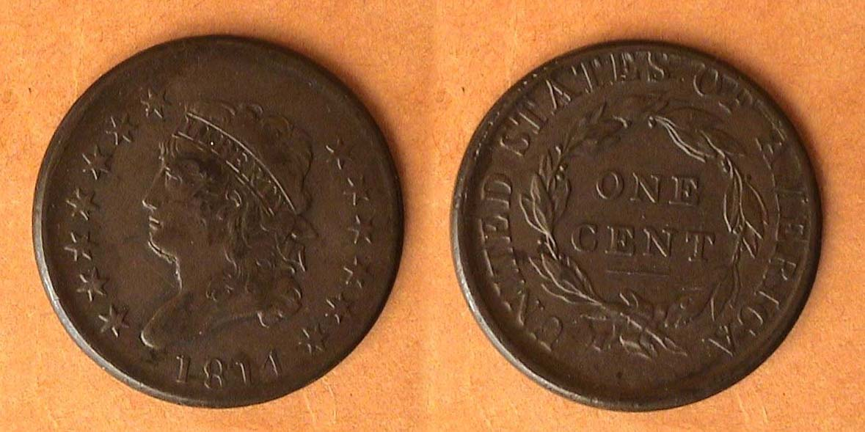

An 1814 Classic Head Cent, S-295, plain 4 variety
[Use 3X glass or magnify page to 200% t view details.]

While the early US large cents (1793-1807) usually had a large number of die varieties for most dates, the Classic Head series (1808-1814) had a a few to only one. In 1814, just two varieties were struck. These are easy for even the novice collector to recognize because of the different punches used to strike the 4 in the date. The Sheldon 294 variety displays a more ornate crosslet 4 while the Sheldon 295 shows a plain 4. William Sheldon was the author of the book, “Penny Whimsy”

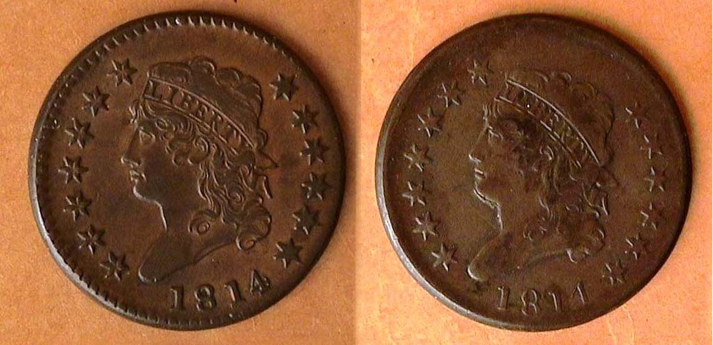

The 1814 Classic head 1c obv. of the crosslet and plain 4 varieties
[Use 3X glass or magnify page to 200% t view details.]

While type collectors may not be interested in die varieties per se, many collectors of large cents are. Below are the two reverses of the 1814 cent. To the novice collector, they look identical but if one merely observes the point of the highest leaf (PHL) in relation to the second S in STATES, the reader will see that the 1814 Crosslet 4 reverse shows the leaf well to the right of the S while the Plain 4 reverse shows the highest leaf positioned more under the right side of the S.

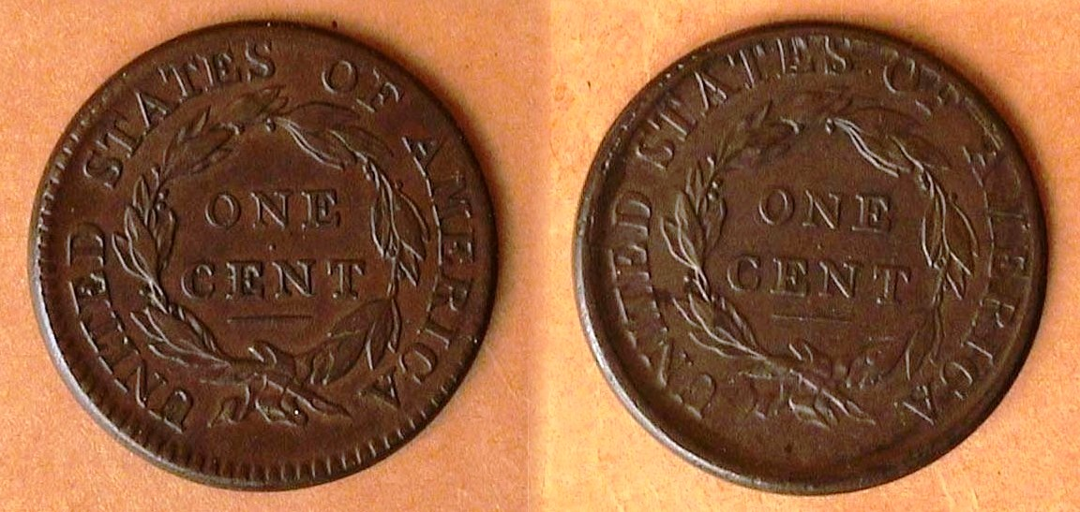

The 1814 Classic head 1c rev. of the crosslet and plain 4 varieties
[Use 3X glass or magnify page to 200% t view details.]

Of the seven dates that comprise the Classic Head large cent series, the 1814--despite its lower reported mintage--is arguably as common as the 1808, 1810 and 1812, each with over one million struck. The engraver of the Classic Head cent type was John Reich who was appointed as Asst. Engraver to Robert Scot in 1807 by Mint Director Robert Patterson on the recommendation of President Thomas Jefferson. He served in the post until 1817 redesigning all our coinage. In 1814, a cent had the purchasing power of 15c.

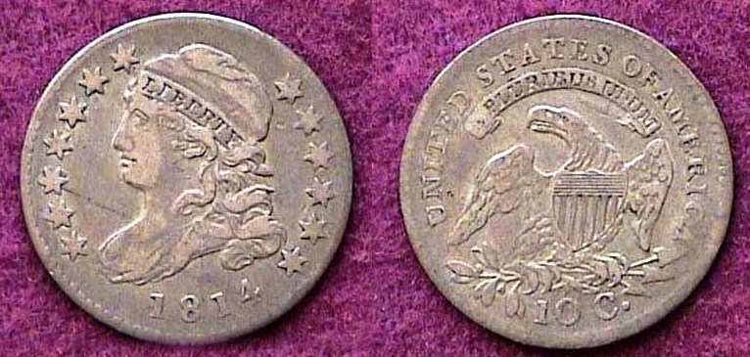

An 1814 Capped Bust dime, JR-1, R3 small date
The coin was later graded VF-30 by ICG
[Use 3X glass or magnify page to 200% t view details.]

In 1814, a reported 421,500 dimes were struck. There were five die varieties. The first var., (JR-1), shown above displays a small date and is listed as an R-3, (less common). The other four display a larger date with the R3 & 4 being slightly more common.

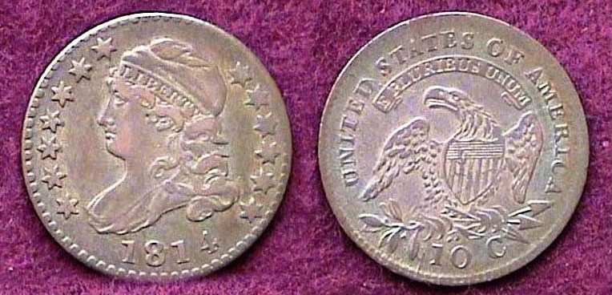

An 1814 Capped Bust dime, JR-4, R2 with larger date
The coin was late graded XF-45 by PCGS
[Use 3X glass or magnify page to 200% t view details.]

Before the Steam Press was implemented at the Mint in 1836, all US coins were struck on a screw press with many features engraved by hand. When a die wore out, new dies were prepared which were never identical to the previous ones. Those dies that wore out more quickly have become rarities treasured by later generation of collectors, much the same as for low mintage dates. One variety of the 1814 dime not shown above is the scarce but popular STATESOFAMERICA variety seen on the reverse of the JR-5 die variety. The reason why the letters of the legend were not spaced properly remains unknown. That said, variety collectors opt to pay higher premiums to obtain them. From 1809 thru 1828, the diameter of the dime was roughly 18.8 mm. In 1814, a dime had the purchasing power of $1.37.
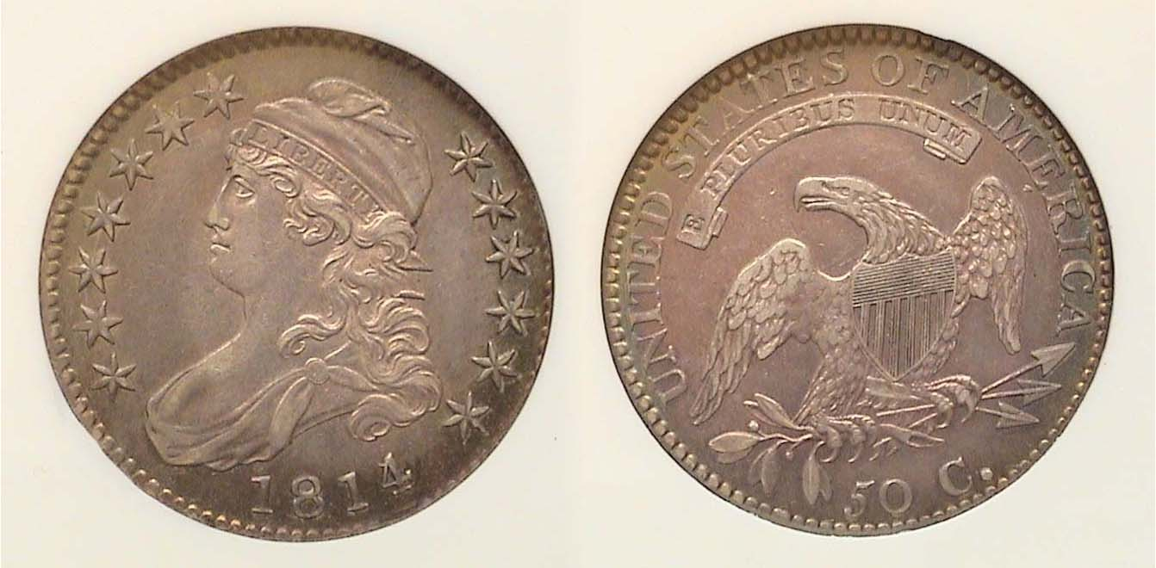
An 1814/3 Capped Bust 50c graded AU-50 by NGC
[Use 3X glass or magnify page to 200% t view details.]

Over 1.2 million Capped Bust lettered edge half dollars were minted in 1814. At the time, this was our largest circulating silver coin and like the Morgan dollars of a later era, the coin was stored in banks as specie with which to back larger business transactions. Fifty cents had the purchasing power of almost $7.00 in 1814. Bust halves were coined from 1807 thru 1836. The earlier dates tend to be scarcer than those struck after 1820. Overdate issues abound within the Bust half series. The 1814/3 shown above, while popular and pricier than the normal date issue is not especially rare however. The 32.5 mm coin was thick enough to have the words FIFTY CENTS or ONE HALF DOLLAR inscribed on the edge.
_____________________________________________________________________________________________________________________________
(Continued on page 3, column 1)
Collecting the US Coins of 1814, (excluding gold)
(Continued from the preceding page)

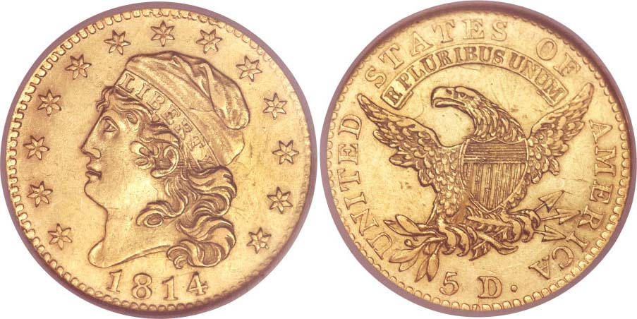

An 1814/3 $5.00 Half Eagle graded AU-58 by NGC
The coin realized $14,687 at a Heritage auction held at the
FUN Show in Orlando, FL Jan. 10, 2014
[Use 3X glass or magnify page to 200% to view details.]

The recorded mintage of the 1814 half eagle was a scant 15,454 but the coin is a lot scarcer than its mintage would suggest due to high meltage. While a specimen of the 1814 half-eagle would be a real jewel to have in any collector’s year set, it is quite rare and considerably expensive. Most collectors will have to satisfy themselves with a three-piece set, the cent, dime and half-dollar and even these three are somewhat pricey in the grades shown.

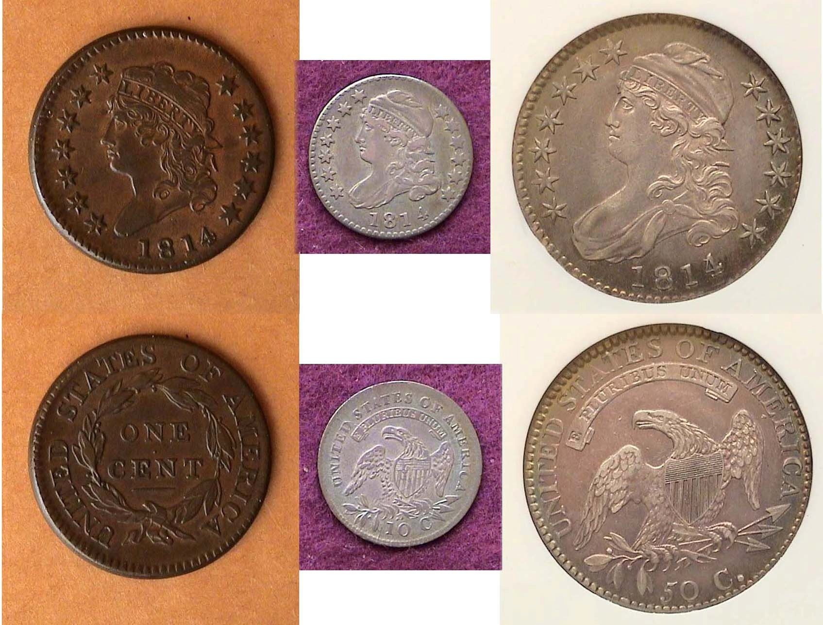
US
An 1814 Year set in scale (excluding the $5.00 gold piece)
showing the Crosslet 4 large cent, large date dime and 14/3 half -dollar
[Use 3X glass or magnify page to 200% to view details.]

While lower-grade specimens from Good-6 to Fine-15 are moderately priced, finding examples with eye appeal presents a challenge to the budget-conscience collector. Regardless of the grade, certified pieces are highly recommended especially for the silver issues.

In 1814, James Madison was serving his second term as President. The second war with England was still raging and not going all that well for our nation. In August, The British advanced on Washington DC. First Lady Dolley Madison single handedly carried the Declaration of Independence to safety while ordering the removal of vital records for safekeeping. By September, the tide began to turn in favor of the Americans. Francis Scott Key penned the words set to an old English drinking song that would become our National Anthem. The British fleet was defeated at Lake Champlain and Andrew Jackson stopped the British in Louisiana. On Christmas Eve, the signing of the Treaty of Ghent in Belgium ended hostilities.
__________________________________________________________________________________________________________________
STEPHEN JAMES CSRA COIN CLUB
Regular Meeting- Aiken County Library
April 3, 2014
Vice President Pat James called the meeting to order at 6:45 p.m. and introduced Willie Simon, who was elected Club President for the next year. Willie Simon served with distinction as President of the Club for the first eight years of its existence, and he was given a warm welcome.
Sgt at Arms, Jim Sproull reported there were 23 members and 2 guests in attendance. Jim also related information about the upcoming coin shows in the area, including the Augusta Coin Club’s annual Spring Coin Show on May 9 and 10, 2014. John Sanfratello won the members’ door prize, a Franklin Half Dollar. There was a motion by J. J. Engel to waive the reading of the minutes of the March meeting. David Amey seconded the motion, which was voted upon and carried. A copy of the minutes will appear in the Club Newsletter and are on file in the Club’s records. Treasurer Chuck Goergen reported that the April balance was $1396.18. (This was updated later in the evening after writing several checks, resulting in a new balance of $1078.75)
Bourse Chairman Steve Kuhl confirmed that the Club’s coin show this year would be held on Saturday, September 6, 2014, even though there would be a conflict that weekend with the Low Country Coin Club’s decision to hold their show the same weekend. The only other weekends in September had conflicts with other shows in the region. President Simon presented outgoing President Steve Kuhl with a plaque from the Club thanking him for five years of stellar service to the Club.
President Simon reported that he had presented the Library on behalf of the Club with a numismatic reference book, the 2014 Standard Catalog of World Coins 1901 – 2000. He further reported that Roger Worpel agreed to conduct the annual audit, and the proposed budget for the coming year would be presented at the May 1 meeting. Finally, he also complimented Arno on the coverage of Barber halves (his personal favorite) in his April newsletter.
There were three Show and Tell presentations. Walt Kublius brought a 1918 note from the Ukraine, a 50-hryvnia note that was minted in Odessa. Chuck Goergen showed an ancient coin minted 215 – 205 B.C. The coin, a 1.7-gram shekel, was minted by Hannibal when he was marching his army around in Italy during the time of the Second Punic War. Glenn Sanders exhibited an 1846 Liberty head $5 gold coin minted in Charlotte, North Carolina. The coin’s mintage was just 13,995, and it was graded VF by PCI. The evening’s program was a power point presentation, U.S. Gold Coins Intended For Circulation 1849-1933, by Arno Safran. Sgt at Arms Jim Sproull, with the assistance of Secretary, Jim Mullaney, conducted the club auction. The meeting was adjourned at 8:40 p.m. Barbara Zirps won the 50/50 ($21).
Respectfully submitted, JimMullaney, Secretary
____________________________________________________________________________________________________________________________

Show & Tell and Appreciation Award Pics
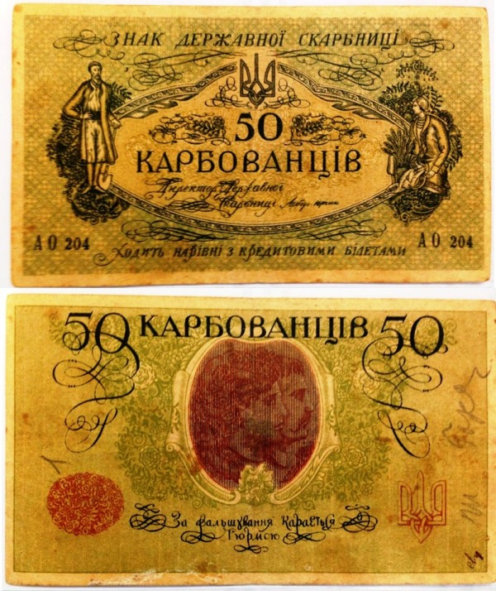

A 1918 50 hryvnia banknote
Brought in by Walter Kublius
(Photo, courtesy of Sec. Jim Mullaney)

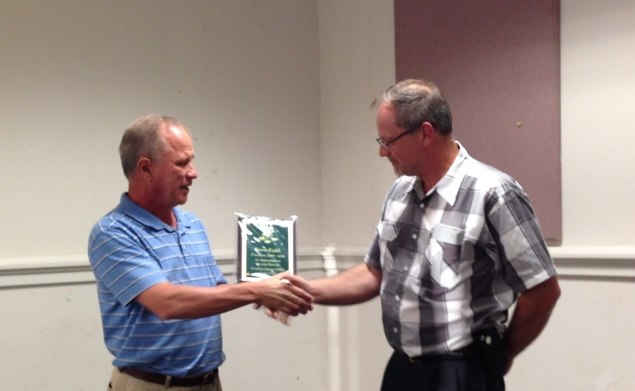

President Willie Simon (left) presenting plaque of appreciation
to outgoing President Steve Kuhl, (right)

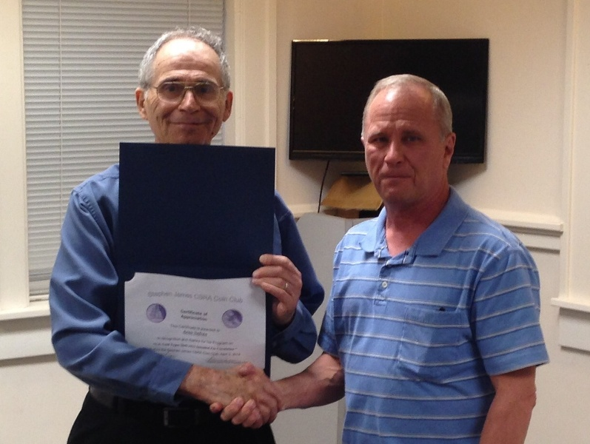

Arno Safran (l) receiving Certificate of Appreciation from President Willie Simon, (r) for program on US Gold Coins (1849-1933)
Kindly Patronize Our Advertisers

